Logging on to SAP
Double-click this icon on your desktop. If the icon is not there, choose Start → All Programs → SAP Front End → SAP Logon.
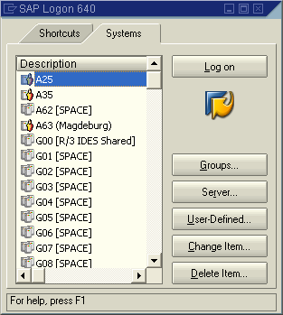
A dialog box similar to the one shown on the right appears. The list of systems may be longer than in the dialog box shown here. Select the SAP system specified by your lecturer and choose Log on or Enter.

The logon screen appears. The system requests the client, your user, password, and preferred language.

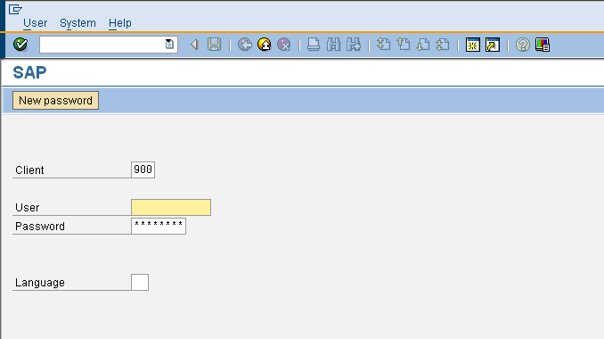

Before you log on, you need to know the definition of the term “client.”

SAP systems are client systems. With the client concept, you can manage several separate companies at the same time in one system.
Clients are the highest organizational level in the system. In business terms, each client can represent a group of companies, a company, or a works – regardless of the size of the organization. In commercial, organizational, and technical terms, a client is therefore a self-contained unit with separate master records and its own set of tables. In SAP systems, the different clients are identified by their client numbers.

Enter the client number specified by your lecturer. For you to be able to log on as a user, a user master record must be created for you in the relevant client. For reasons of access protection, you must enter a password when you log on. Your entries here are not case-sensitive. In the example shown below, it would also be correct to enter “UCC-99.”

SAP systems are multilingual. You choose the language of your current session in the Language field. Then choose or Enter.

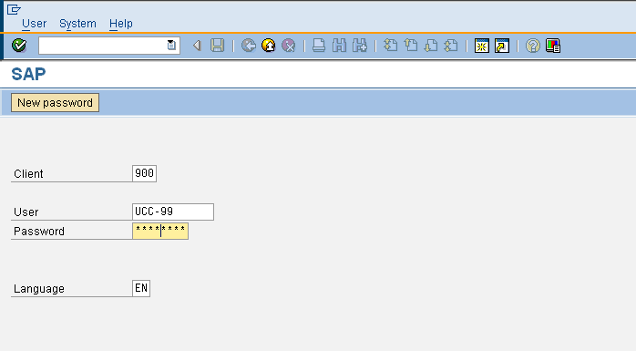

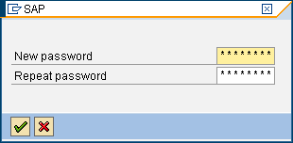
When you log on for the first time, the system requests you to change your password (the rules for passwords are given in the annex). To confirm your new password, choose or Enter.
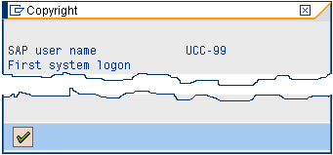
When you log on for the first time, the copyright notice appears. Confirm it with or Enter. The initial screen containing the SAP Easy Access menu appears.

© 2008 by SAP AG. All rights reserved.

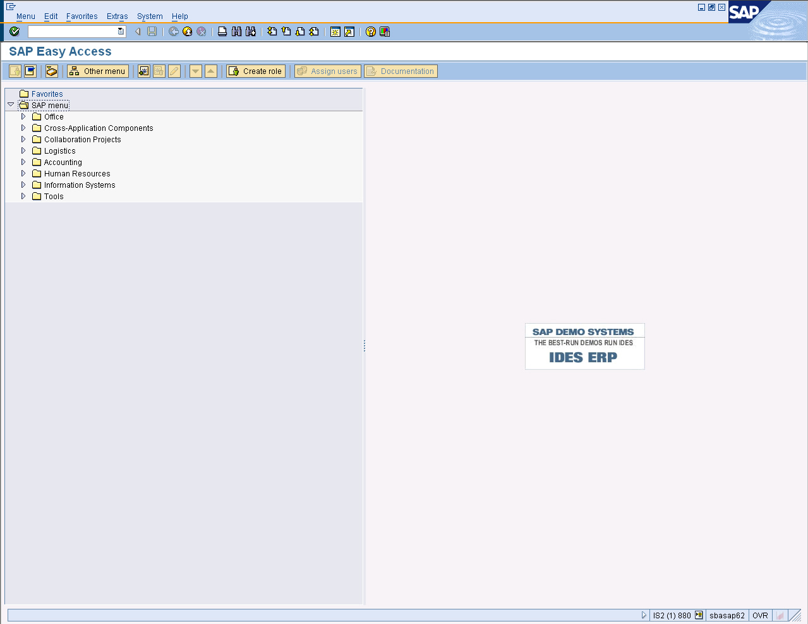

Menu Paths and Transaction Codes

Navigating in the ERP system can get confusing. One way to navigate in the system is through the menus system at the left edge of the screen. For example, to enter a sales order, the user can click on the triangle in front of Logistics, which expand the menu to show the following options under Logistics:

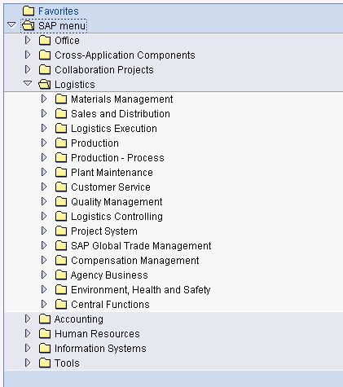
Click on the triangle in front of logistics to expand the menu

The user can then expand Sales and Distribution, which provides a listing of options for the sales and distribution module:

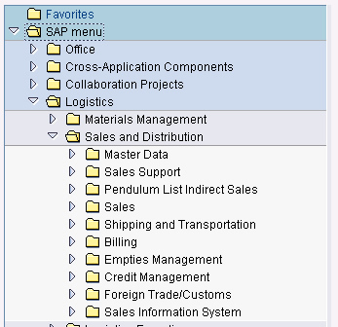

To get to the sales order entry screen, the user has to expand the Sales option, and then Order to get to Create.
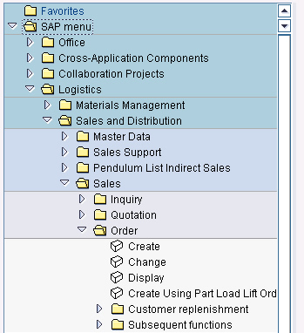
Double-click here

Double-clicking on the Create line will bring up the order entry screen.

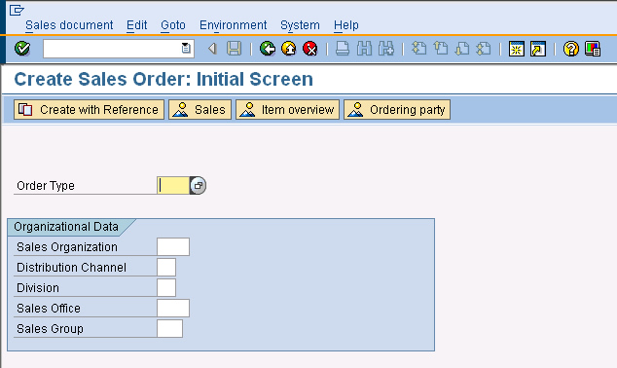

Notice that the tree-structure menu has disappeared. You are now in the area of the SAP program where you will enter a sales transaction.
In these instructions, the previous series of menu paths will be described using bold text with arrows showing each of the menu selections. Thus, the menu paths to get to the customer order entry screen will be shown as follow:

Logistics Sales and Distribution Sales Order Create

IMPORTANT FEATURE

Frequently the tree-structure menu paths can get a little confusing. When that happens, the SAP standard menu icon can be used to collapse the menu back to its original starting point.

Users of the ERP system typically use only a few of the thousands of transaction screens available, and they tend to use them frequently. For example, people performing customer order entry may use screens to enter inquiries, quotes and sales orders and check on the status of material, but they will not likely be performing human resource functions or determining plant maintenance schedules. For these users, the SAP ERP system provides an easier way to navigate the system.

First, we can save this transaction in our favorites folder. Click on the back icon to return to the tree-structured menu. The tree structure should still be opened to the Create Sales Order transaction. To add this to our favorites folder, simple click on the create line and drag it to the favorites folder:

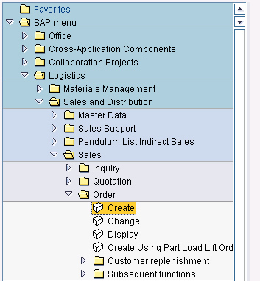
Drag Create to Favorites

This will create a link to the Create Sales Order transaction under the Favorites menu:

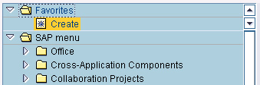

Favorites can also be added and deleted using the add and delete favorites icons .

The title of this new short cut leaves something to be desired, but we can edit it. Click on the new Create shortcut, the follow the pull-down menu path Favorites→Change:

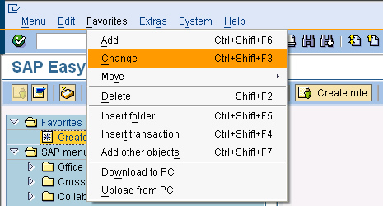

Note that in these instructions pull-down menu paths will be given using arrows rather than triangles. The Favorites→Change menu path will produce the following pop-up window:

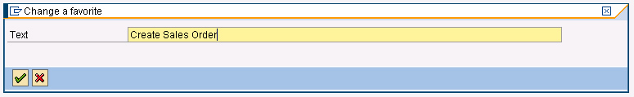

Edit the transaction description so that it reads “Create Sales Order” and then click on the enter icon . The Favorites menu will now have the transaction Create Sales Order.

The Change a favorite pop-up window can also be accessed by clicking on the change favorites icon . Test this shortcut by clicking on it. This should bring you directly to Create Sales Order: Initial Screen.

Transaction Codes

Another way to navigate in the ERP system is through Transaction Codes. Every transaction in the ERP system is given a code number, and the ERP system allows for users to enter these code numbers as another means of going directly to a transaction. SAP has been trying to move users away from using transaction codes and had threatened to remove this option, but many users are used to them, so entering transaction codes as a means of navigation is still available.

To find the transaction code for the Create Sales Order process, make sure you are at the screen Create Sales Order: Initial Screen. Then select the pull-down menu path:

System→Status

and the following screen will appear:

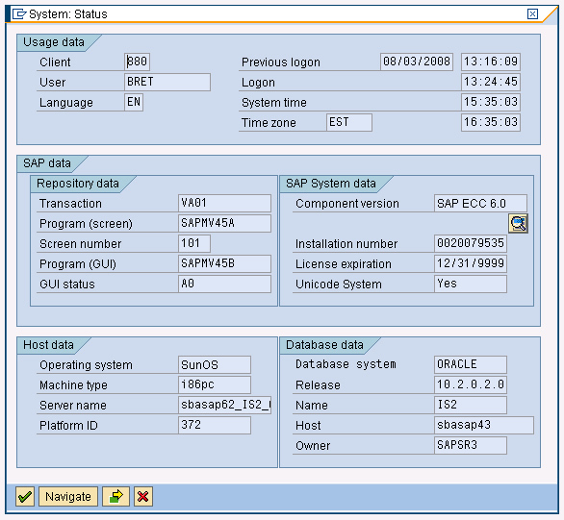
Transaction Code

This screen gives a lot of information about the SAP installation including the version of SAP (SAP ECC 6.0), the database the system is using (Oracle) and the operating system of the server (SunOS). Additionally, it gives the Transaction Code of the transaction associated with the current screen, which in this case is VA01. This code can be used to get to the order entry screen from anywhere in the ERP system. To illustrate this, we must first get back to the main screen. To do this, click on the cancel icon .

SAP provides three ways to move “back” in the ERP system, two of which are the Back and Exit commands. The back command can be invoked using either the back icon or the F3 key. The exit command is invoked using the exit icon or the by holding the Shift key while hitting the F3 key. The functions of these two keys differ depending on where they are used. In general the Exit key moves you farther out of the module or transaction you are currently in, but this isn’t always the case. The Cancel command is invoked with the cancel icon or with the F12 key. The cancel command allows the user to exit a transaction without saving any data. Frequently the Cancel and Exit commands work identically.

To see how to use the transaction code, use the Back, Exit or Cancel commands to get back to the main menu. If you exit too far, you will log off the SAP ERP system, but not before getting a warning message:

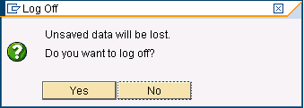

Transaction codes are entered in the command field at the top-left of the ERP screen:

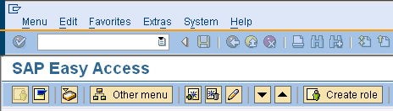
Command Field

If the command field is not visible, it may be opened by clicking on the triangle:

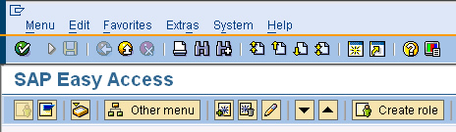
Click here to access command field

We can use the transaction code VA01 to go directly to the sales order entry screen. To do this, enter /nva01 into the command field as follows:

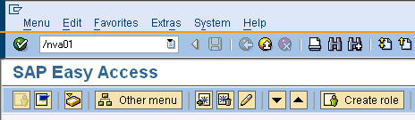

The /n tells SAP you want to cancel the current transaction and go to a new one. You can enter the transaction code in upper or lower case. Click on the enter icon or hit the return key and you will go directly to the sales order entry screen.

Click on the exit icon to exit this screen. Now that we have entered the VA01 transaction in the command field it is available from a pull-down menu.

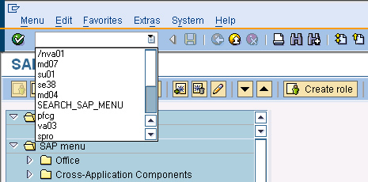
Click on the page icon to get a list of transaction codes that you’ve used.

Select the transaction code from the pull-down menu and click on the enter icon or hit the enter key to go to the create sales order screen one more time. Click on the back icon or exit icon , to go back to the main screen.

Important Icons

In the last section you were introduced to three of the most common SAP icons. While there are many icons used throughout the ERP system, the most common ones are summarized below. If you are unsure of the function of a particular icon, just hold the mouse pointer over the icon for a few seconds and a description of the icon will appear:

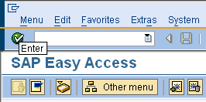
ENTER Enter

Enter: This icon is typically used to move to the next step in a transaction process after some basic data is entered in an initial screen of a transaction. For example, in the initial create sales order screen, the user has to enter initial data about the order type (sales organization, distribution channel and division) before the actual order entry can begin. Once that data is entered, the user can then click on the enter icon which signals the ERP system to go to the next screen in the sales order process, retrieving any required information from the database.

Hitting the enter key will achieve the same result as clicking on the enter icon.

Important point: The enter icon doesn’t cause transactions to be saved. It moves the process along and retrieves data from the database. To save a transaction like a customer order, you will have to click on the save icon. The ERP system will warn you if you try to leave a transaction without saving.

Back: As described previously, the back icon allows the user to exit a transaction without saving data.

Cancel: The cancel icon functions very similarly to the back and exit icons.

Exit: As described previously, the exit button allows the user to exit a transaction and typically moves the user closer to the main screen than the back or cancel icon.

Execute: The execute icon is used to initiate a process that is typically time consuming, like creating a report or calculating a new material requirements plan.

Save: This icon is used to save a completed transaction. It is important to remember that nothing is saved until this icon is clicked.

Basic Interface Customization

Some configuration options can be set by following the pull-down menu path:

System→User profile→Own data

First, note that following this menu path will create a new session (window). Select the Defaults tab. Confirm the following entries on this screen:

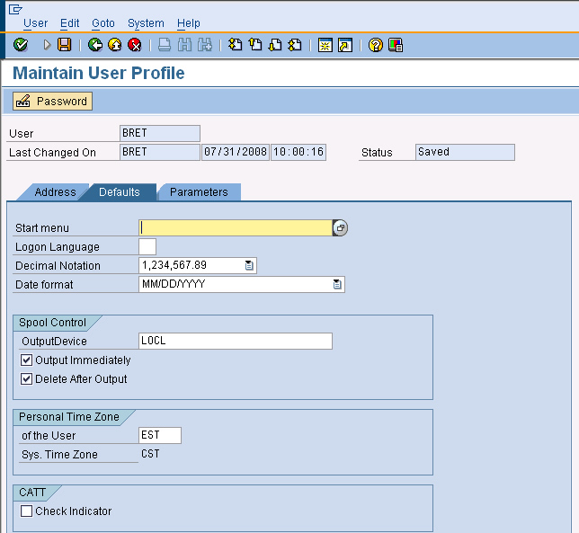
Confirm that the OutputDevice (printer) is set to LOCL with Output Immediately and Delete After Output selected
Confirm the number and date format are set properly for the US

In an enterprise-wide system, managing output (printing) is a significant task. For our purposes, we will just tell the system to send any printed output immediately to the default Windows printer.

As the SAP ERP system is used internationally, it must be adaptable to other languages and practices. In Europe, for example, commas are used where we use decimal points and vice-versa. Dates are specified in the form DD.MM.YYYY instead of MM/DD/YYYY as in the US. The SAP ERP system can be configured to accommodate these differences. Click on the save icon () to save these settings.

Note: Some changes made in this screen will not take effect until the user logs off and logs on again.

One other change should be made to the interface. As transaction codes are useful, we can tell the ERP system to display the transaction codes as part of the menu paths. To do this, from the SAP Easy Access screen follow the pull-down menu path:

Extras→Settings

Which will produce the following pop-up screen:

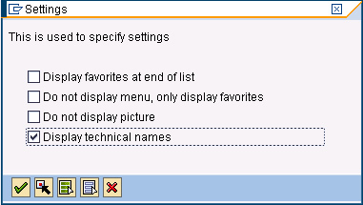
Check Display technical names

Check Display technical names and then click on the continue icon . To see that the transaction codes are now displayed, follow the tree-structure menu path:

Logistics Sales and Distribution Sales Order

And notice that the transaction code VA01 is listed in front of the Create option.

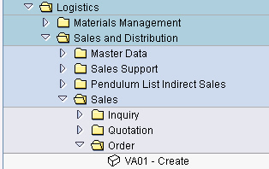

Multiple Sessions

Some times it is useful to be looking at two (or more) different screens in SAP simultaneously. To do this, the ERP system allows you to start up to six interactive sessions under one User ID. In some cases, like following the menu path System→User profile→Own data, the system automatically creases a new session. To create another session, follow the pull down menu path:

System→Create Session

and another session will be started. You can switch between sessions using the Task Bar in Windows:

Select session using Task Bar buttons

NOTE: If you have more than three sessions open at one time, this will usually lead to confusion.

