Instructions for the Use of SampleCalc
By
Peter Tryfos

CONTENTS
Introduction 1
To load SampleCalc: 1
To unload SampleCalc 2
Using SampleCalc, Overview 2
Common first steps 3
Method: simple random sampling 5
Method: Stratified random sampling 8
Method: Two-stage sampling 12
Method: Cluster sampling 16
Glossary 19

Introduction

In the course of obtaining information from a random sample, two stages can be distinguished. Before taking the sample, the main issues to be resolved are how to select the sample, how large it should be, and often how the total sample size should be allocated among groups of population elements. After taking the sample, the main tasks are to calculate point and interval estimates of the population characteristics of interest.

The program SampleCalc (short for Sample Calculator) is aimed exclusively at this second stage. It calculates unbiased point estimates and approximate confidence intervals of the principal population characteristics for each specified variable and each category of specified attributes.

It is assumed throughout that sampling is without replacement. The methodology is described in, among other sources, Peter Tryfos, Sampling for Applied Research: Text and Cases, Wiley, 1996, Chs. 3 to 5.

SampleCalc is a Microsoft Excel 97 Add-In that can be loaded when needed and unloaded when not. Although the program RCalc can also be used for calculations after the sample is taken, the user must summarize beforehand the sample observations in the form of, say, group means, proportions, or variances for every variable and attribute of interest. By contrast, SampleCalc performs the appropriate preliminary calculations automatically on the sample observations. Also, because SampleCalc is an Excel Add-In, any corrections, changes, creation of new variables, and coding or re-coding of the sample observations can be carried by Excel just prior to the application of SampleCalc.

To load SampleCalc:

- Start Microsoft Excel.
- Select Tools|Add-Ins.
- In the Add-Ins dialog box, check the SampleCalc box, then click OK. The SampleCalc submenu should now appear in the Tools menu.

To unload SampleCalc

- Select Tools|Add-Ins.
- Uncheck the SampleCalc box.
- Delete the SampleCalc submenu from the Tools menu.

Using SampleCalc, Overview

It is assumed that the observations are entered in an Excel worksheet and arranged in the form of a table, the columns of which correspond to the variables and attributes of interest and the rows to the sampled elements. The editing of the data, and the coding of the variables, attributes, and missing values, should take place before SampleCalc is used.

Before using SampleCalc, be aware that the following additional information is required by each sampling method. Make sure that this information is entered on the worksheet containing the observations or is otherwise available before SampleCalc is called.

Simple Number of elements in the population
Confidence level
Stratified Labels identifying the groups (strata)
Number of elements in each group (stratum) in the population
Confidence level
Two-stage Labels identifying the selected groups (strata)
Number of elements in each selected group (stratum) in the population
Number of elements in the population
Number of groups (strata) in the population
Number of selected groups (strata)
Confidence level
Cluster Labels identifying the selected groups (strata)
Number of elements in the population
Number of groups (strata) in the population
Number of selected groups (strata)
Confidence level

It should be noted that the confidence intervals generally require large samples; however, SampleCalc does not check that this requirement is satisfied. Also, the number of categories of an attribute cannot exceed 50.

The first steps when using SampleCalc are common for all sampling methods. The remaining steps depend on the method by which the sample was selected.

The application of SampleCalc will be illustrated with the help of a simple example. It will be assumed that a random sample without replacement of 10 households was selected from the population of households in a city. The observations are entered in an Excel spreadsheet in the manner shown in Figure 1.

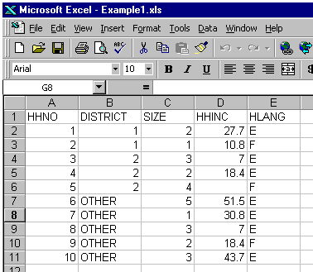
Figure 1

The labels of the variables and attributes are entered in the first row. HHNO stands for household number, DISTRICT for the district identification (1, 2, or OTHER), SIZE for the number of persons in the household, HHINC for household income (in $000), and HLANG for language spoken at home (E: English, F: French). There is a missing value (an empty cell) in cell D6.

These observations could have been obtained using a simple, stratified, two-stage, or cluster random sample. In the following sections we describe how the analysis of the same observations depends on the sampling method used. The fact that the number of observations is small is ignored in all illustrations that follow.

Common first steps

Enter the sample observations (data) in the form of a compact table in an Excel worksheet. The rows must correspond to the sampled elements and the columns to the variables and attributes of the study. It is strongly recommended that the first row of this table contain the labels of the variables and attributes (see Figure 1). A missing value should be represented either by a blank cell or one containing a period.

- Click on any one cell of this compact table (SampleCalc tentatively assumes that the surrounding cells contain the observations).
- In the Tools menu, click on SampleCalc. A dialog box entitled Data and Labels will appear (see Figure 2).

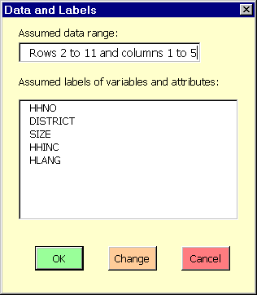
Figure 2
  - If the displayed data range and labels are correct (they should be if the first two instructions were followed correctly), click the OK button and go to Step 4.
  - If the displayed data range or the labels are not correct, or if the data do not have the recommended format, click the Change button. In the two ensuing dialog boxes, select the proper ranges for the data and the labels. The Data and Labels dialog box will reappear. Go back to Step 2.1.
  - Click the Cancel button to abort SampleCalc.
- The Method dialog box now appears (see Figure 3). Select the method by which the sample was selected (simple, stratified, two-stage, or cluster), and click either the OK button to proceed, or the Cancel button to abort SampleCalc.

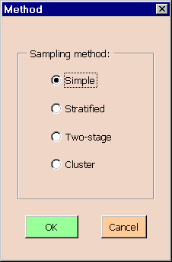
Figure 3

The subsequent conversation with SampleCalc depends on the sampling method selected. Refer to the section corresponding to the method by which the sample was selected.

Method: simple random sampling

To illustrate the application of SampleCalc, it will be assumed that the observations shown in Figure 1 were selected by drawing a simple random sample without replacement of 10 households from among the 2400 households in the city.

After selecting Simple in the Method box, the Simple random sampling dialog box appears (see Figure 4).

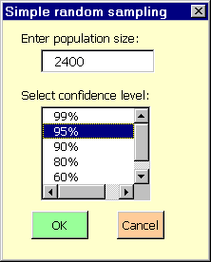
Figure 4

- In the dialog box entitled Simple random sampling (Figure 4), enter the number of elements in the population and select the confidence level (99%, 95%, 90%, 80%, 60%, or 50%). Then, click either the OK button to proceed, or the Cancel button to abort SampleCalc.

- The program will display a message for your information to the effect that it is creating the worksheet VRESULTS; acknowledge by clicking OK. A similar second message to the effect that the program is creating the worksheet ARESULTS should also be acknowledged by clicking OK. (VRESULTS will contain the results of calculations concerning the selected variables, while ARESULTS will contain the results regarding the selected attributes.)

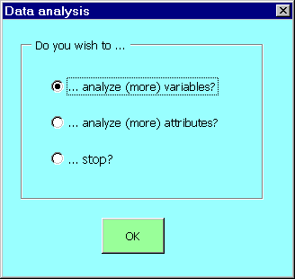
Figure 5

- The dialog box entitled Data analysis will now appear (see Figure 5). To analyze one or more variables, select the first option. To analyze one or more attributes, select the second option. To stop, select the third option. Click OK.

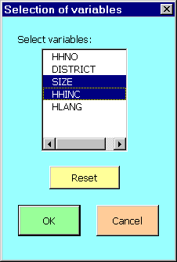
Figure 6

- If you chose to analyze one or more variables, a dialog box entitled Selection of variables will appear (see Figure 6). Select the variables to be analyzed by clicking on their labels. (Clicking on a label again cancels the selection. Clicking the Reset button cancels the entire selection.) Click OK to proceed, or Cancel to return to the Data analysis dialog box in Step 7. If you clicked OK, you will find that the VRESULTS worksheet now contains for each selected variable the number of observations with non-missing values, the estimates of the mean and total of the variable, the estimated variance of the variable, the estimated standard deviation of the estimate of the population mean, and the lower and upper limits of the specified confidence intervals for the mean and total of the variable (see Figure 7). The dialog box Data analysis will reappear; the same choices are again available as in Step 7.

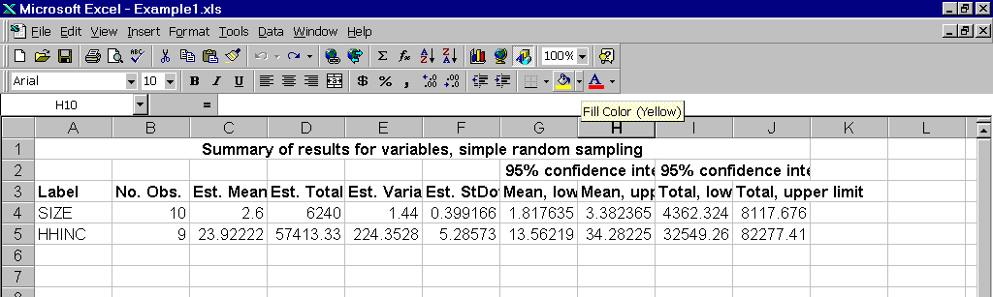
Figure 7

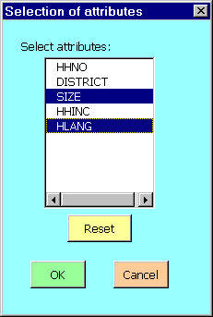
Figure 8

- If you chose to analyze one or more attributes, a dialog box entitled Selection of attributes will appear (see Figure 8). Select the attributes to be analyzed by clicking on their labels in the first list box. (Clicking on a label again cancels the selection. Clicking the Reset button cancels the entire selection.) Click OK to proceed, or Cancel to return to the Data analysis dialog box in Step 7. If you clicked OK, you will find that the ARESULTS worksheet now contains for each category of each selected attribute the number of observations with non-missing values, the estimates of the proportion and number in the category, the estimated standard deviation of the estimate of the population proportion, and the lower and upper limits of the specified confidence intervals for the proportion and number in the category (see Figure 9). The dialog box Data analysis will reappear; the same choices are again available as in Step 7.

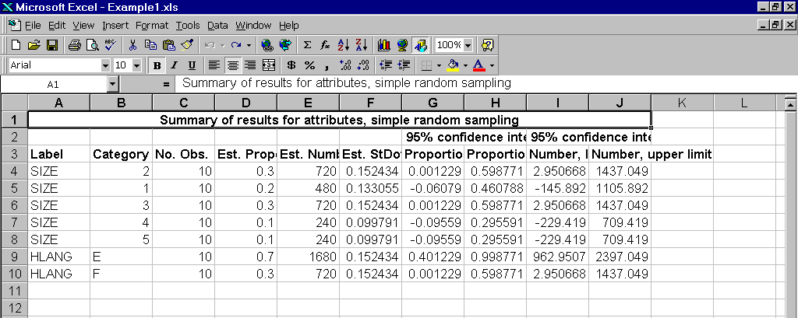
Figure 9

- If you chose to Stop, a message will appear reminding you to save the calculations before leaving Excel. Click OK to leave SampleCalc and return to Excel. You may want to adjust the column widths of VRESULTS and ARESULTS in order to see the results more clearly. (If you wish to delete the worksheets VRESULTS and ARESULTS, right-click on the tab of the worksheet and select Delete from the pop-up menu.)

Method: Stratified random sampling

To illustrate the application of SampleCalc, it will be assumed that the city households are grouped into three districts and that the observations shown in Figure 1 were selected by drawing a simple random sample without replacement of 2 households from among the 500 households in District 1, one of 3 households from among the 1100 households in District 2, and one of 5 households from among the 800 households in the district labeled Other. The labels and the number of households in each district are entered in the same worksheet as the sample observations (see Figure 10).

After selecting Stratified in the Method box, the Group labels dialog box appears.

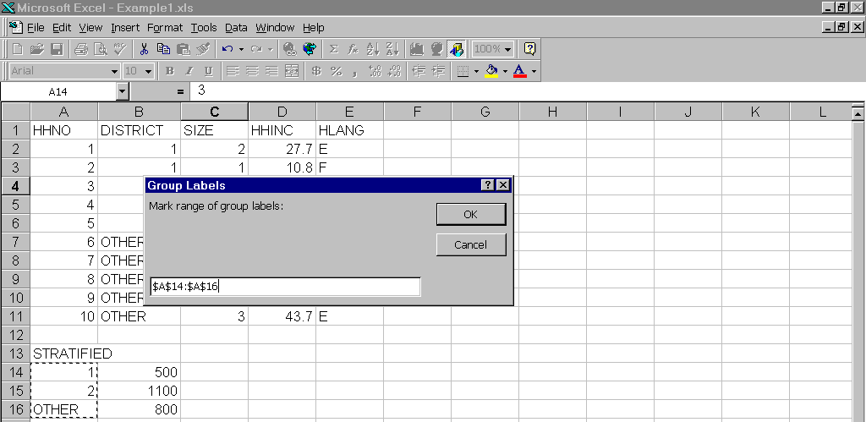
Figure 10

- In the dialog box entitled Group labels (see Figure 10), select the range containing the labels of the groups (strata). Click OK to proceed, or Cancel to abort the program.

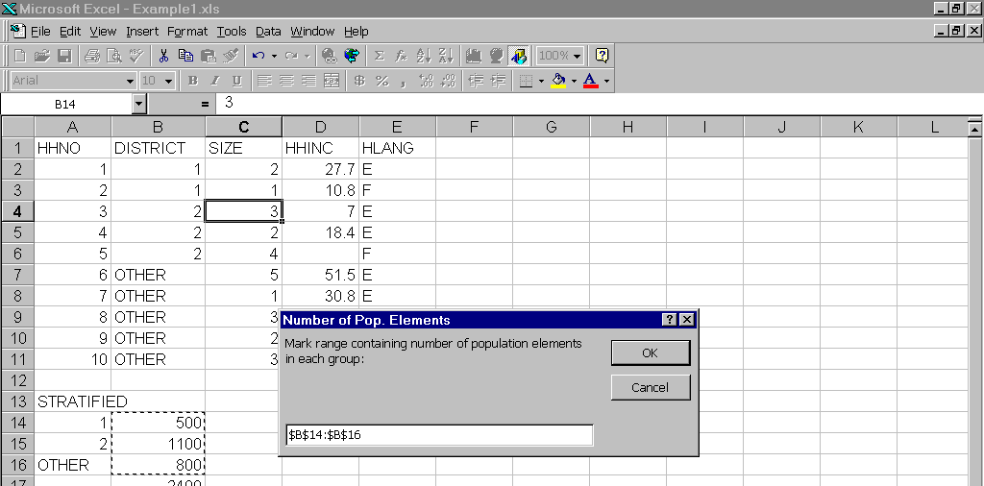
Figure 11

- In the dialog box entitled Number of Pop. Elements (see Figure 11), select the range containing the number of elements in each group (stratum) in the population. Click OK to proceed, or Cancel to abort the program.

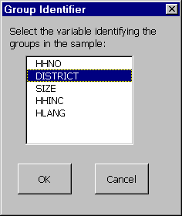
Figure 12

- A dialog box entitled Group Identifier will now appear (see Figure 12). Select the label of the column in the table of data that identifies the group (stratum) to which each sampled element belongs. These labels should be consistent with those in Step 5; otherwise, an error message will eventually appear. Click OK to proceed, or Cancel to abort.

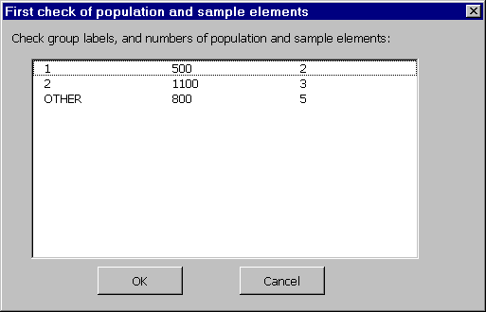
Figure 13

- A dialog box entitled First check of population and sample elements will now appear (see Figure 13). It shows the program’s understanding of the group (stratum) labels, and of the corresponding number of elements in the population and sample. If you observe an anomaly, click Cancel to abort SampleCalc, check the data, and begin anew. If the program’s understanding appears correct, click OK to proceed.

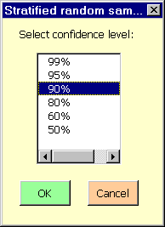
Figure 14

- In the dialog box entitled Stratified random sampling (see Figure 14), select the desired confidence level (99%, 95%, 90%, 80%, 60%, or 50%), and click OK to proceed or Cancel to abort.
- The program will display a message for your information to the effect that it is creating the worksheet VRESULTS; acknowledge by clicking OK. A similar second message to the effect that the program is creating the worksheet ARESULTS should also be acknowledged by clicking OK. (VRESULTS will contain the results of calculations concerning the selected variables, while ARESULTS will contain the results regarding the selected attributes.)
- The dialog box entitled Data analysis will now appear (see Figure 5). To analyze one or more variables, select the first option. To analyze one or more attributes, select the second option. To stop, select the third option. Click OK.
- If you chose to analyze one or more variables, a dialog box entitled Selection of variables will appear (see Figure 6). Select the variables to be analyzed by clicking on their labels. (Clicking on a label again cancels the selection. Clicking the Reset button cancels the entire selection.) Click OK to proceed, or Cancel to return to the Data analysis dialog box in Step 11. If you clicked OK, you will find that the VRESULTS worksheet now contains for each selected variable the number of observations with non-missing values, the estimates of the mean and total of the variable, the estimated standard deviation of the estimate of the population mean, and the lower and upper limits of the specified confidence intervals for the mean and total of the variable (see Figure 15). The dialog box Data analysis will reappear; the same choices are again available as in Step 11.

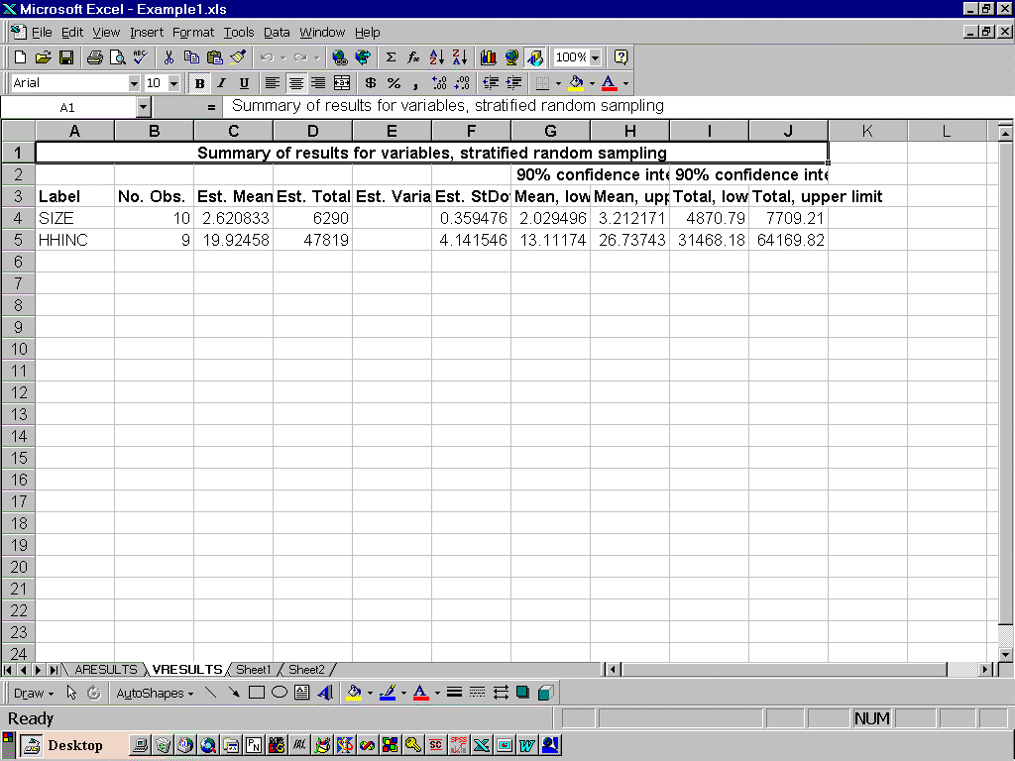
Figure 15

- If you chose to analyze one or more attributes, a dialog box entitled Selection of attributes will appear (see Figure 8). Select the attributes to be analyzed by clicking on their labels in the first list box. (Clicking on a label again cancels the selection. Clicking the Reset button cancels the entire selection.) Click OK to proceed, or Cancel to return to the Data analysis dialog box in Step 11. If you clicked OK, you will find that the ARESULTS worksheet now contains for each category of each selected attribute the number of observations with non-missing values, the estimates of the proportion and number in the category, the estimated standard deviation of the estimate of the population proportion, and the lower and upper limits of the specified confidence intervals for the proportion and number in the category (see Figure 16). The dialog box Data analysis will reappear; the same choices are again available as in Step 11.

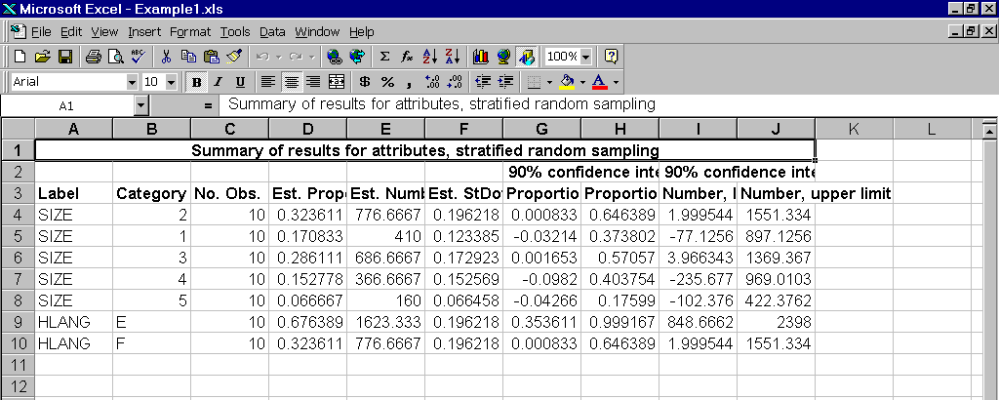
Figure 16

- If you chose to Stop, a message will appear reminding you to save the calculations before leaving Excel. Click OK to return to Excel. You may want to adjust the column width of VRESULTS and ARESULTS in order to see the results more clearly. (If you wish to delete the worksheets VRESULTS and ARESULTS, right-click on the tab of the worksheet and select Delete from the pop-up menu.)

Method: Two-stage sampling

To illustrate the application of SampleCalc, it will be assumed that the 5000 city households are grouped into six districts and that the observations shown in Figure 1 were selected in two stages. In the first, three of the six districts were selected at random and without replacement; these were the districts 1, 2, and Other. In the second stage, a simple random sample without replacement of 2 households was drawn from among the 500 households in District 1, one of 3 households from among the 1100 households in District 2, and one of 5 households from among the 800 households in the district labeled Other. The labels and the number of households in each district are entered in the same worksheet as the sample observations (see Figure 17).

After selecting Two-stage in the Method box, the Group labels dialog box appears.

- In the dialog box entitled Group labels (see Figure 17), select the range containing the labels of the selected groups (strata). Click OK to proceed, or Cancel to abort the program.

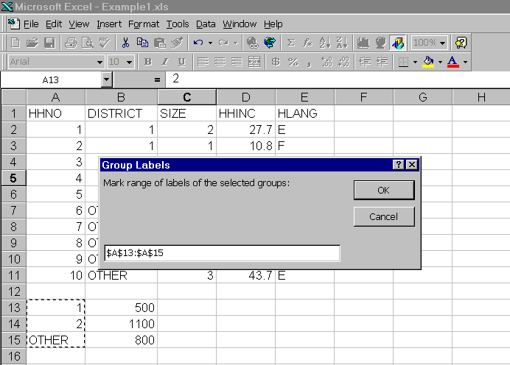
Figure 17

- In the dialog box entitled Number of Pop. Elements (see Figure 18), select the range containing the number of elements in each selected group (stratum) in the population. Click OK to proceed, or Cancel to abort the program.

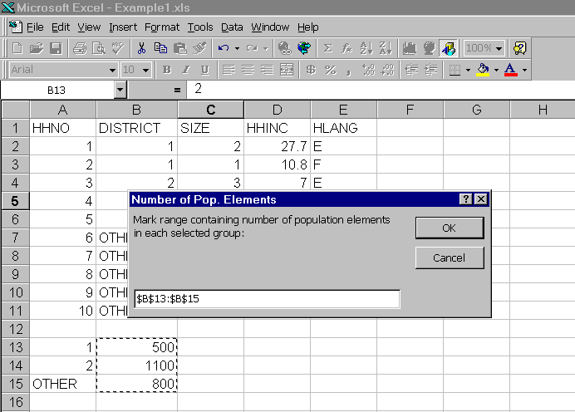
Figure 18

- In the dialog box entitled Two-stage random sampling (see Figure 19), enter the number of elements and the number of groups (strata) in the population, and select the desired confidence level (99%, 95%, 90%, 80%, 60%, or 50%). Click OK to proceed or Cancel to abort.

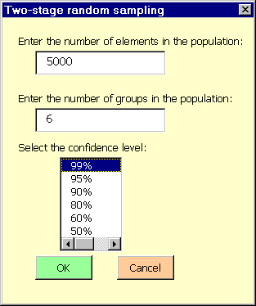
Figure 19

- A dialog box entitled Group Identifier will now appear (see Figure 20). Select the label of the one column in the table of data that identifies the group (stratum) to which each sampled element belongs. These labels should be consistent with those in Step 5; otherwise, an error message will eventually appear. Click OK to proceed, or Cancel to abort.

Figure 20

- A dialog box entitled First check of population and sample elements will now appear (see Figure 21). It shows the program’s understanding of the labels of the selected groups (strata), and of the corresponding number of elements in the population and sample. If you observe an anomaly, click Cancel to abort SampleCalc, check the data, and begin anew. If the program’s understanding appears correct, click OK to proceed.

Figure 21

- The program will display for your information a message to the effect that it is creating the worksheet VRESULTS; acknowledge by clicking OK. A similar second message to the effect that the program is creating the worksheet ARESULTS should also be acknowledged by clicking OK. (VRESULTS will contain the results of calculations concerning the selected variables, while ARESULTS will contain the results regarding the selected attributes.)
- The dialog box entitled Data analysis will now appear (see Figure 5). To analyze one or more variables, select the first option. To analyze one or more attributes, select the second option. To stop, select the third option. You can change the selection at any time before clicking OK. Click OK to confirm your selection and proceed.
- If you chose to analyze one or more variables, a dialog box entitled Selection of variables will appear (see Figure 6). Select the variables to be analyzed by clicking on their labels. (Clicking on a label again cancels the selection. Clicking the Reset button cancels the entire selection.) Click OK to proceed, or Cancel to return to the Data analysis dialog box in Step 11. If you clicked OK, you will find that the VRESULTS worksheet now contains (see Figure 22) for each selected variable the number of observations with non-missing values, the estimates of the mean and total of the variable, the estimated standard deviation of the estimate of the population mean, and the lower and upper limits of the specified confidence intervals for the mean and total of the variable. The dialog box Data analysis will reappear; the same choices are again available as in Step 11.

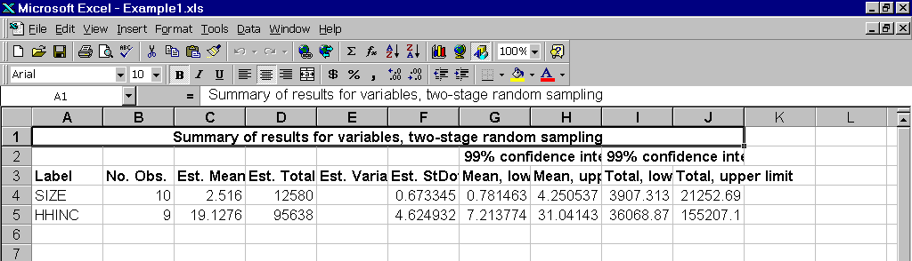
Figure 22

- If you chose to analyze one or more attributes, a dialog box entitled Selection of attributes will appear (see Figure 8). Select the attributes to be analyzed by clicking on their labels in the first list box. (Clicking on a label again cancels the selection. Clicking the Reset button cancels the entire selection.) Click OK to proceed, or Cancel to return to the Data analysis dialog box in Step 11. If you clicked OK, you will find that the ARESULTS worksheet now contains (see Figure 23) for each category of each selected attribute the number of observations with non-missing values, the estimates of the proportion and number in the category, the estimated standard deviation of the estimate of the population proportion, and the lower and upper limits of the specified confidence intervals for the proportion and number in the category. The dialog box Data analysis will reappear; the same choices are again available as in Step 11.

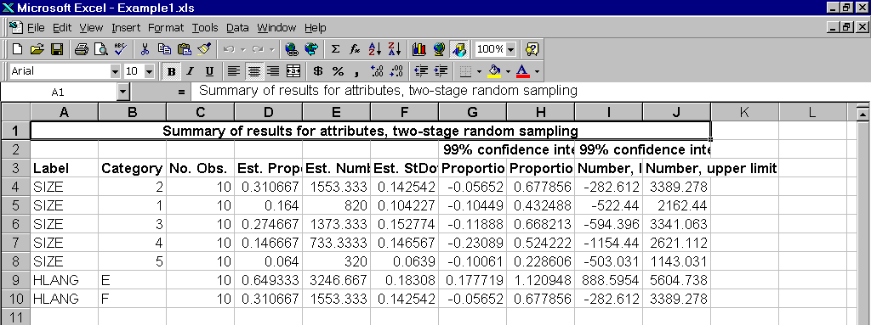
Figure 23

- If you chose to Stop, a message will appear reminding you to save the calculations before leaving Excel. Click OK to return to Excel. You may want to adjust the column widths of VRESULTS and ARESULTS in order to see the results more clearly. (If you wish to delete the worksheets VRESULTS and ARESULTS, right-click on the tab of the worksheet and select Delete from the pop-up menu.)

Method: Cluster sampling

To illustrate the application of SampleCalc, it will be assumed that a population consists of 500 city households grouped into 20 districts, and that the observations shown in Figure 1 were selected by drawing a simple random sample without replacement of three of the six districts; these were the districts 1, 2, and Other. All the households in the selected districts were interviewed.

After selecting Cluster in the Method box, the Cluster random sampling dialog box appears.

- In the dialog box entitled Cluster random sampling (see Figure 24), enter the number of elements in the population, the number of groups (strata) in the population, and the number of selected groups, and select the desired confidence level (99%, 95%, 90%, 80%, 60%, or 50%). Click OK to proceed or Cancel to abort.

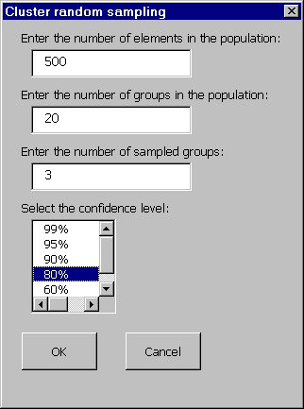
Figure 24

- A dialog box entitled Group Identifier will now appear (see Figure 24). Select the label of the one column in the table of data that identifies the group (stratum) to which each sampled element belongs. Click OK to proceed, or Cancel to abort.
- A dialog box entitled First check of population and sample elements will now appear (see Figure 25). It shows the program’s understanding of the labels of the selected groups (strata), and of the corresponding number of elements in the population and sample. If you observe an anomaly, click Cancel to abort SampleCalc, check the data, and begin anew. If the program’s understanding appears correct, click OK to proceed.

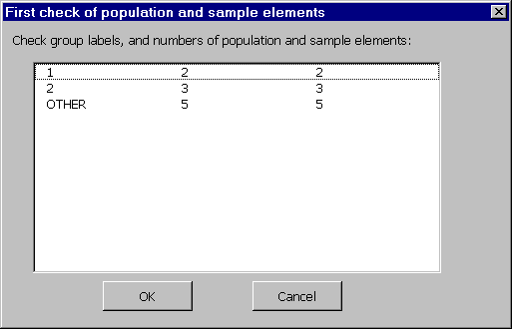
Figure 25

- The program will display for your information a message to the effect that it is creating the worksheet VRESULTS; acknowledge by clicking OK. A similar second message to the effect that the program is creating the worksheet ARESULTS should also be acknowledged by clicking OK. (VRESULTS will contain the results of calculations concerning the selected variables, while ARESULTS will contain the results regarding the selected attributes.)
- The dialog box entitled Data analysis will now appear (see Figure 5). To analyze one or more variables, select the first option. To analyze one or more attributes, select the second option. To stop, select the third option. You can change the selection at any time before clicking OK. Click OK to confirm your selection and proceed.
- If you chose to analyze one or more variables, a dialog box entitled Selection of variables will appear (see Figure 6). Select the variables to be analyzed by clicking on their labels. (Clicking on a label again cancels the selection. Clicking the Reset button cancels the entire selection.) Click OK to proceed, or Cancel to return to the Data analysis dialog box in Step 9. If you clicked OK, you will find that the VRESULTS worksheet now contains (see Figure 26) for each selected variable the number of observations with non-missing values, the estimates of the mean and total of the variable, the estimated standard deviation of the estimate of the population mean, and the lower and upper limits of the specified confidence intervals for the mean and total of the variable. The dialog box Data analysis will reappear; the same choices are again available as in Step 9.

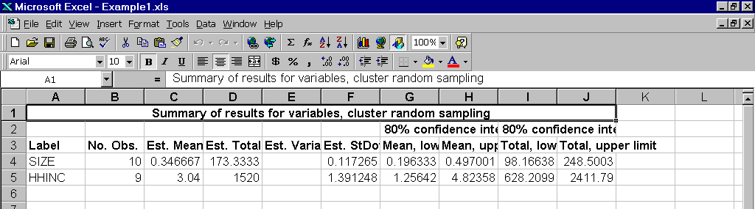
Figure 26

- If you chose to analyze one or more attributes, a dialog box entitled Selection of attributes will appear (see Figure 8). Select the attributes to be analyzed by clicking on their labels in the first list box. (Clicking on a label again cancels the selection. Clicking the Reset button cancels the entire selection.) Click OK to proceed, or Cancel to return to the Data analysis dialog box in Step 9. If you clicked OK, you will find that the ARESULTS worksheet now contains (see Figure 27) for each category of each selected attribute the number of observations with non-missing values, the estimates of the proportion and number in the category, the estimated standard deviation of the estimate of the population proportion, and the lower and upper limits of the specified confidence intervals for the proportion and number in the category. The dialog box Data analysis will reappear; the same choices are again available as in Step 9.

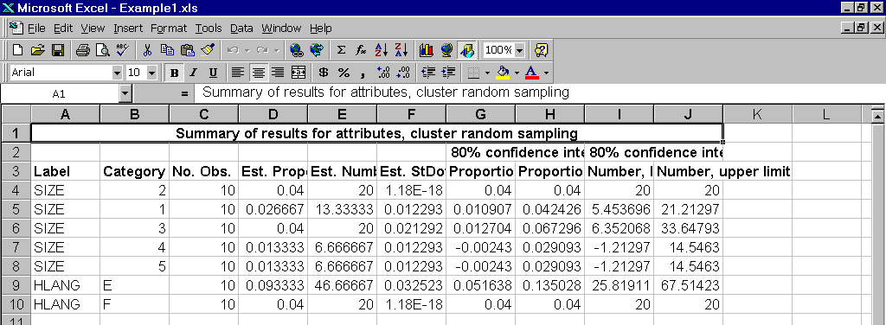
Figure 27

- If you chose to Stop, a message will appear reminding you to save the calculations before leaving Excel. Click OK to return to Excel. You may want to adjust the column widths of VRESULTS and ARESULTS in order to see the results more clearly. (If you wish to delete the worksheets VRESULTS and ARESULTS, right-click on the tab of the worksheet and select Delete from the pop-up menu.)

Glossary

Sampling with and without replacement. Sampling is said to be with or without replacement according to whether or not an element or group of elements can appear more than once in the sample.

Simple random sampling. One method of selecting a simple random sample is by a series of draws, in every one of which each eligible element has the same chance of being selected, and each selection is unrelated to (independent of) other selections. Such a sample is without replacement if the element selected in any draw is not eligible for selection in any subsequent draw.

Stratified random sampling. Requires that the elements of the population be grouped according to one or more criteria. A stratified random sample consists of simple random samples without replacement from each and every group (stratum).

Two-stage random sampling. Requires that the elements of the population be grouped according to one or more criteria. As the name implies, the sample is selected in two stages. In the first, a simple random sample of groups (strata) is selected. Then, in the second stage, a simple random sample of elements is selected from each group (stratum) that was selected in the first stage.

Cluster random sampling. Cluster sampling can be viewed as a special case of two-stage sampling. A cluster sample requires that the elements of the population be grouped according to one or more criteria. In the first stage, a simple random sample of groups (strata) is selected. Then, in the second stage, all the elements are selected from each group (stratum) that was selected in the first stage.

Variables and attributes. A variable is a feature or aspect of an element that lends itself naturally to a numerical description. For example, the age of a person, the income of a household, the maximum temperature in a day, etc. Unlike a variable, an attribute is a feature or aspect of an element that lends itself only to a categorical, qualitative---not numerical---description. For example, a person’s gender (male, female), a household’s location (in, say, district A, B, or C), the industrial classification of a manufacturing company, etc.

Population characteristics. The population characteristics of greatest interest in practice are the mean or total of a variable, and the proportion or number in a category of an attribute.

Point and interval estimates. Rather than, or in addition to, saying that a population characteristic is estimated to have such and such a value (the point estimate of the characteristic), it may be informative to state that a certain interval is estimated to contain a population characteristic with a certain probability. For example, instead of saying that the population mean of a variable is estimated to be 7.3, it may be informative to state that the population mean of the variable is in the interval from 6.5 to 8.1, where this statement is correct with probability 95%. The probability is often referred to as the confidence level and the interval estimate as a confidence interval.

Unbiased estimates. An estimate (more precisely, an estimator) of a population characteristic is said to be unbiased if its average value in a very large number of identical samples is equal to the population characteristic.

