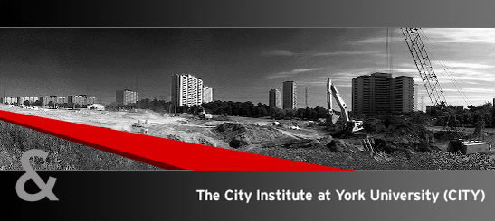

Suburbia in Transition:
Infrastructure and Planning in Toronto's In-Between City
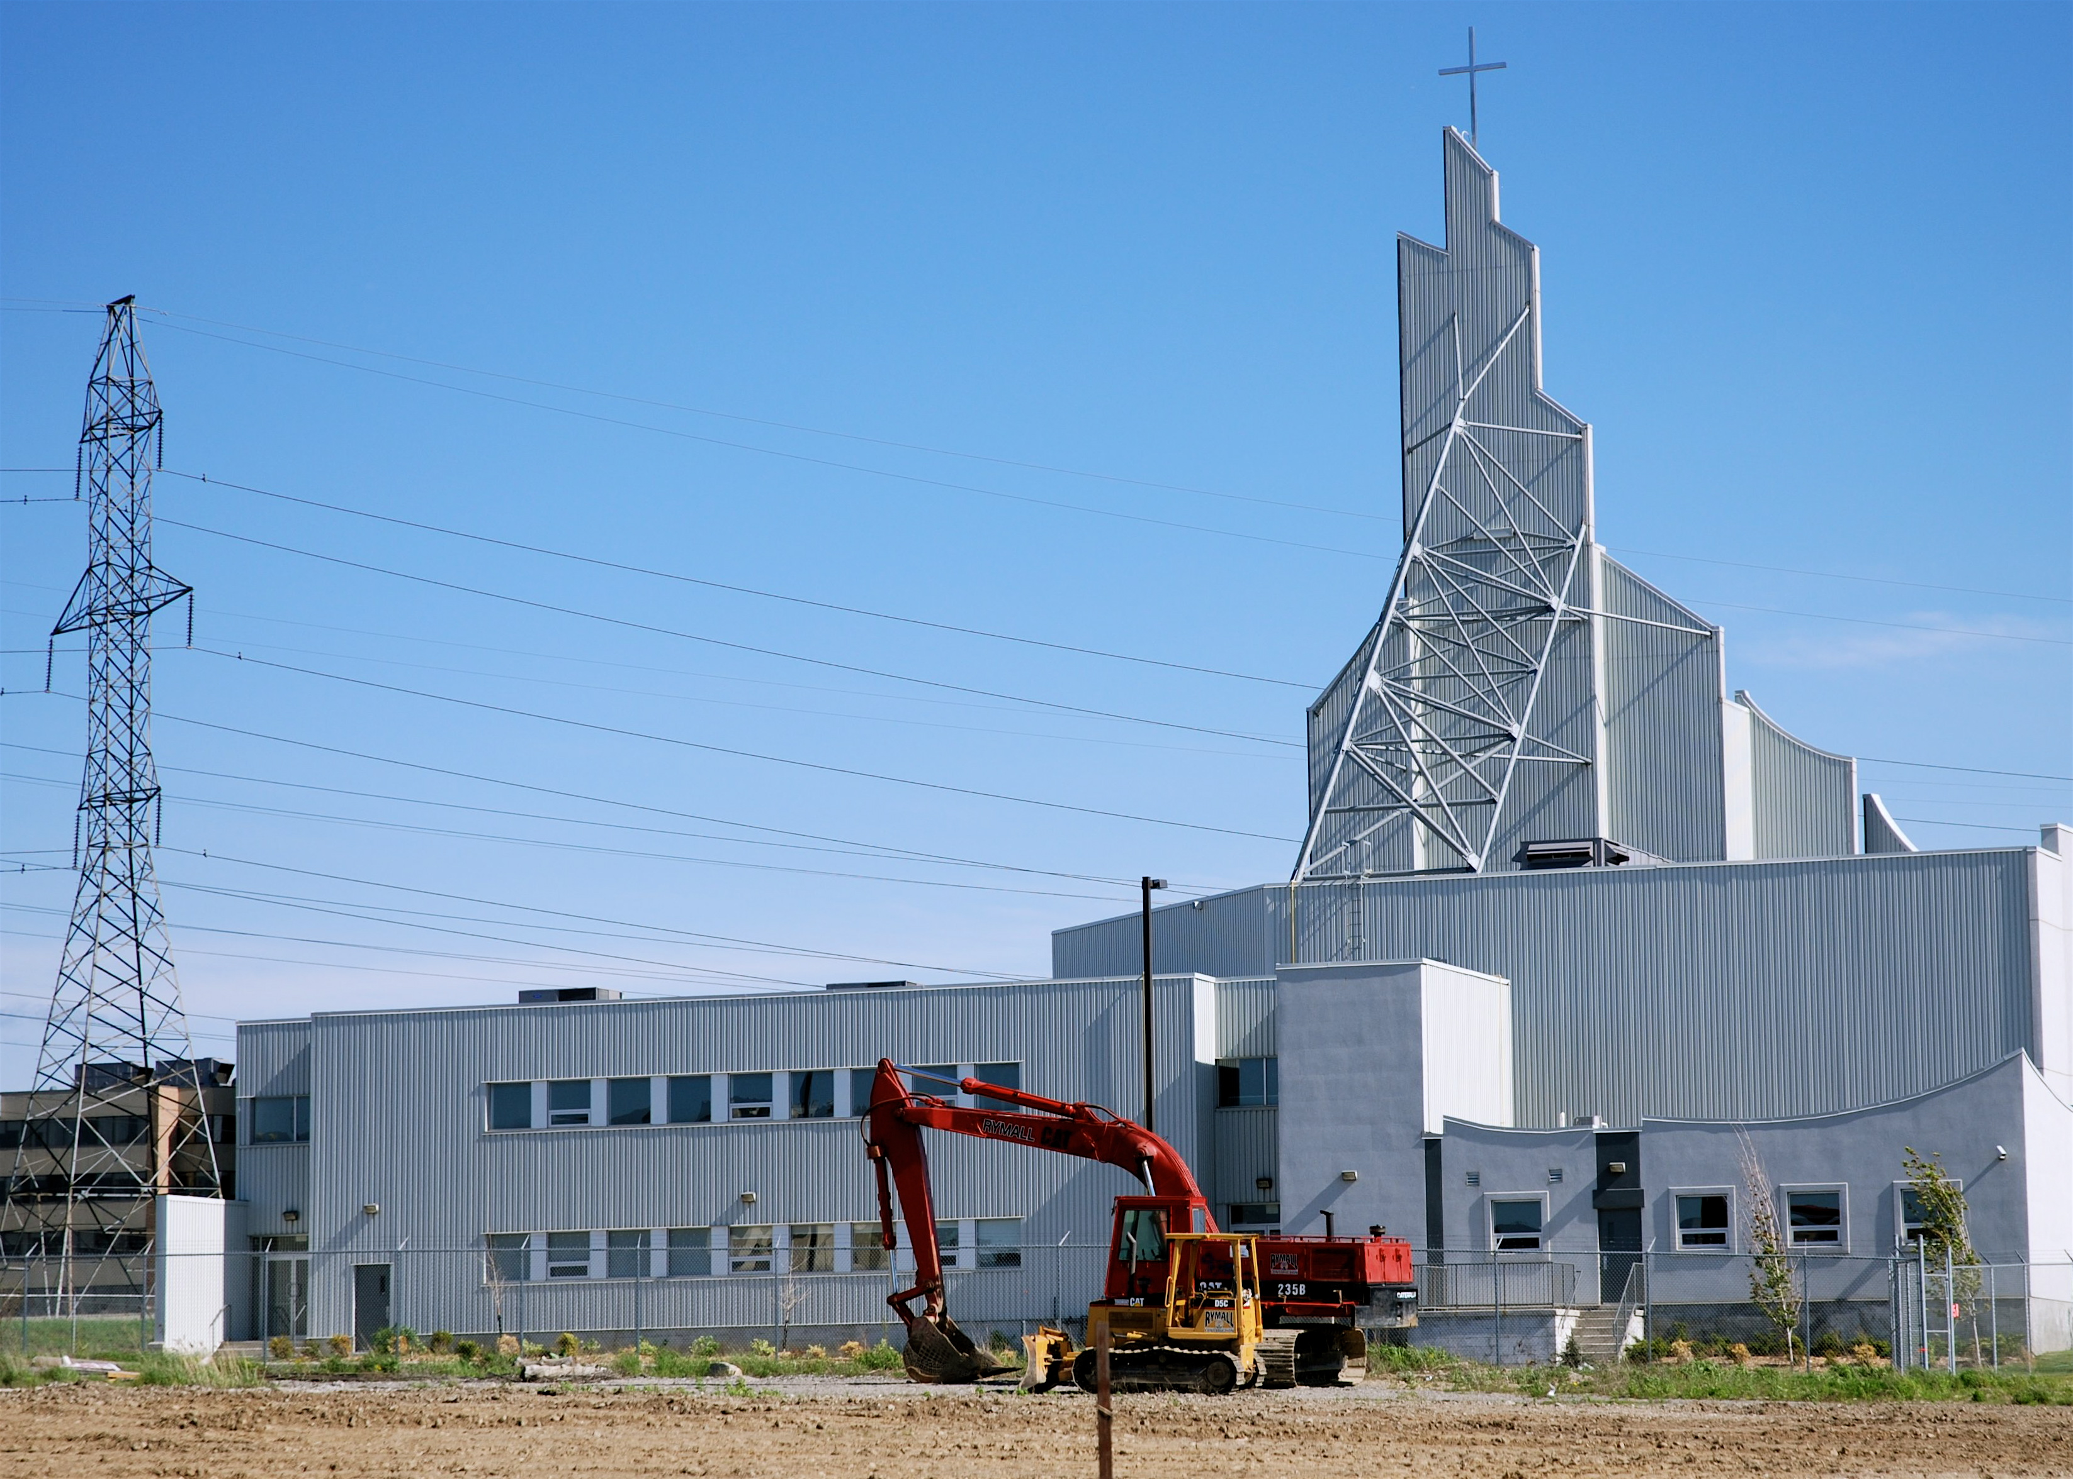
A lunchtime panel featuring presentations by researchers from the “In-Between Infrastructure” project and urban planning professionals

Thursday March 25, 2010
12:30-2:00 PM
7th Floor Lounge, York Research Tower

Please RSVP to city@york.ca by Monday March 22, 2010

Refreshments will be served. Everyone is welcome.


Research sponsored by:


