Guidelines for Developing Mode of Delivery Proposals
- Please use the minor change course proposal (CEC) for proposing a change in mode of delivery.
- Please fill in the required information on the first three boxes (Departmental Curriculum Approval, Contact Information, and Current Course information). These are required fields.
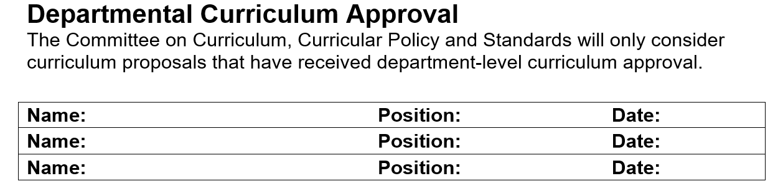
- Current Mode of Delivery: Please specify the current mode of delivery of the course.

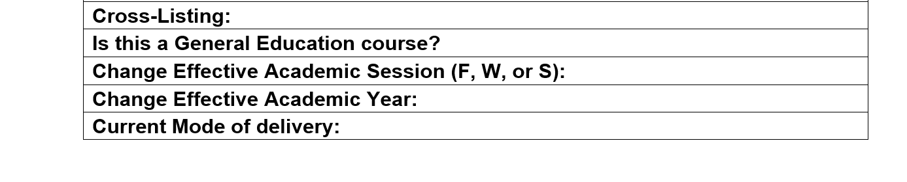
- Type of change: Indicate that it is a mode of delivery change.
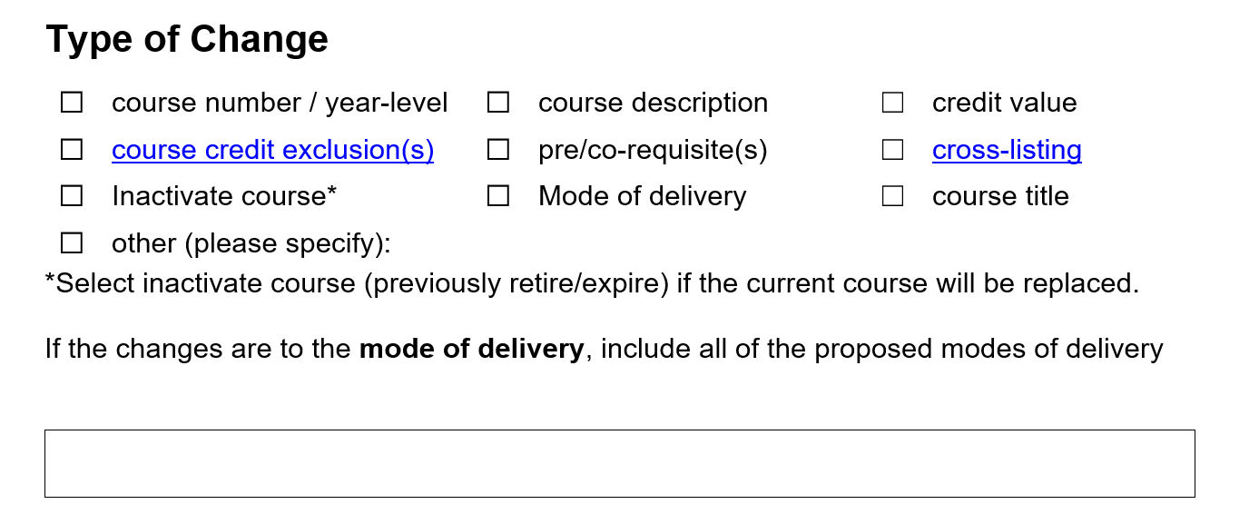
- Describe the change: please specify whether you are adding an alternate mode of delivery option to the existing one or you are proposing a complete change in the MOD. For Online, please specify about the synchronous and asynchronous options. For BLENDED, please specify both online and in person aspects.

- Academic Rationale Section: Please respond to each question in the academic rationale section. For Mode of Delivery proposal, based on the LA&PS Guidance on Mode of Delivery Changes 2021, it is recommended that the proposal addresses the following criteria in the Academic Rationale Section:
- A pedagogical or access rationale to explain the proposed change
- An explanation of how the course will be adapted to the alternate mode and the
suitability of the technological platform
- An explanation of how learning outcomes will be maintained in alternate modes
- An explanation of how academic honesty will be maintained in alternate modes
Please explain whether the proposed change will change the learning outcomes. If it changes, present the updated learning outcomes, and indicate how they have been adjusted. If they do not change, also provide the existing learning outcomes, and explain how the change is aligned with the learning outcomes or how the change also helps to achieve the learning outcomes.
Please explain how the course will be adapted to the alternate mode and the suitability of the technological platform. Please be informed that you are not requested to specify which technological platforms will be used in the alternate mode. Rather, you are requested to address how the course will be designed to accommodate that change and how the technology will be supportive to address that change.
Please explain how the academic honesty will be maintained in the alternate modes. Providing information on the updated course design or evaluation format or plan may speak to this question.
- Please provide the information on the following area:
- Course title
- Course brief description
- Long description
Please be informed that this information should be aligned with the information that appear on Kuali. It is strongly recommended that the proponent check the course in Kuali before the final proposal submission. Anybody who has York Passport ID can access Kuali (Curriculum Management System) and view the existing information on any courses. The curriculum team can also help in accessing any information that the proponent needs. If the information in Kuali contradicts with the original information of the course, please contact us for further guidance. If it is a technical error, that can be addressed by the curriculum team and does not need to go through the curriculum governance process. If it is a curricular change, then submitting a CEC proposal will be required. Multiple minor changes can be proposed through one single CEC Proposal. In that case, the proposal only needs a clear rationale for every change it proposes.

