How to Develop Integrated Courses

What is Course Integration?

Course integration refers to the formal combination of a 4000-level undergraduate course with a graduate-level course, allowing students from both academic levels to enroll in the same class under the instruction of a faculty member appointed to the Faculty of Graduate Studies.
A 4000-level undergraduate course can be integrated with a graduate course in which students from both levels can enroll into the same class with the same instructor.
Graduate courses may be integrated only with undergraduate courses at the 4000-level, where it is understood that 4000-level indicates an advanced level. Graduate students will be expected to do work at a higher level than undergraduates. Integrated courses must have an instructor in charge who is appointed to the Faculty of Graduate Studies. Graduate students may not take or receive credit for an integrated course at the graduate level if they took it at York or elsewhere at the undergraduate level.

How to Develop Curriculum Proposals for Course Integration

If the proposed course is to be integrated, proponents must consider the following:
- Consultation
Proponents must consult with both the undergraduate and graduate program coordinators.
- Course Identification
Identify a graduate course that the graduate-level course to be integrated with the undergraduate course. This may be a generic experiential education course code or a directed reading course if no direct equivalent exists.
- Differentiated Content and Assessment
Provide a grading scheme that clearly differentiates between the work that undergraduate and graduate students perform, including a description of how the work performed by graduate students is at a higher level. Therefore, the proposal must clearly outline how course content, description, learning outcomes, reading lists, and assessments will differ for undergraduate and graduate students or in other words, will be adjusted for students at both levels. These differences should also be reflected in the course description and learning outcomes for graduate students.
- Letter from Graduate Coordinates:
If the base course is an undergraduate course, a letter from the graduate chair or coordinator is required. This letter should confirm that consultation has taken place and that the graduate unit will provide the necessary support. If the base course is a graduate course, the same will be required from the undergraduate chair or coordinator.

CMS Submission:
For submitting the course proposal in CMS, proponents should:
- Click on the “Create” option to propose a new course. If both graduate and undergraduate courses are new, then both courses need to be created separately and linked later.
- Complete all required fields for integrated course proposals.
- Indicate in the course a brief description that the course is an integrated course.
- Complete the “Course Integration” section in CMS with all relevant details.
- The courses can be linked with each other through CMS by completing the course integration section in CMS. Please see the image below:

If “yes” is checked, some new boxes will appear for adding the information on course integration.
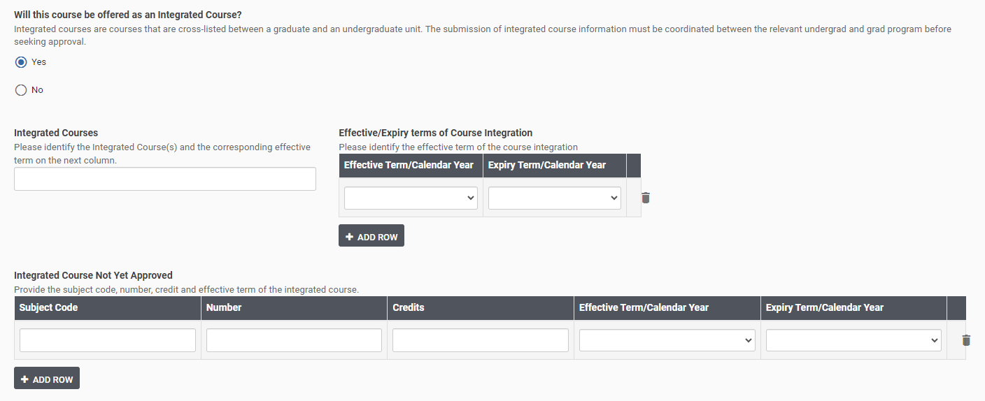

Mach Form:
Proponents need to submit two proposals together articulating the differences in the rationale section.
The course proposal forms have the following section to indicate whether it is an integrated course or not. Please add details in the academic rationale section.
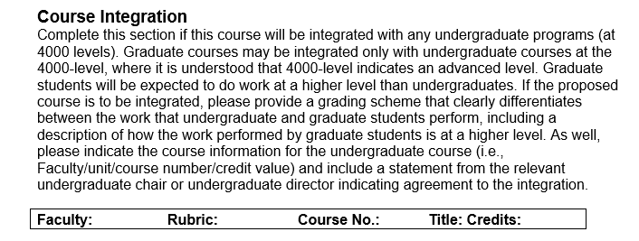

Different Scenarios:

Integration of Existing Courses
- If the courses already exist in the system and the academic unit intends to integrate them, this will be considered a minor change to existing courses. In such cases, proponents should choose “propose a change” option for both courses and adjust the relevant areas to make the courses integrated. The proposals should clearly articulate how the following components will be adjusted to reflect the integration:

- Course content
- Learning outcomes
- Brief course description
- Evaluation strategies
- Other pedagogical components
- If only one course requires adjustment, then one proposal should be submitted. The proposal should address:
- A rationale explaining how the course will be adjusted
- Information about the other course with which it will be integrated
- A letter of support from the graduate/undergraduate coordinator
- Proposal for New Courses
If the courses are newly proposed, two New Course Proposals (NCPs) must be submitted, each with a distinct course number. While the core content may be similar, the proposals must clearly explain how the pedagogical components (e.g., learning outcomes, assessments, instructional strategies) will be tailored to suit the different year levels.
If the academic unit wishes to offer both an integrated and a non-integrated version of the same course, this must be explicitly stated in the proposal. The distinctions between the two versions should be clearly outlined to ensure transparency and consistency in delivery.
For the technical part, proponents must consider the following:
- The two versions will have two different courses numbers with the same titles.
- The two versions will be scheduled at the same day/time and assigned to the same room.
- Course maximums are set to be equivalent to one course e.g. 15+15.

Governance Approval:
The proposal needs to be reviewed by both CCPS and Graduate Curriculum Committee.

Consultation:
Consultation needs to be done with relevant units.

Please see Senate Policy on Integrated Courses.
Please reach out to the curriculum team @lapscurriculum@yorku.ca.

