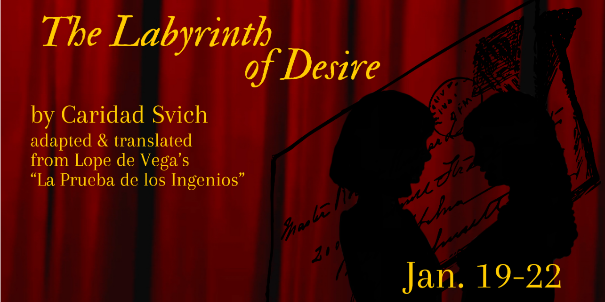

VCP’s Labyrinth of Desire
Visual Story

- What is a Visual Story?
A visual story is a simplified summary of the show with pictures.
Visual stories also help the audience to know which scenes have triggering content to prepare accordingly.
The visual story does contain spoilers to the show.

- Content Warnings for Labyrinth of Desire:
Loud yelling
Mentions of suicidal ideation
Manipulation

Act 1
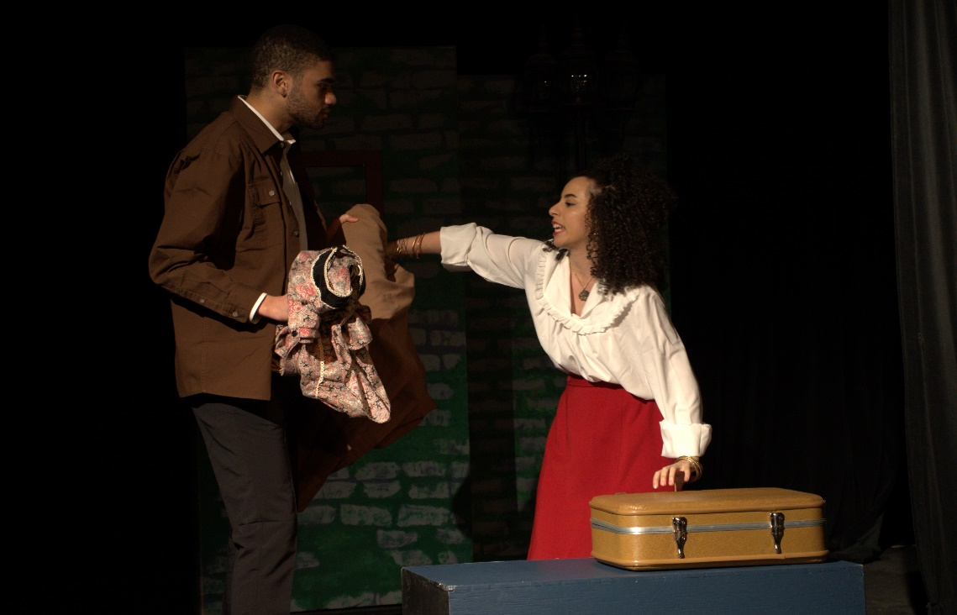
Florela wants to go after her fiancé, Alejandro, who left her for a richer woman. Ricardo tries to stop her.
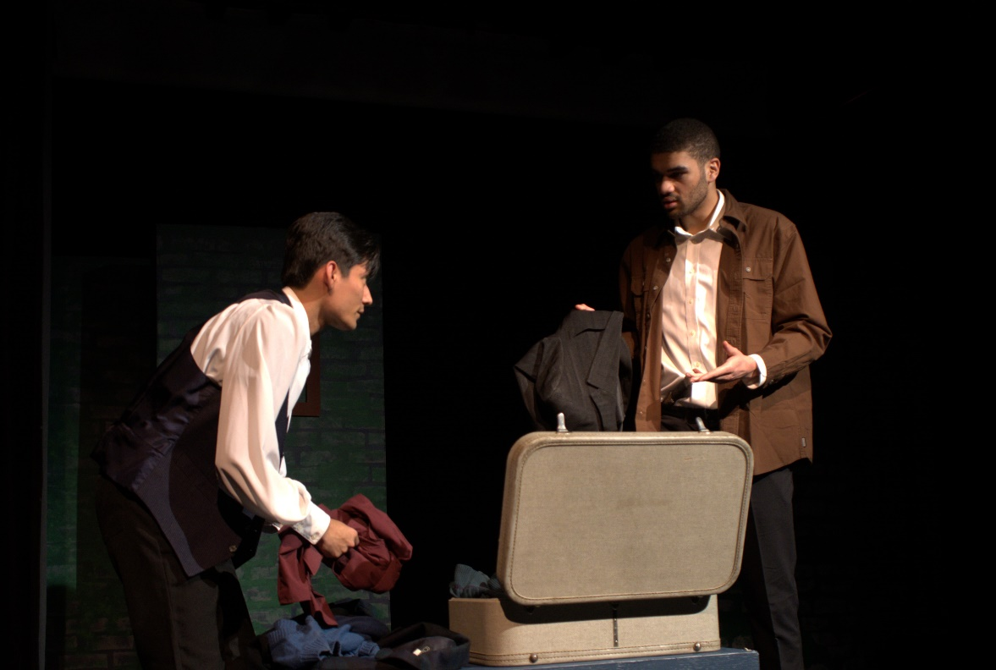
Alejandro insists that Florela is to not follow him. Ricardo tries to reason with him.
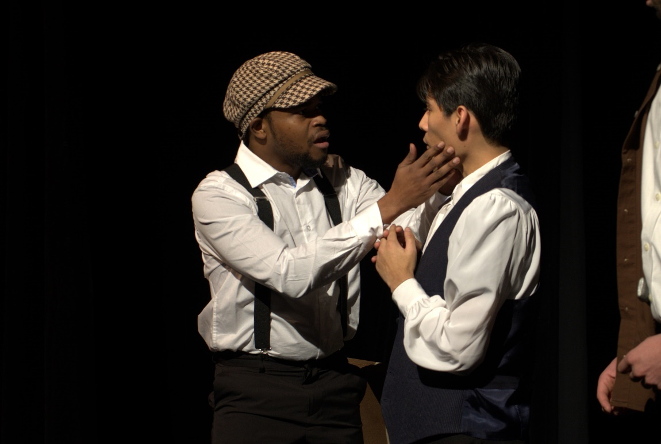
Camacho comes in with a letter telling them about all the men who want to marry Laura. Alejandro and Camacho work together to help Alejandro get Laura.

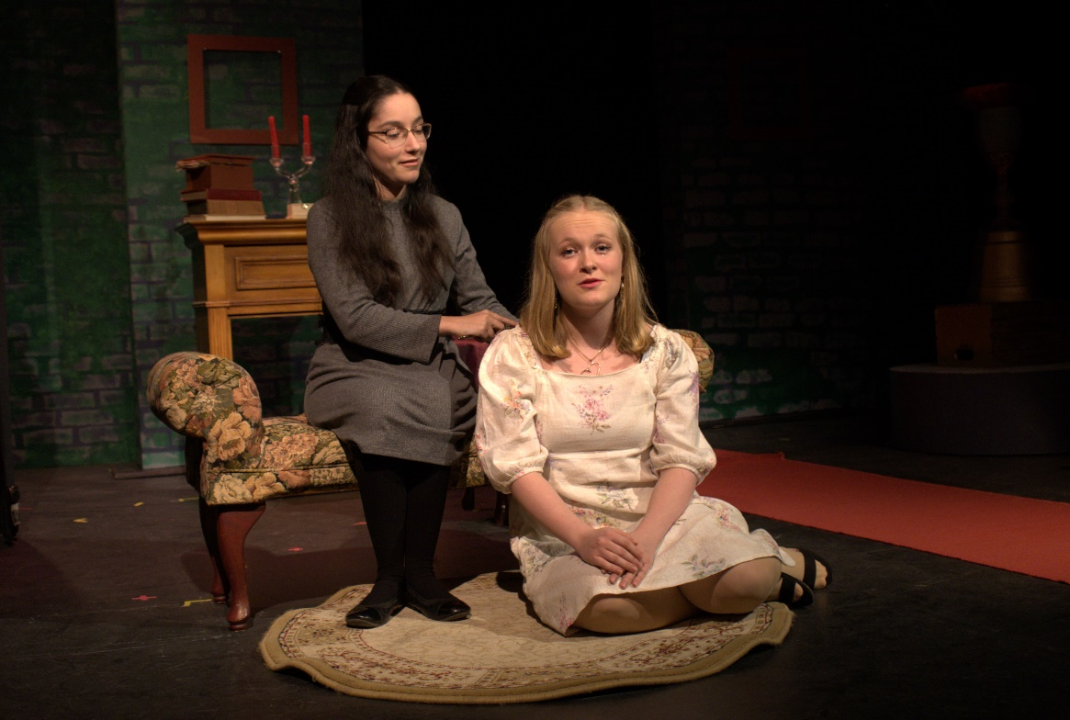
Laura tells Finea about her worries with the suitors.
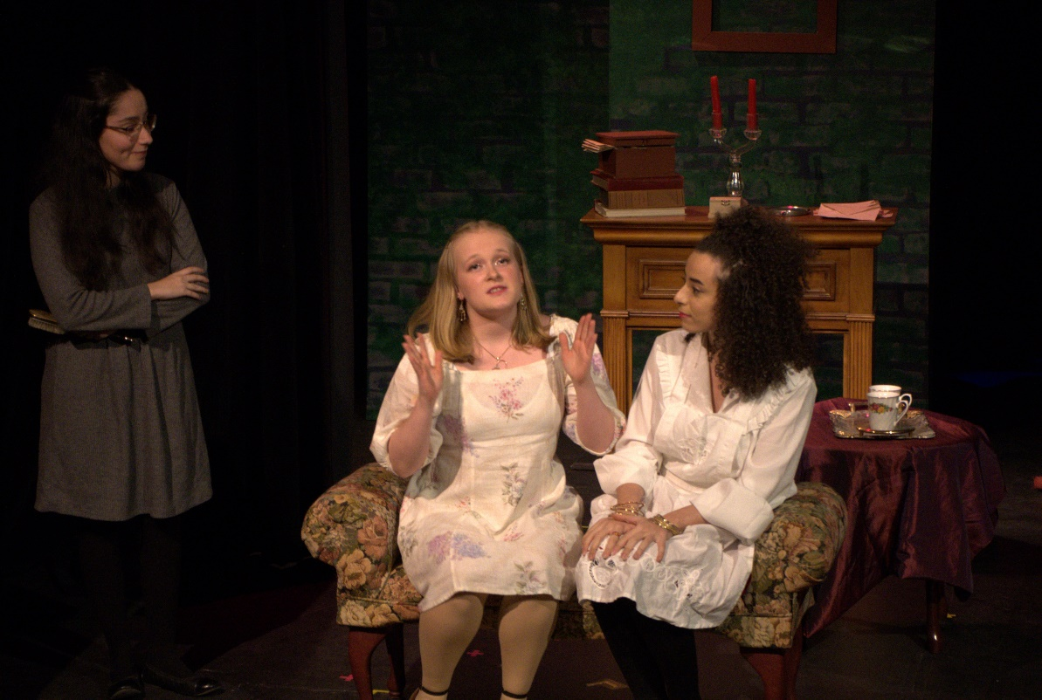
Florela, disguised as Diana, convinces Laura to let her work for her as her secretary.
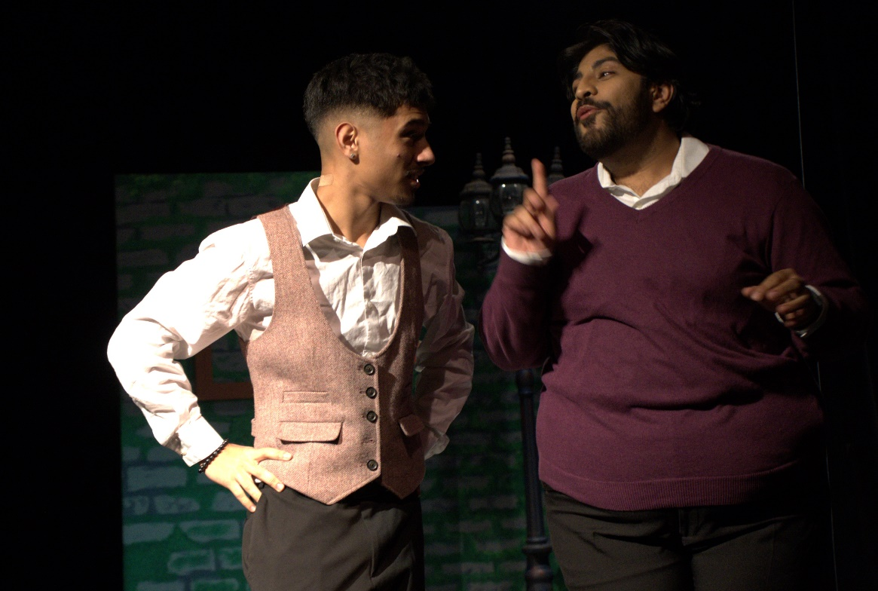
Estacio tells Paris about the other suitors.
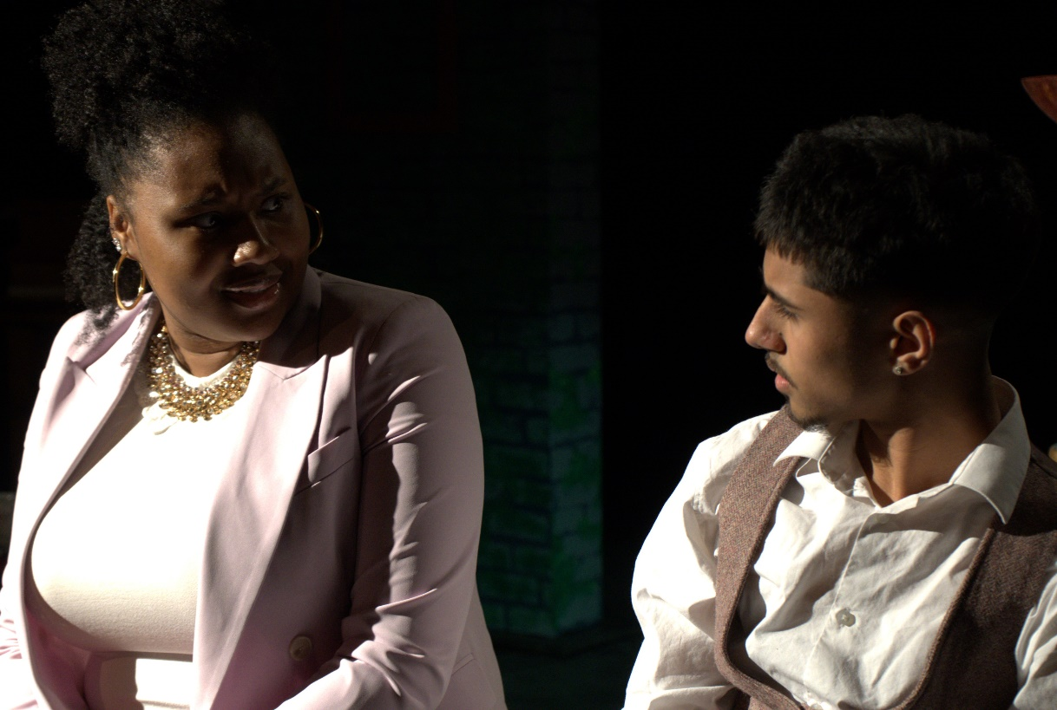
The Duchess tells Paris about how she is worried about Laura choosing someone to marry.
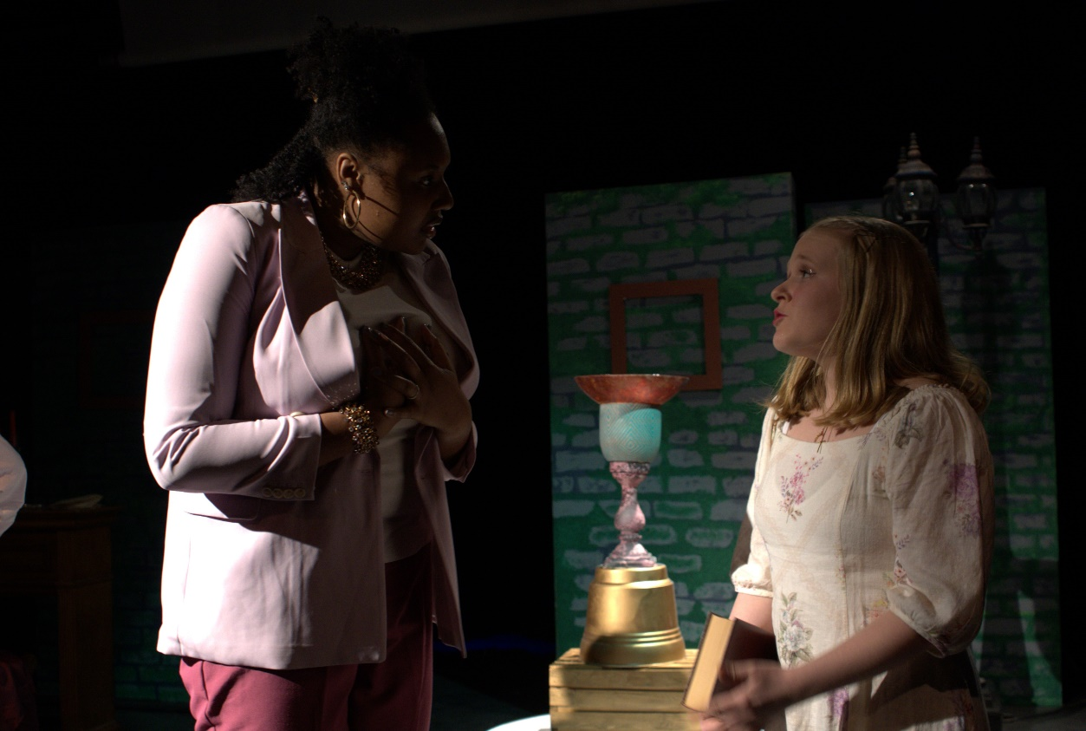
Laura asks the Duchess for more time to decide.
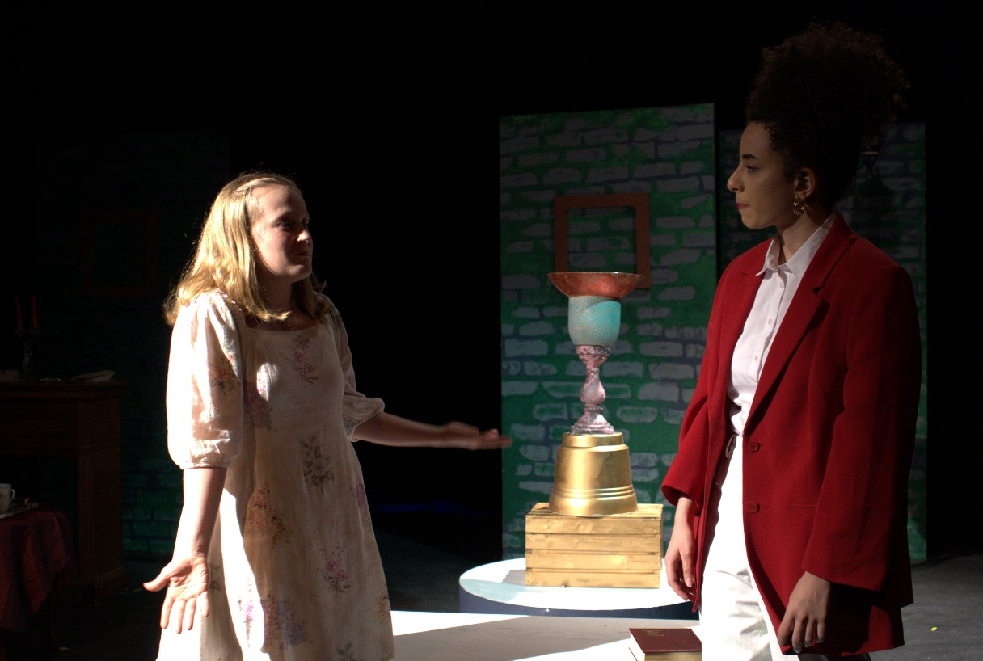
Florela, as Diana, asks Laura what is bothering her. Laura explains.
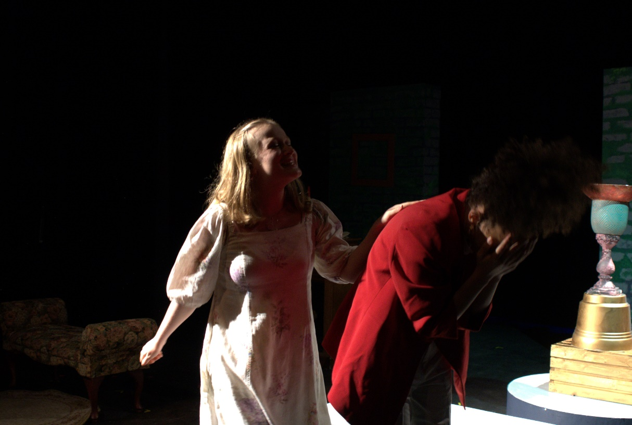
Laura starts to wonder if Alejandro is the best option for her and Florela becomes very upset.
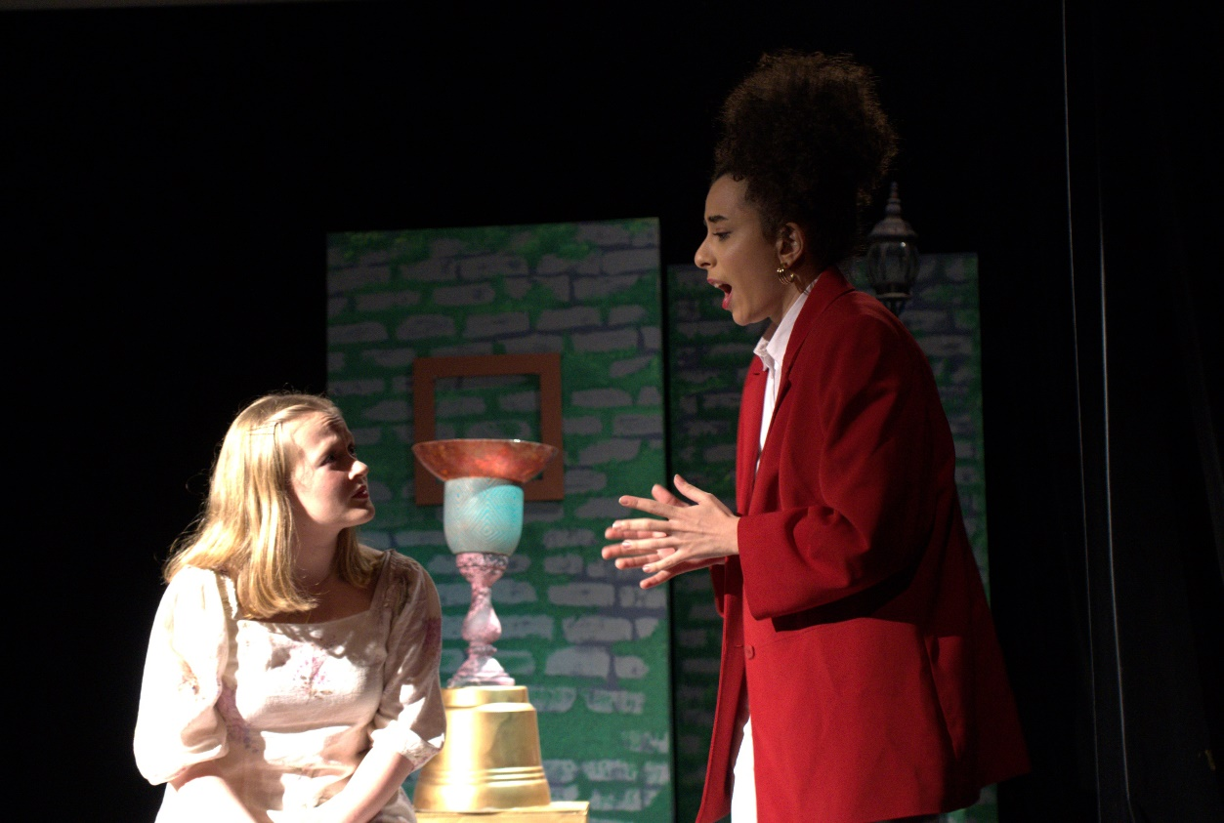
Florela decides to distract Laura and tells her that she is secretly a man named Felipe.
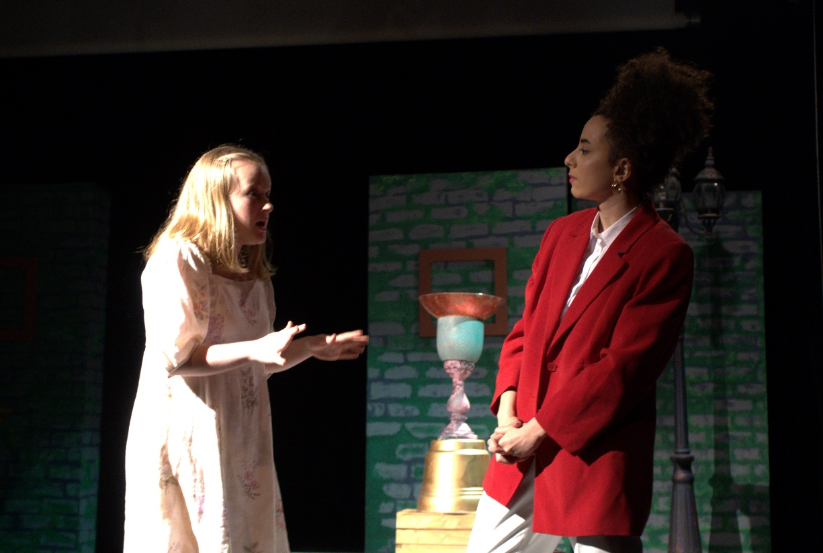
Florela tells Laura her plan to delay her from getting married.
ACT 2
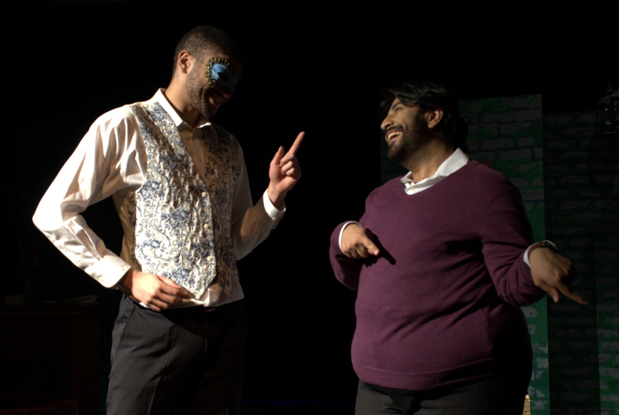
Ricardo, as the Infante and Estacio discuss the competition Diana has planned for the suitors.
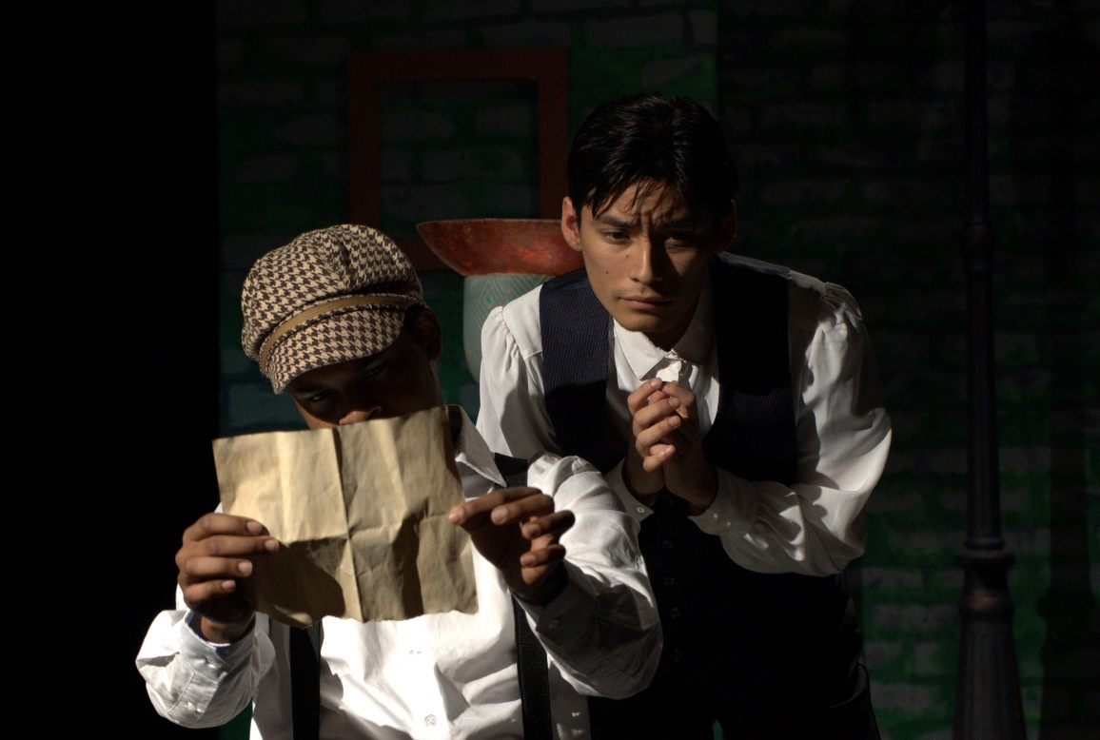
Alejandro complains about the competition while Camacho tries to help.
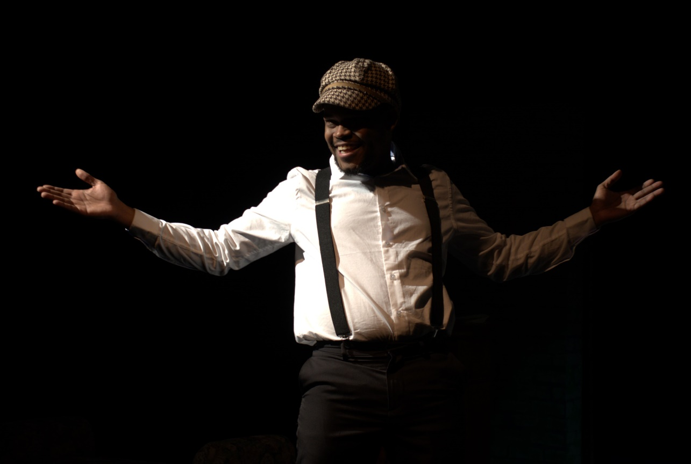
Camacho is going to go undercover and to seduce Diana.
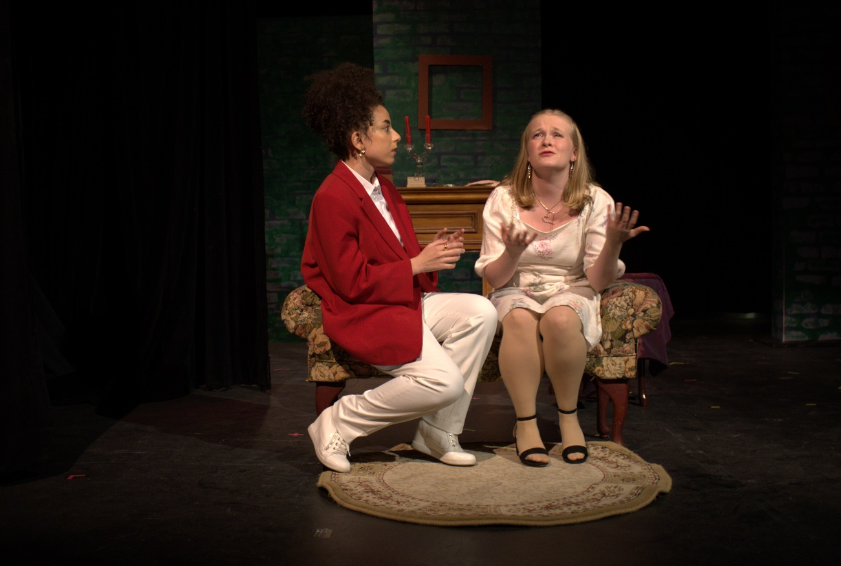
Florela tries to charm Laura as Felipe.
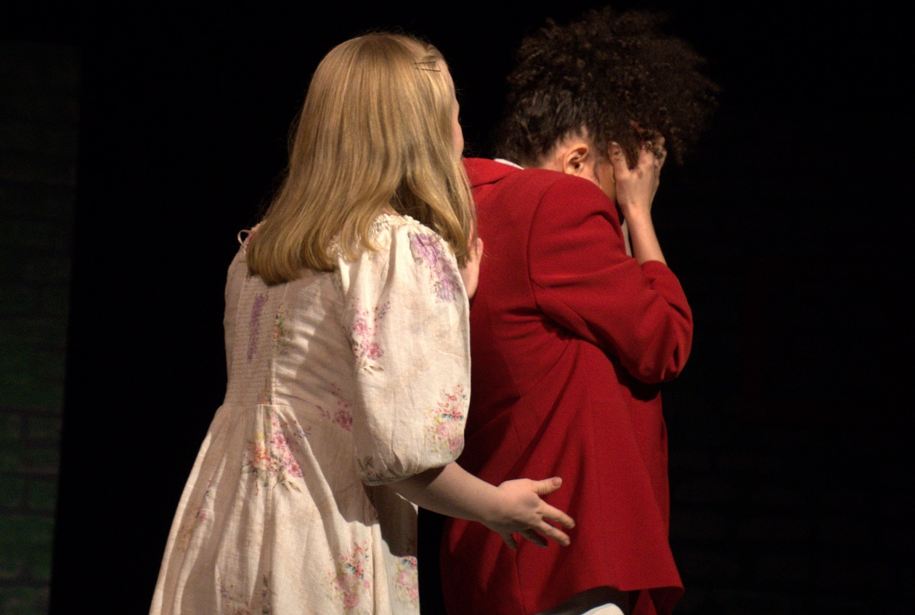
Laura suggests talking about Alejandro instead and Florela gets angry and storms out.
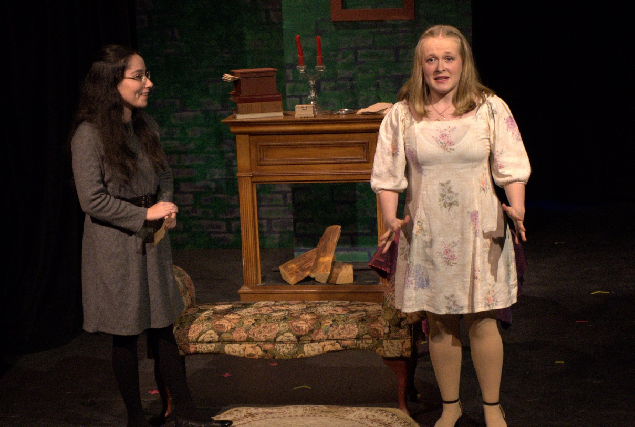
Laura tells Finea about her feeling for Florela and asks Finea to talk to Florela about how she feels.
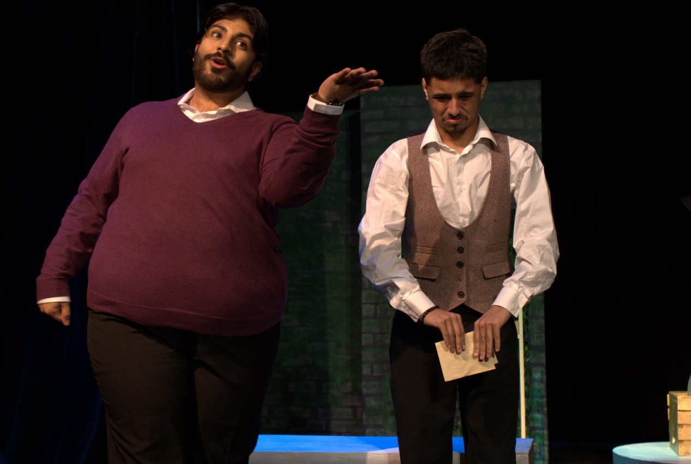
Paris complains to Estacio about the competition.
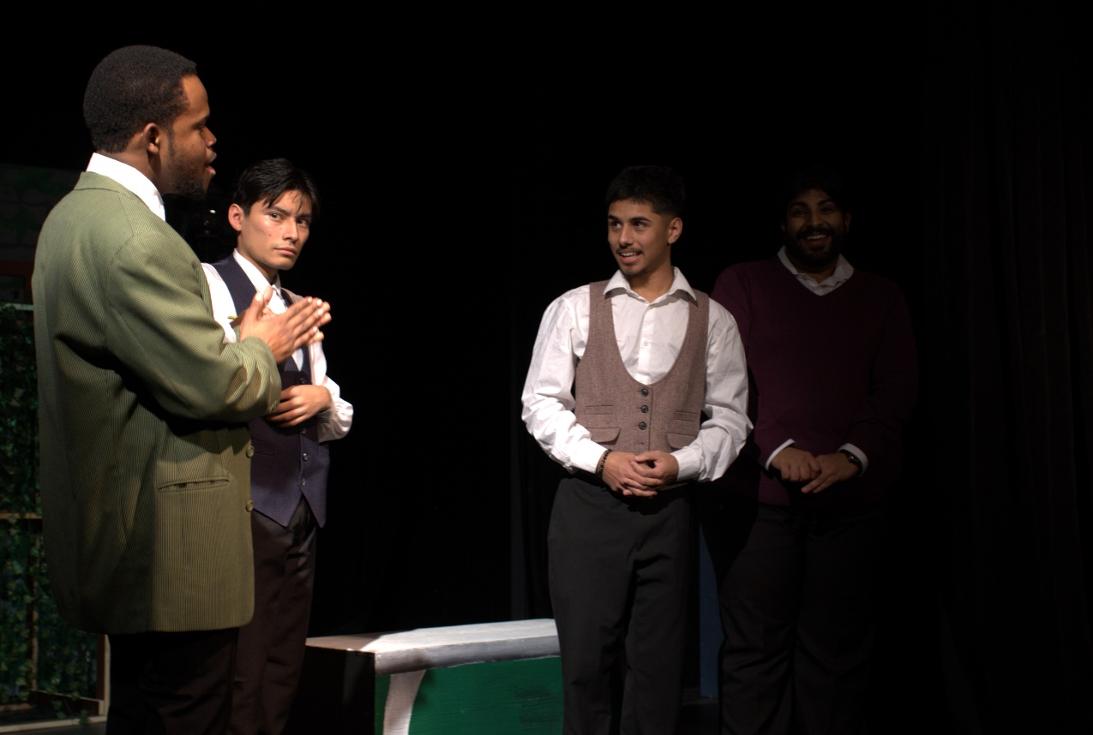
Paris befriends Camacho, disguised as the Marquis.
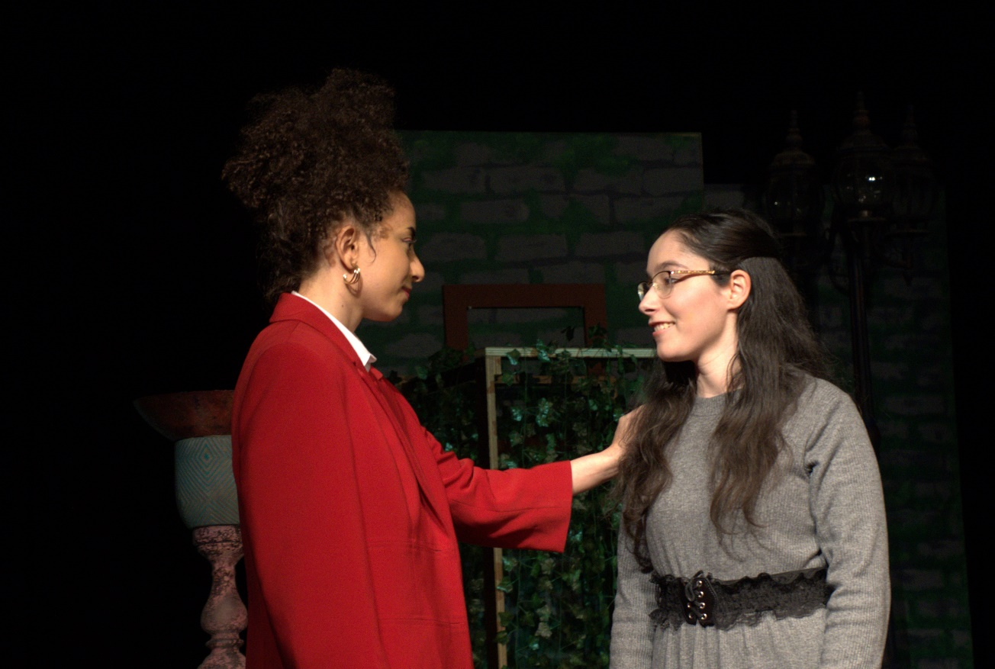
Finea tries to interrogate Florela. Florela charms her instead.
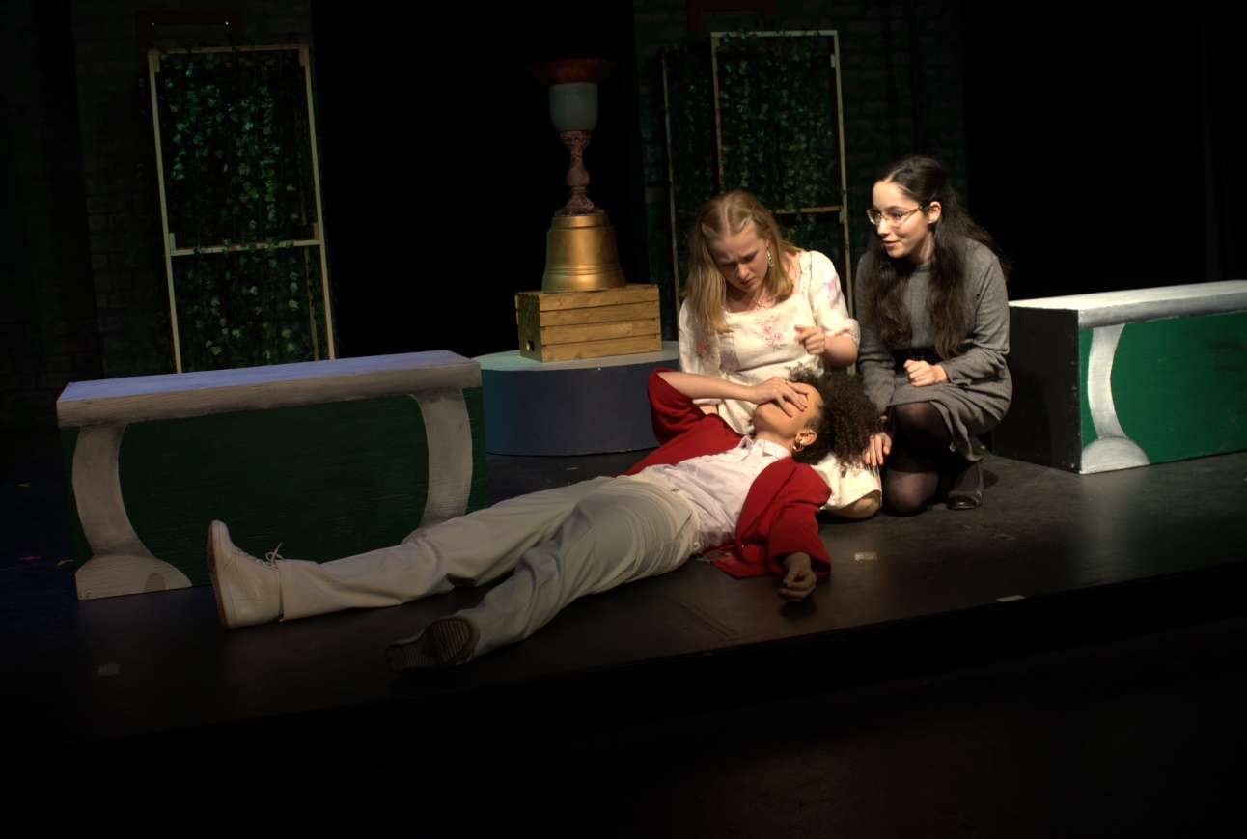
Laura says that she got a note from Alejandro and Florela faints.
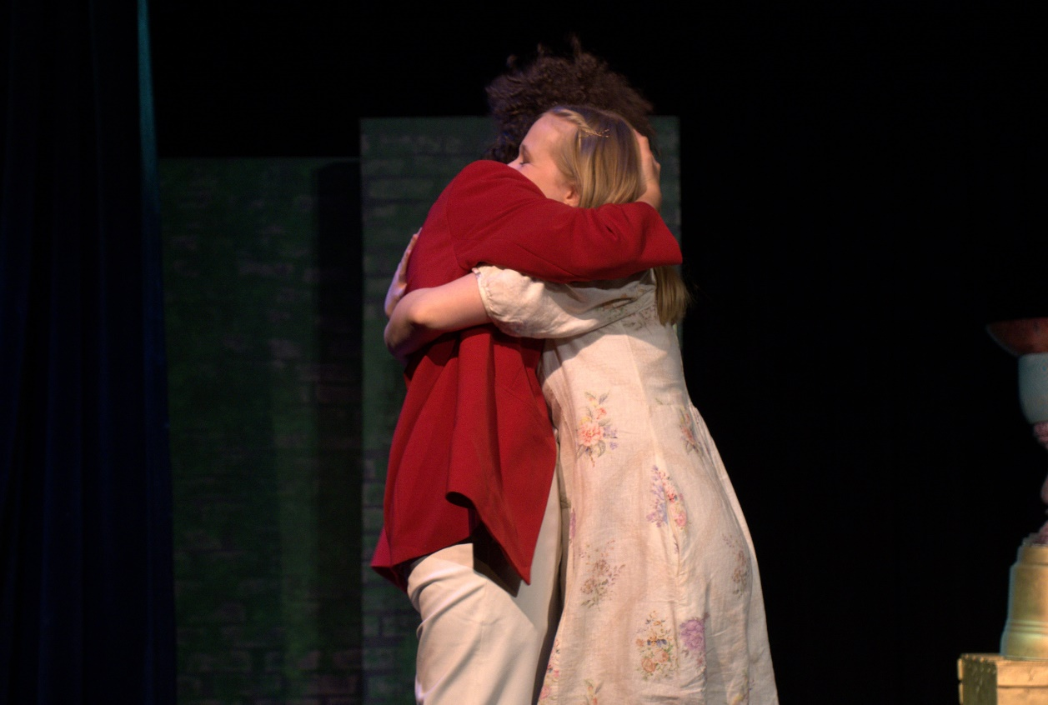
Florela gets mad at Laura for trying to talk about her feelings through Finea. Laura confesses to her.
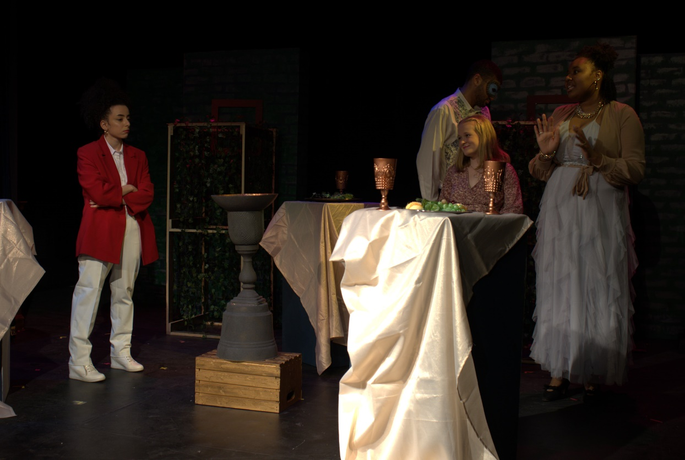
The Duchess introduces Laura to the suitors at the cocktail party.
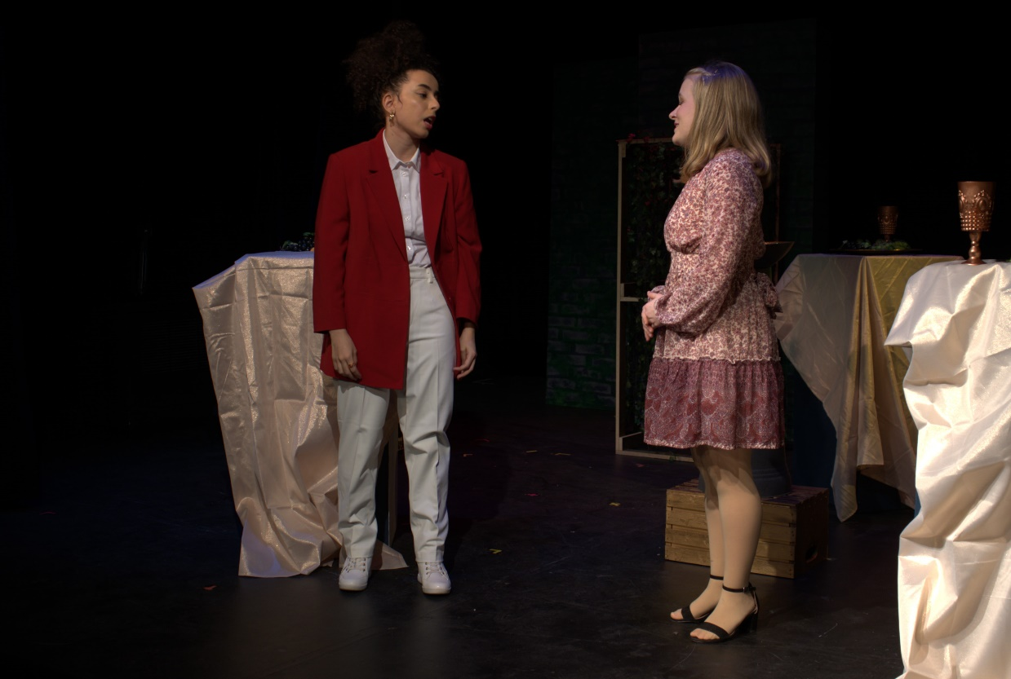
Laura suggests that Florela, as Felipe, talks to Alejandro instead of her.
ACT 3
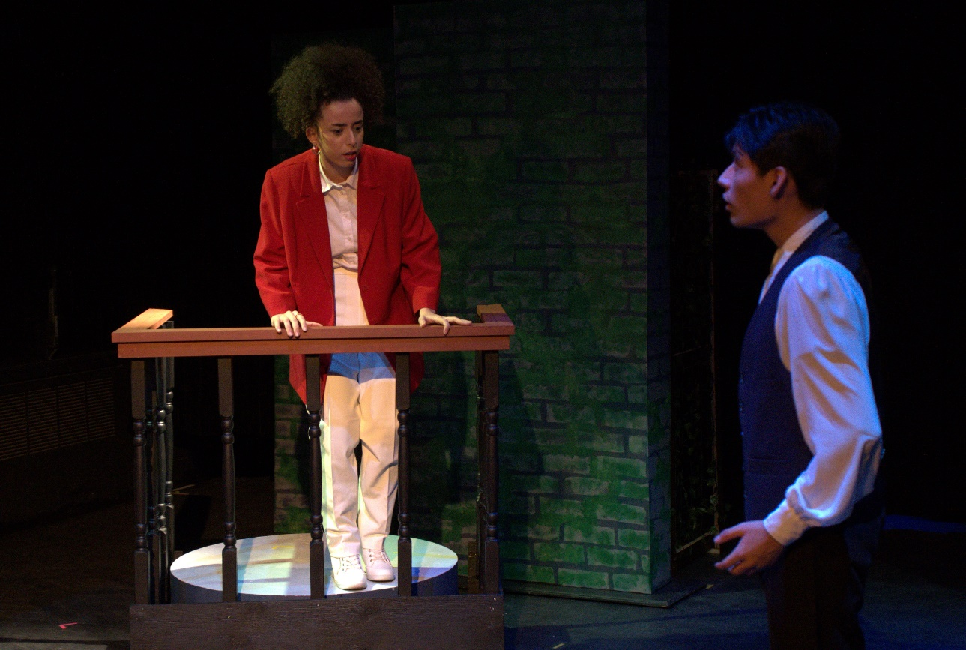
Florela anonymously talks to Alejandro through the terrace.
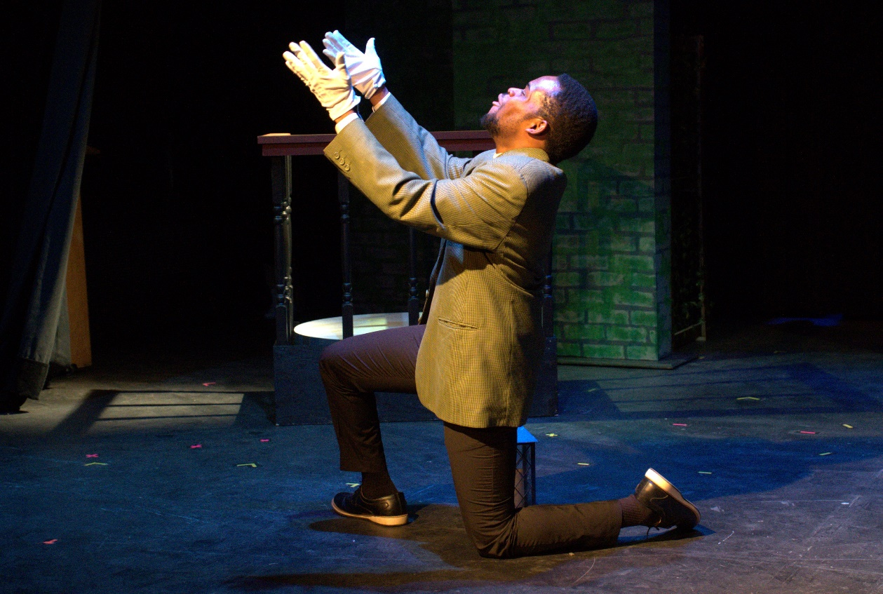
Camacho runs into Alejandro and calls out to Diana.
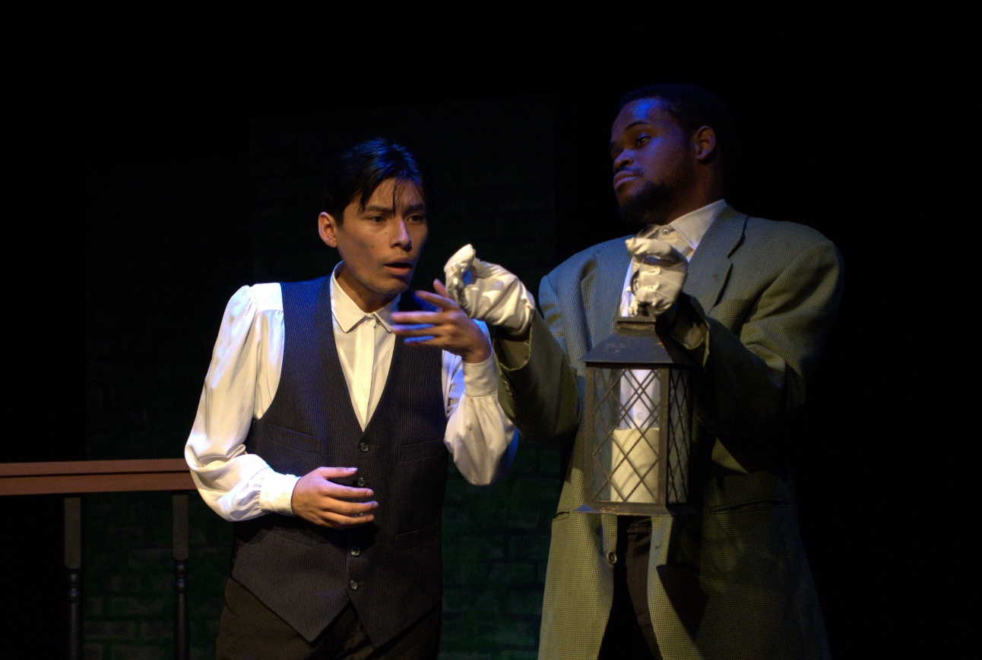
Camacho reveals to Alejandro that he planted a fake fountain full of supplies in the labyrinth.
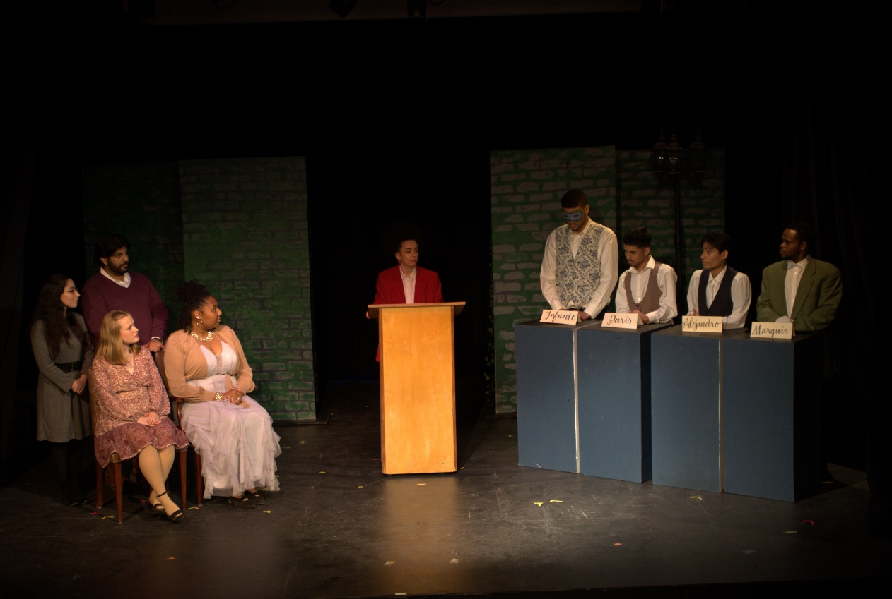
Florela, as Diana runs a debate between the suitors. Alejandro realises that Diana is Florela.
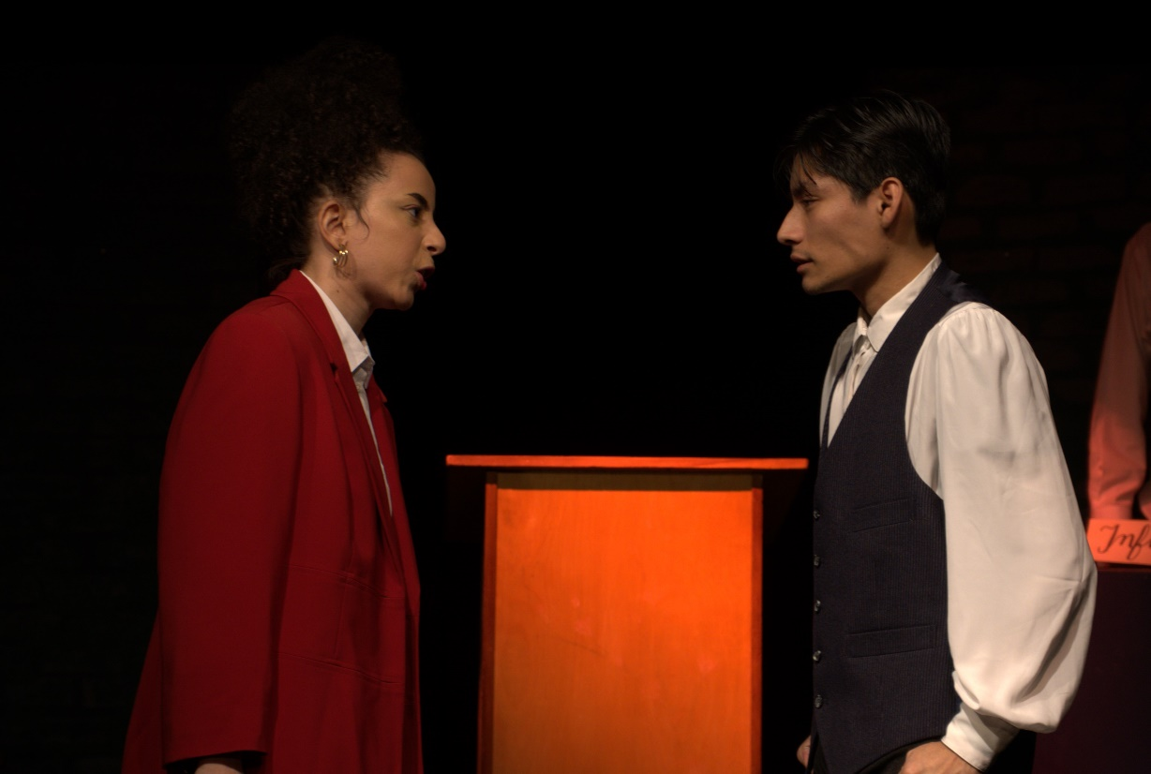
Florela and Alejandro have an intense argument.
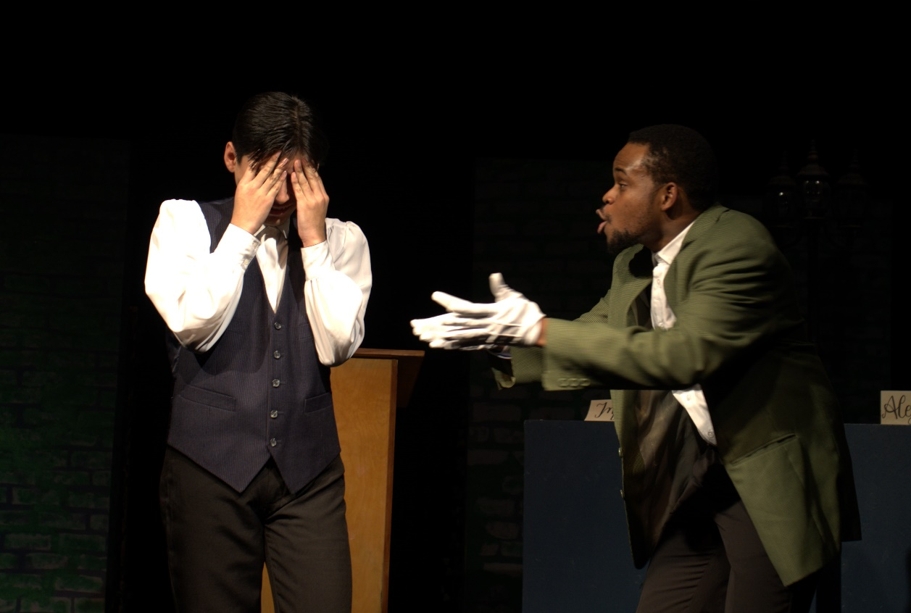
Alejandro feels defeated and Camacho cheers him up.

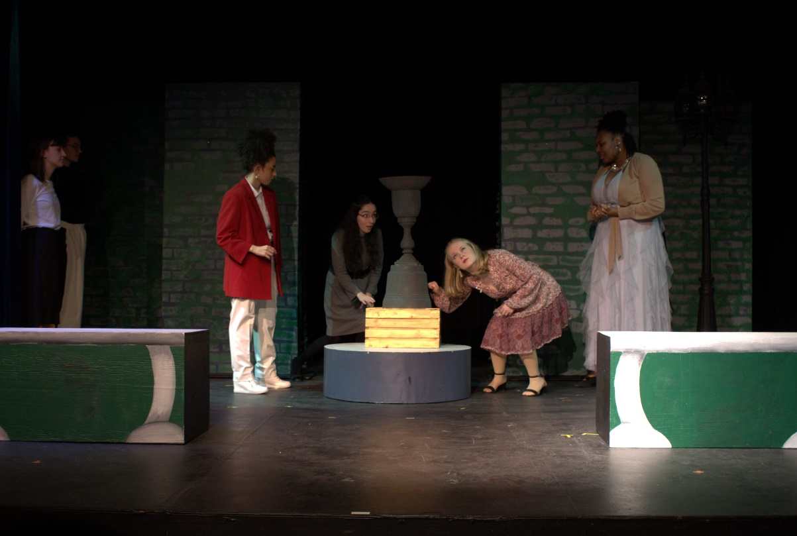
The women discover the fake fountain.
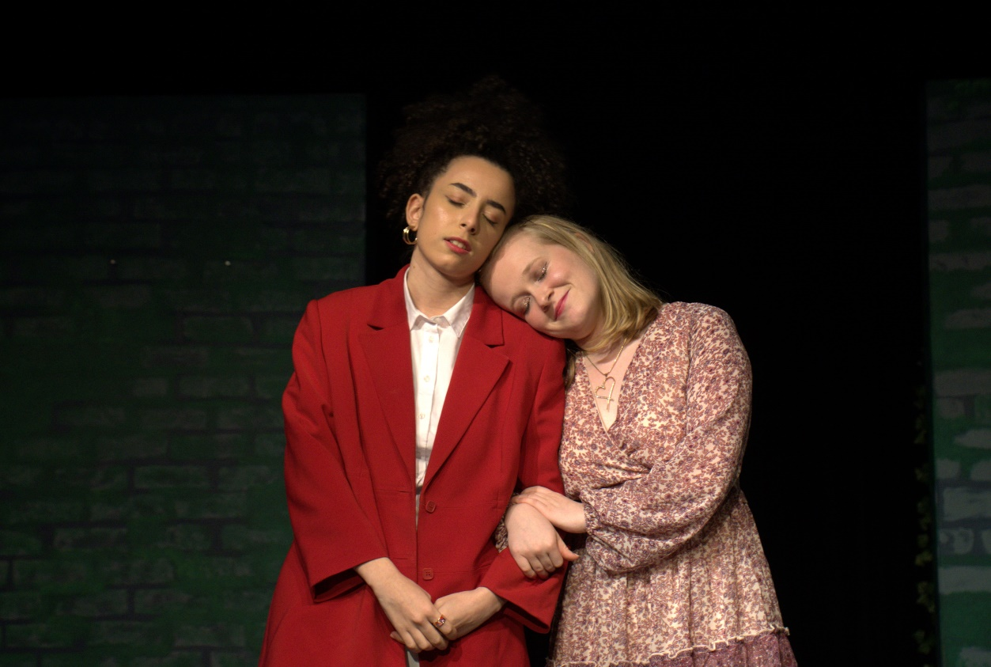
Florela confesses her love to Laura.
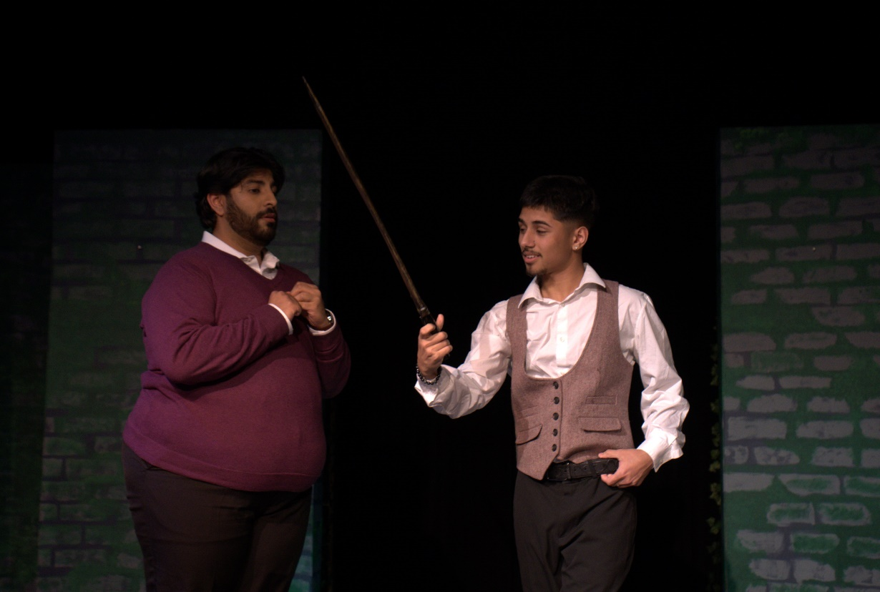
The suitors are about to enter the labyrinth, revealing ways to cheat their way in.
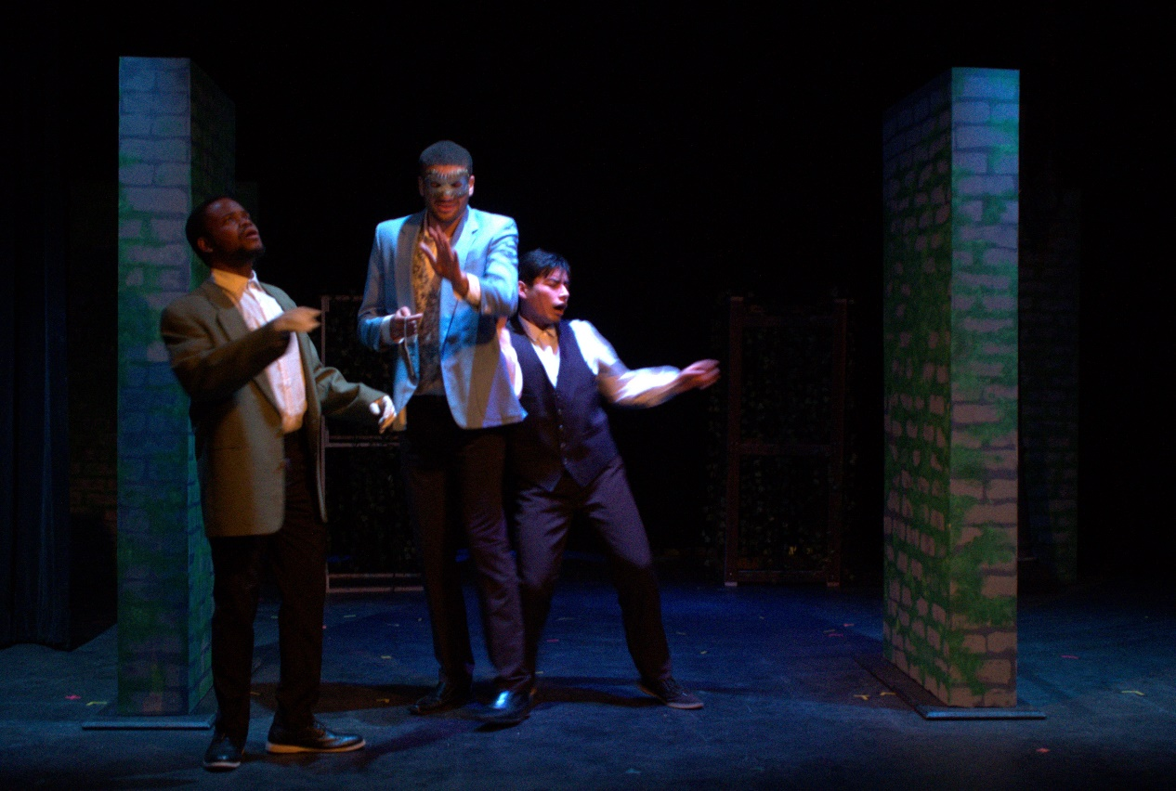
The suitors are confused and lost in the labyrinth.
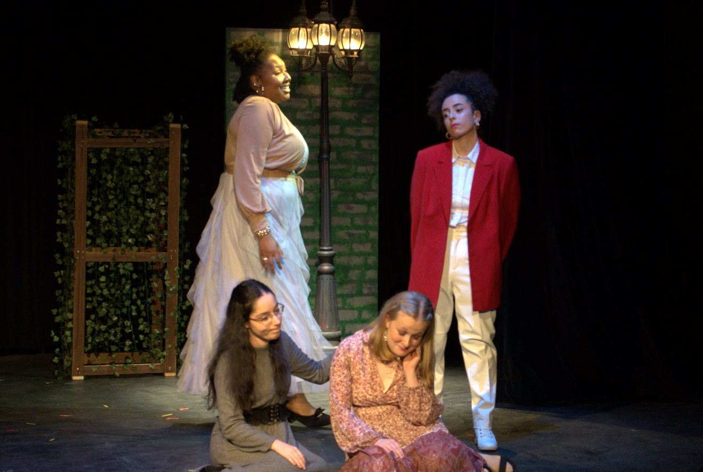
The women are waiting outside the labyrinth.
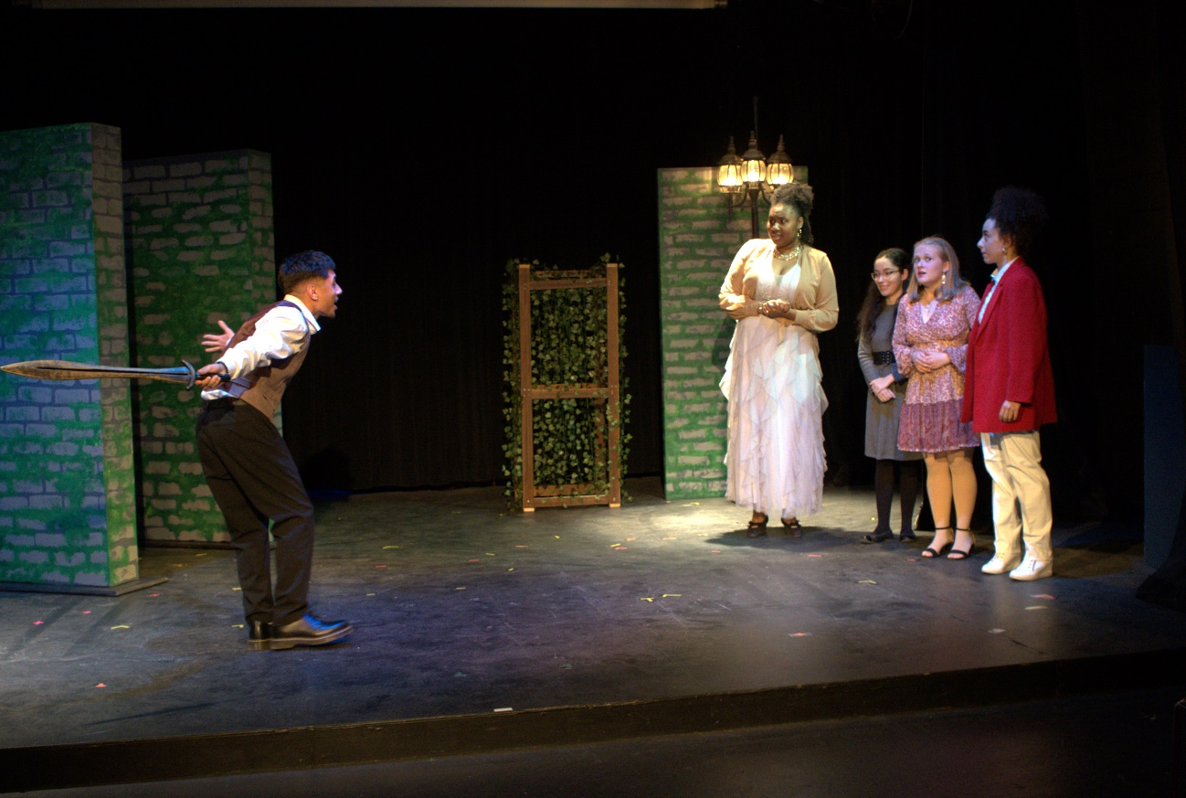
Paris makes it through the labyrinth and wins Laura’s hand.
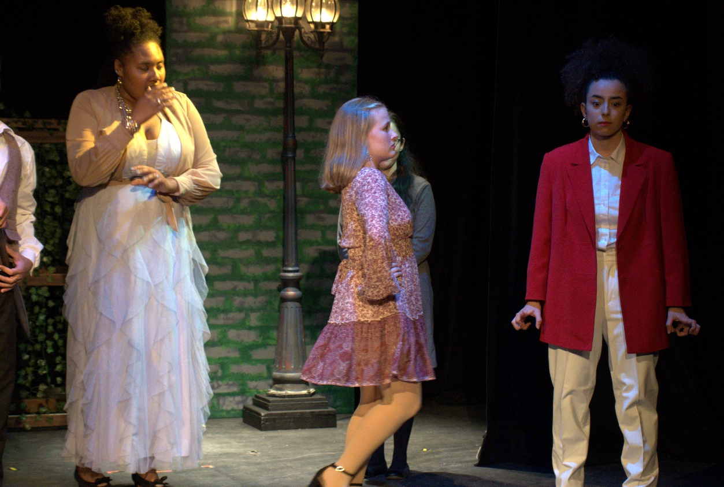
Laura reveals that her true love is her secretary, who she thinks is Felipe.
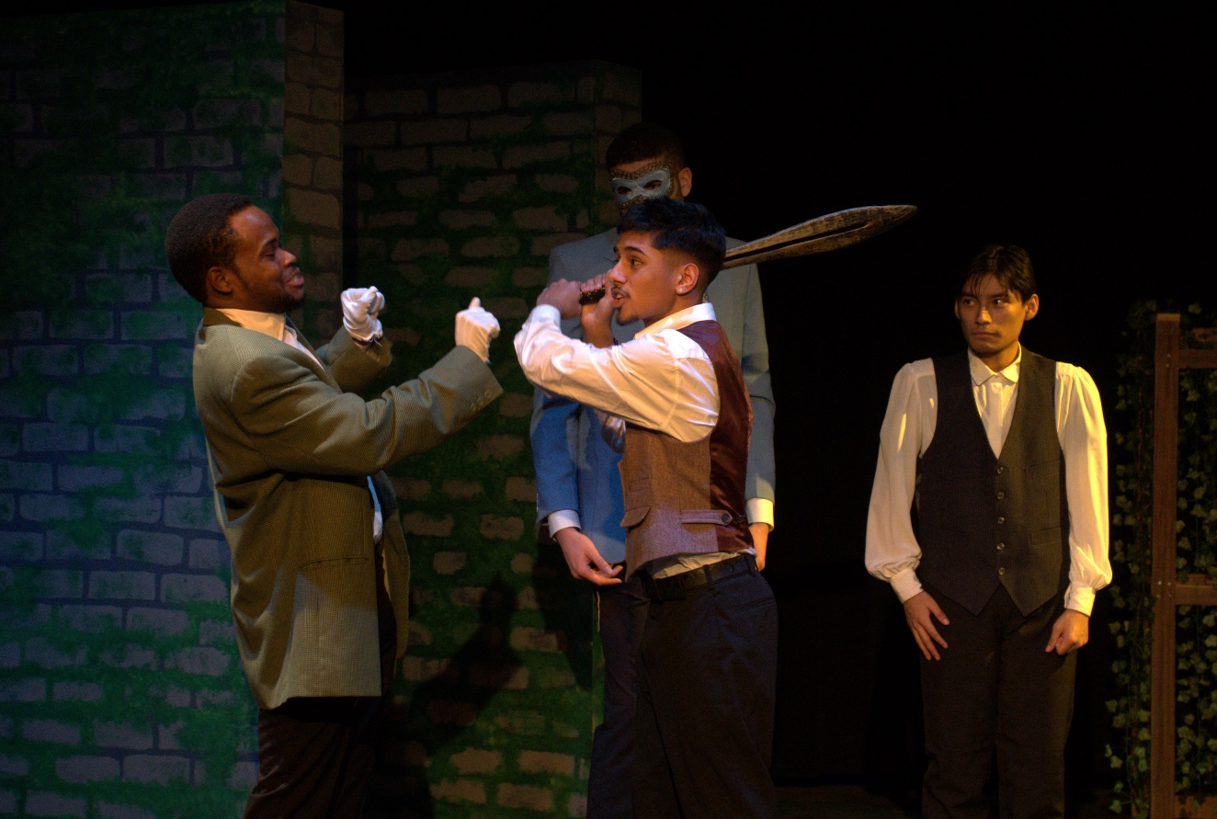
Camacho reveals his identity when Paris threatens him.
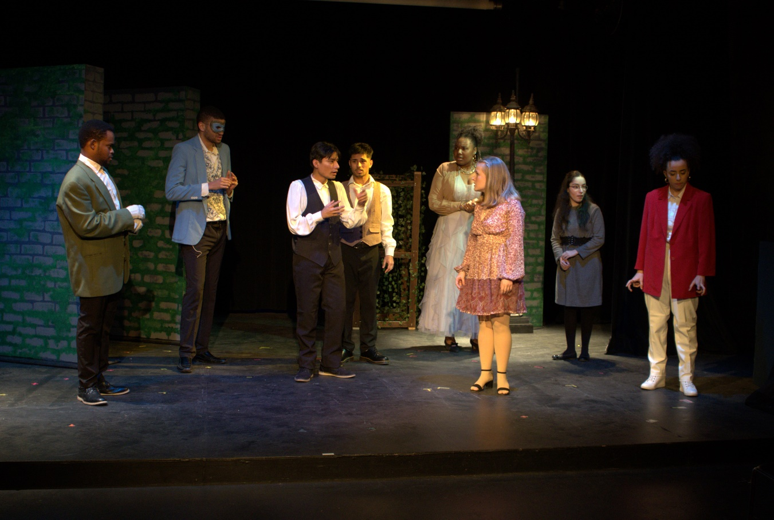
Alejandro reveals Florela’s identity.
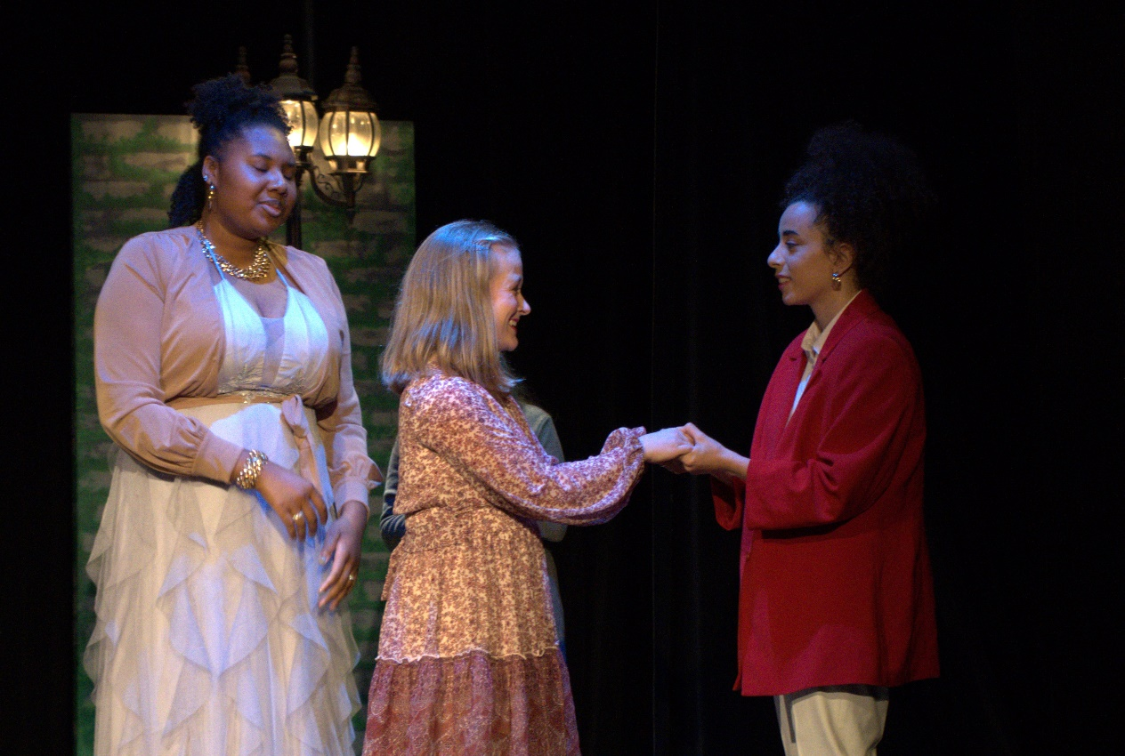
Florela confesses everything to Laura including her true feelings.
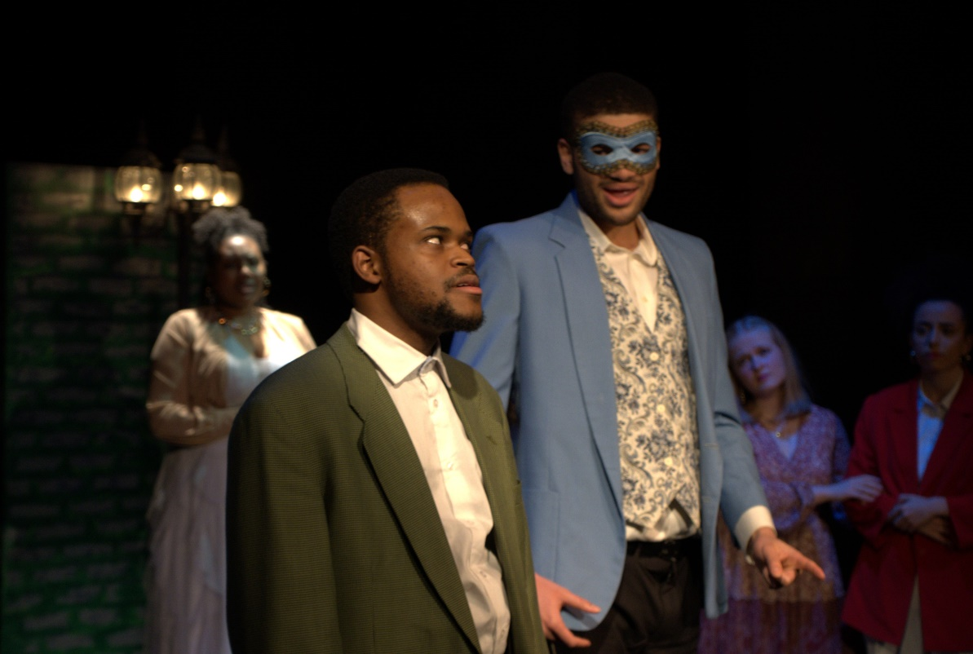
Camacho tries to end the play and is interrupted by the Infante.
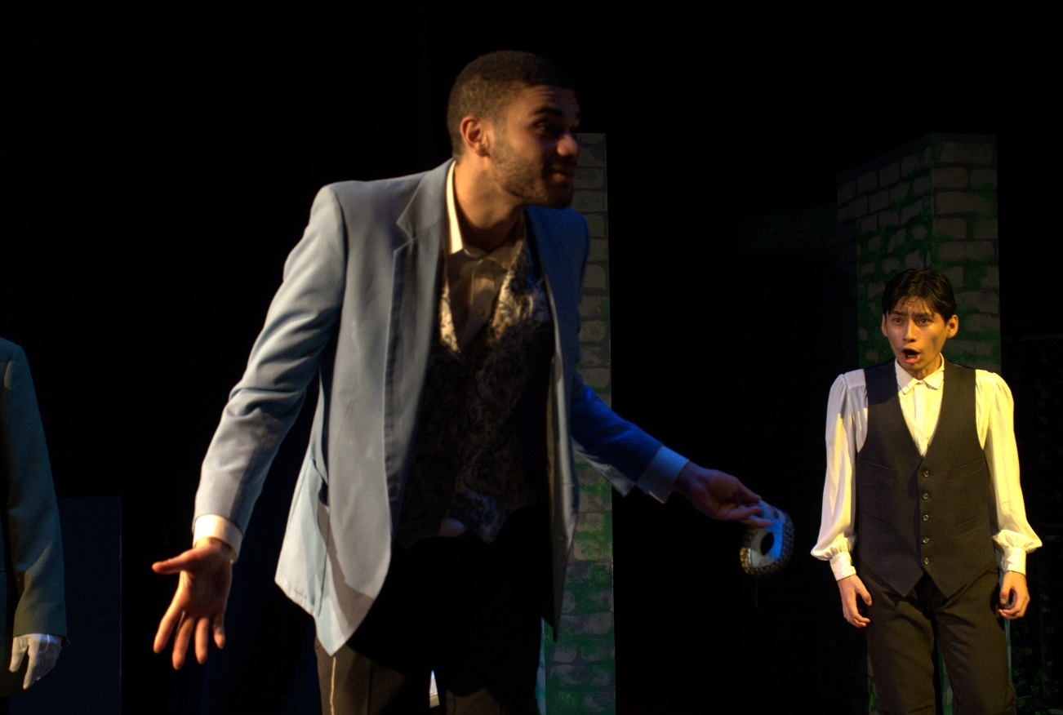
Infante reveals that he is Ricardo, and asks what love is due him.
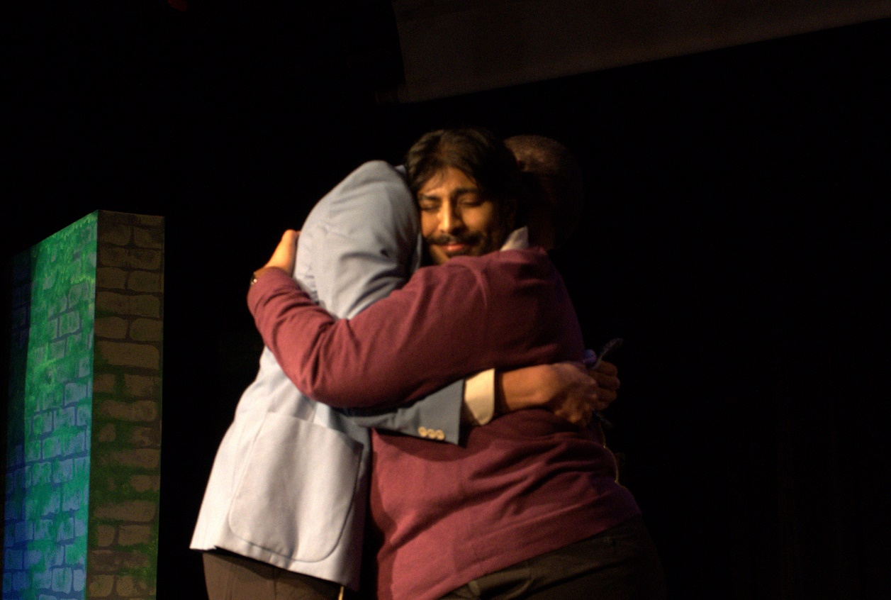
Estacio bursts in and confesses his love for Ricardo.
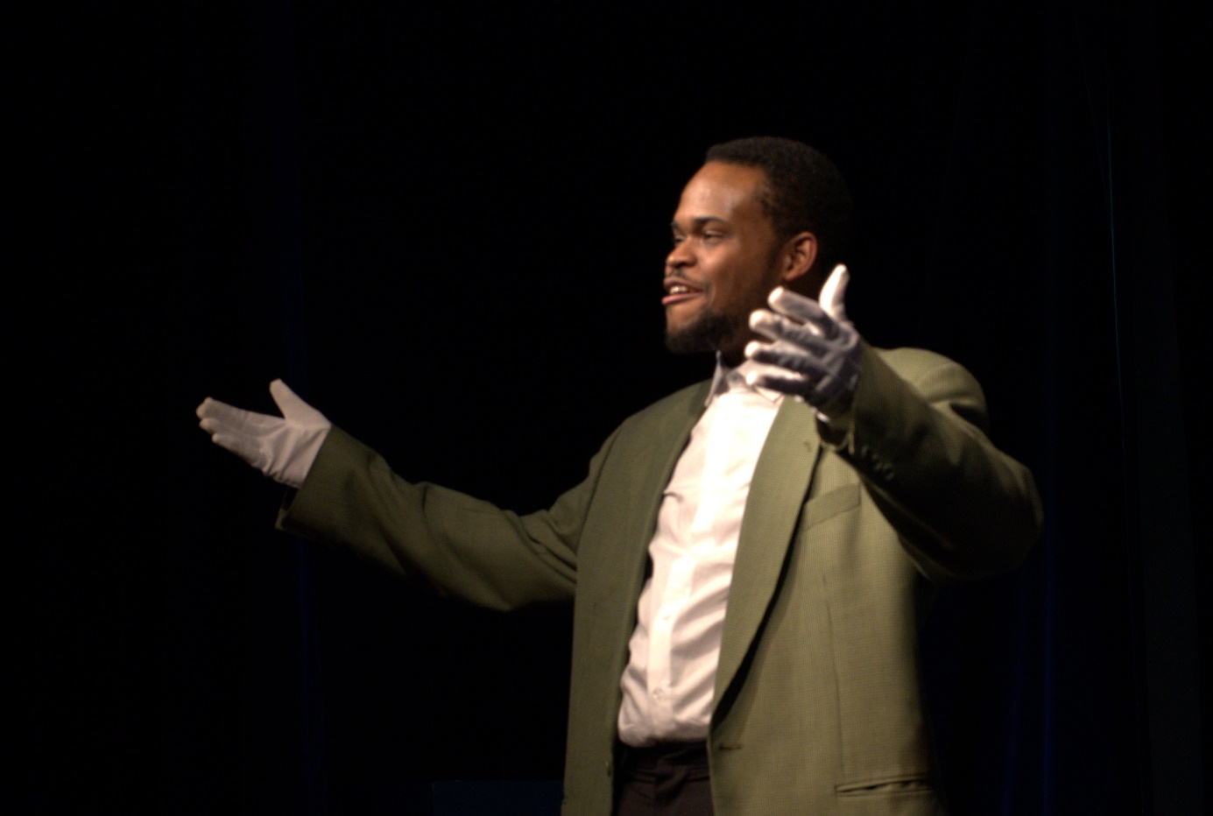
Camacho ends the play.

THE END

