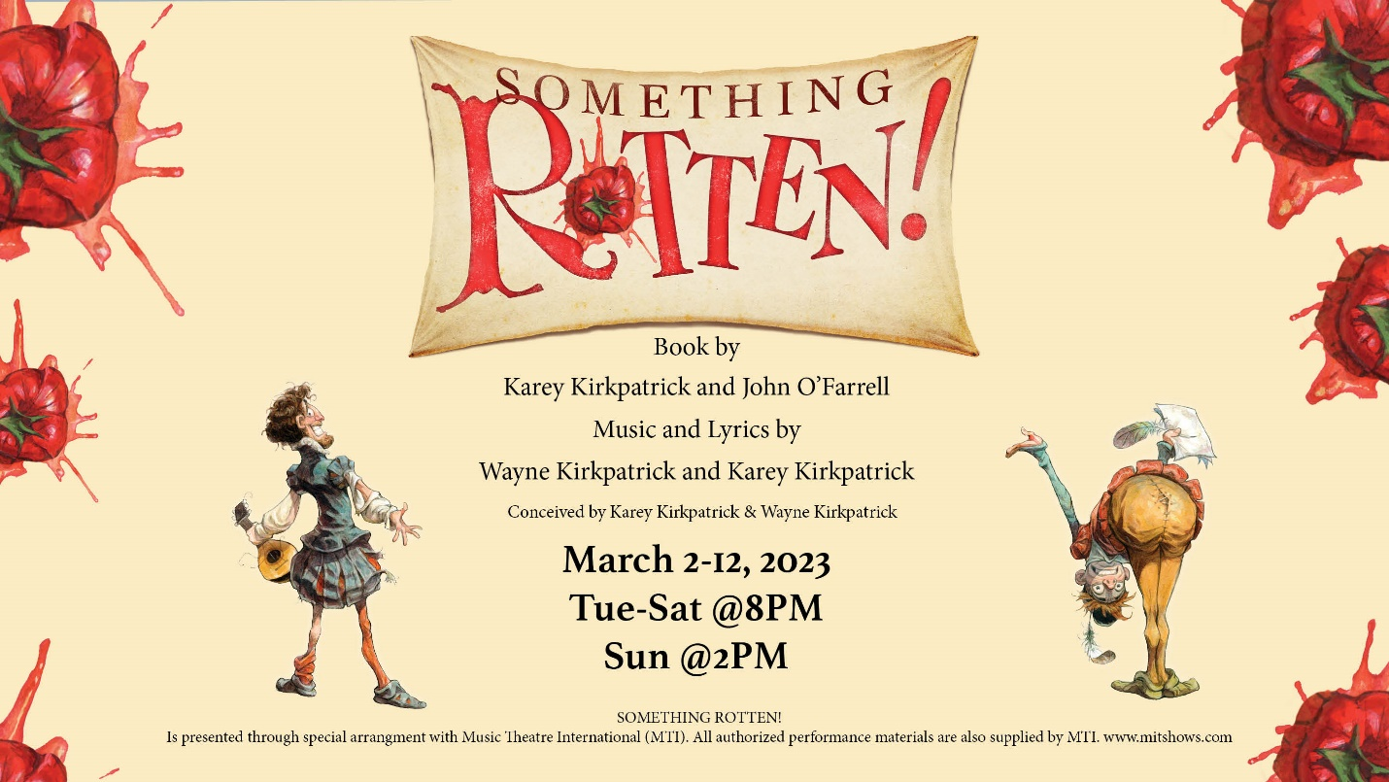

VCP’s Something Rotten
Visual Story
- What is a Visual Story?
A visual story is a simplified summary of the show with pictures.
Visual stories also help the audience to know which scenes have triggering content to prepare accordingly.
The visual story does contain spoilers to the show.

- Content Warnings for Something Rotten:
Loud yelling
Coarse language
Something Rotten is a satirical comedy that pokes fun at the ideologies presented from a different era. These views do not reflect Vanier College Productions or our company members.

Act 1
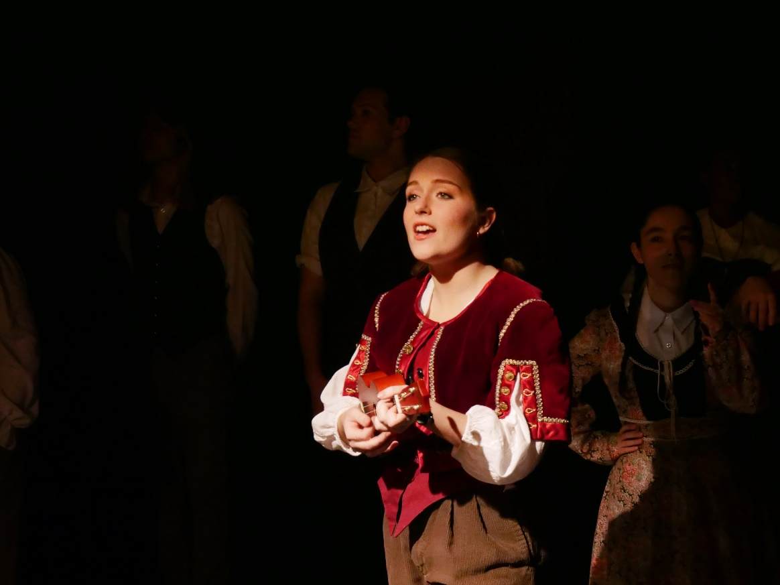
A minstrel welcomes us to the renaissance.
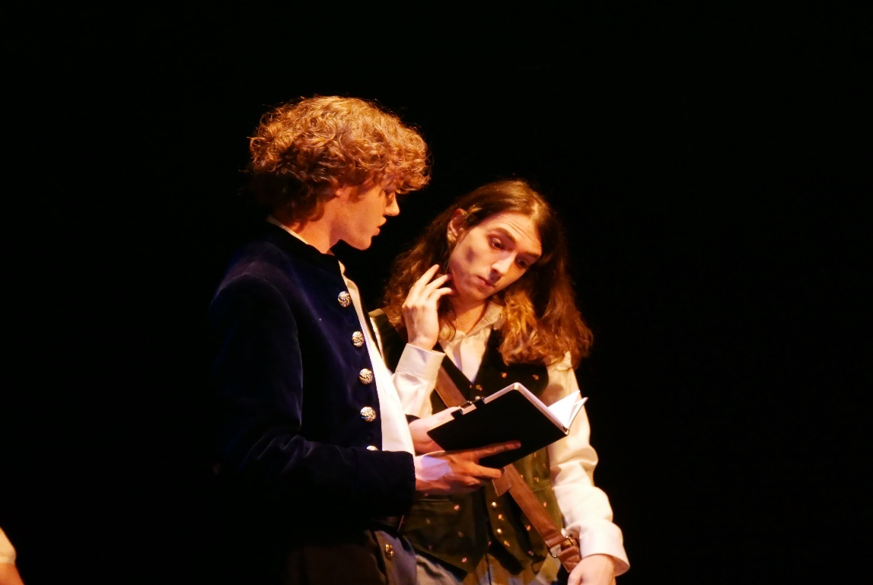
Nick and Nigel Bottom discuss their writing.
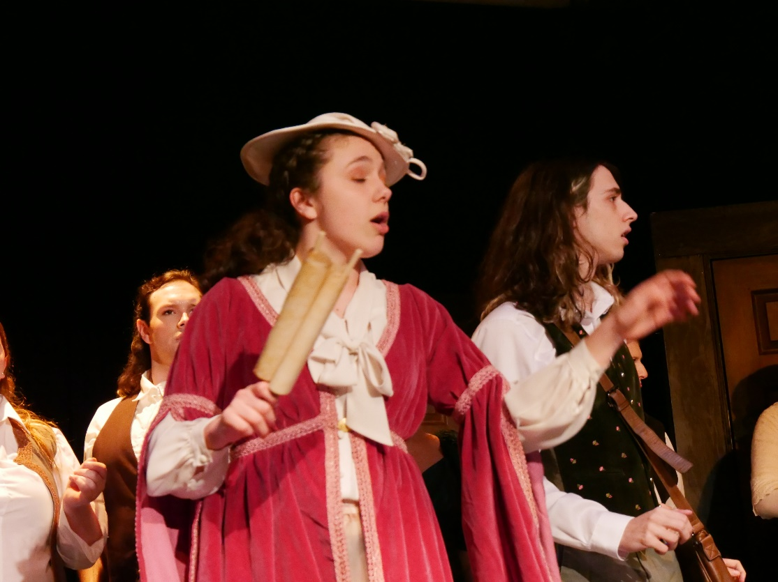
Lady Clapham pressures the Bottom brothers to come up with a new play idea the next day.
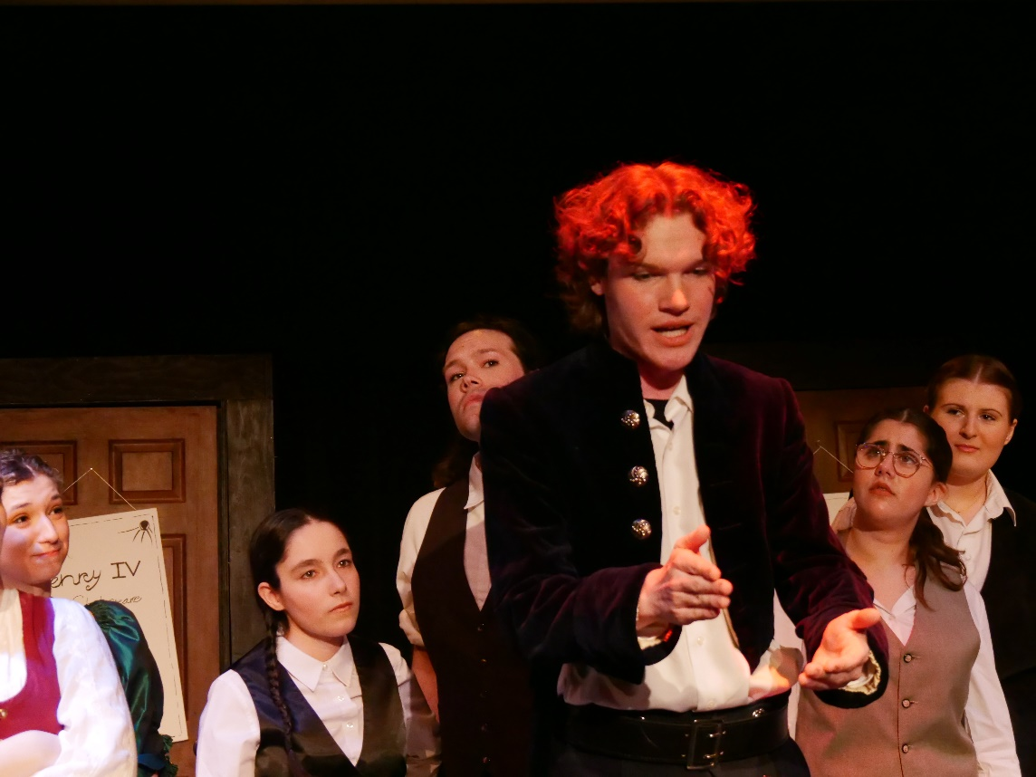
Nick expresses his hate of Shakespeare.

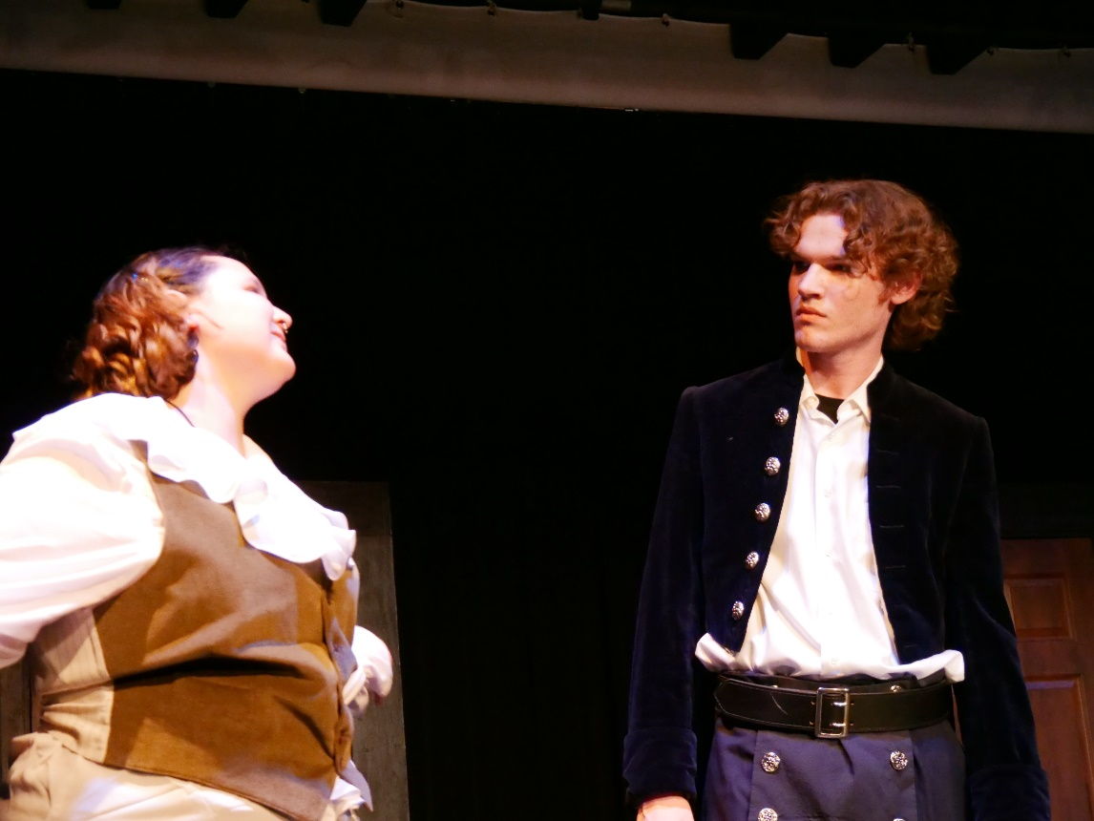
Shylock confronts Nick about his due debt.
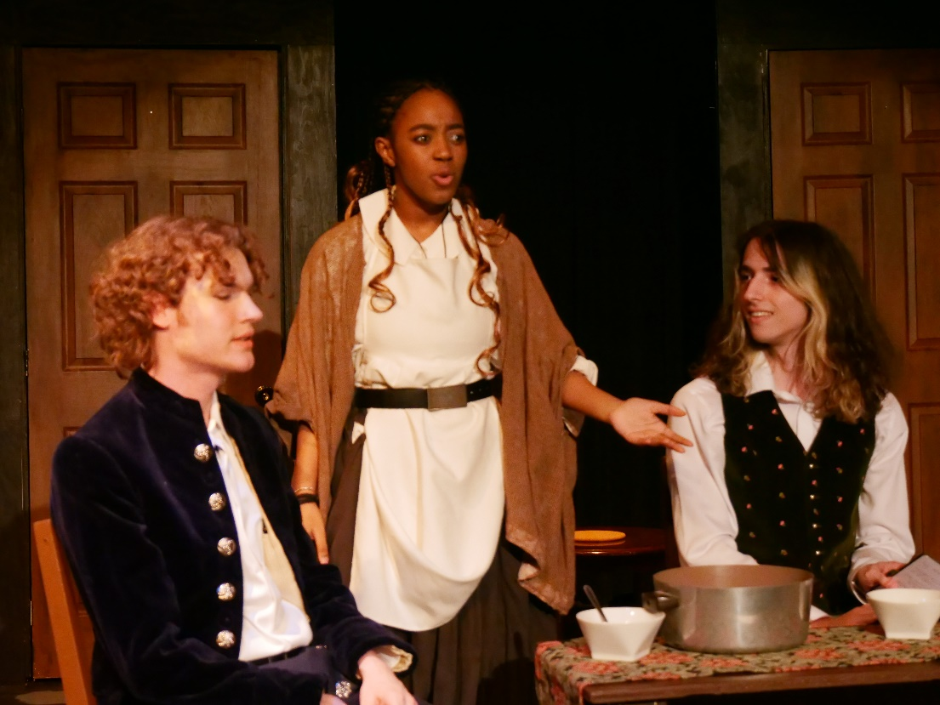
Bea and Nick discuss their money issues as Nigel eats.
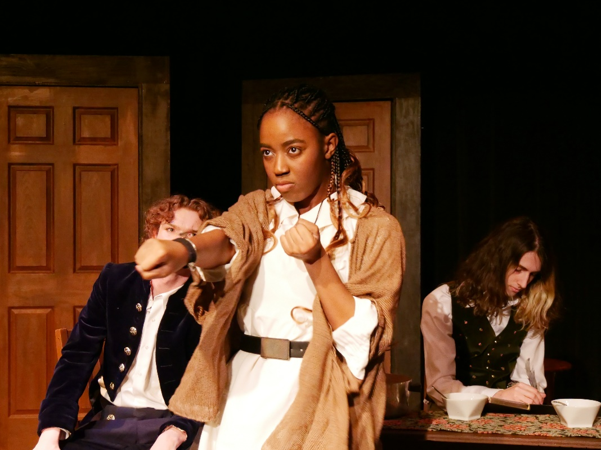
Bea insists on helping out Nick.
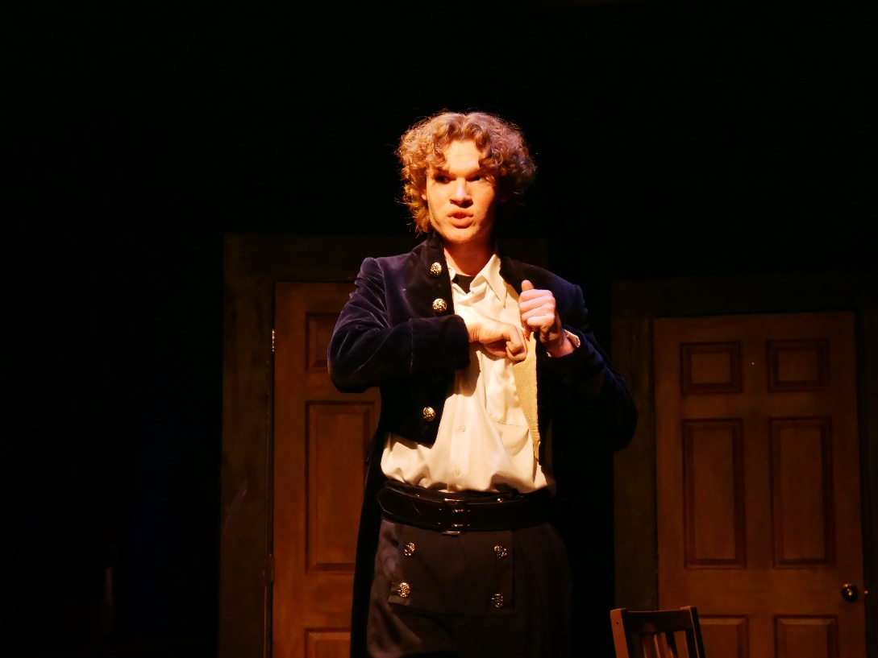
Nick secretly removes a bag of coins from their savings box.

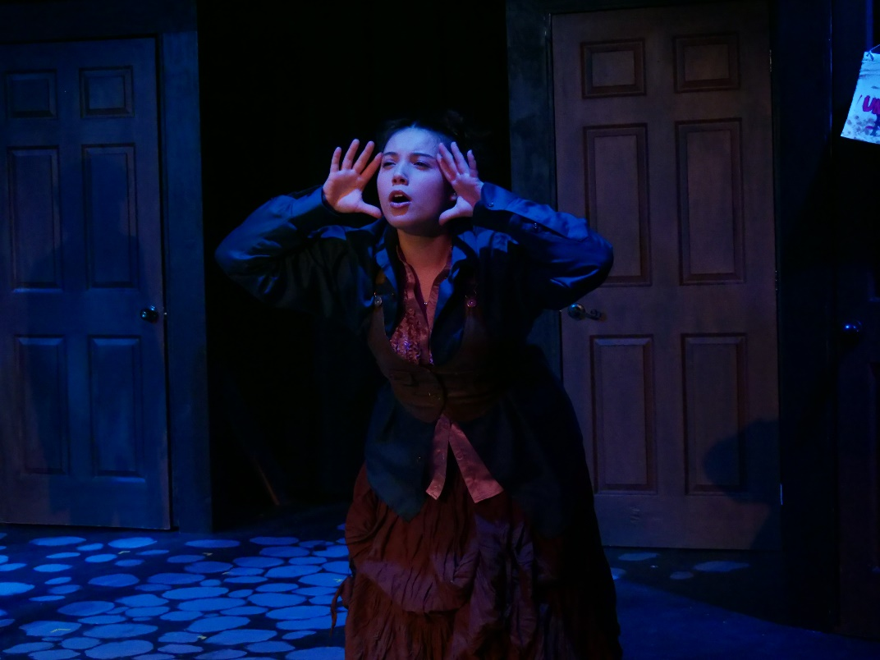
Nostradamus reads Nick’s future.


Nostradamus sees musicals in the future and explains the concept to Nick.
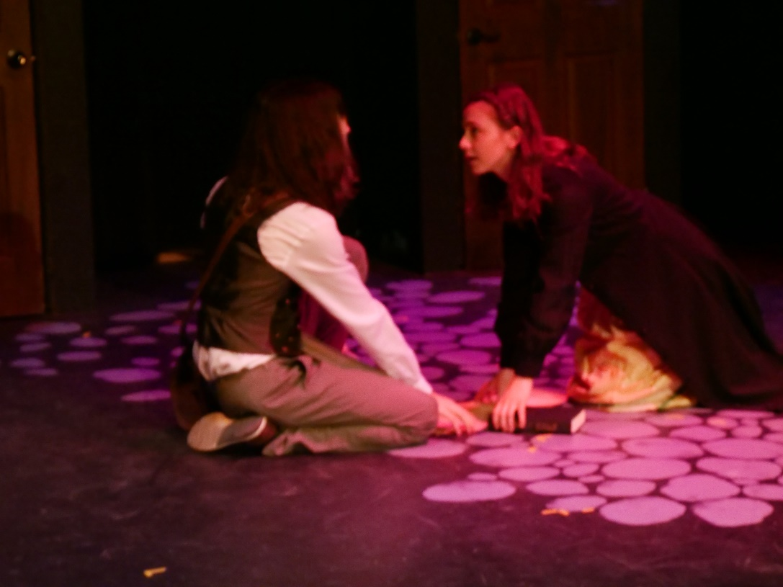
Nigel bumps into Portia–it is love at first sight.
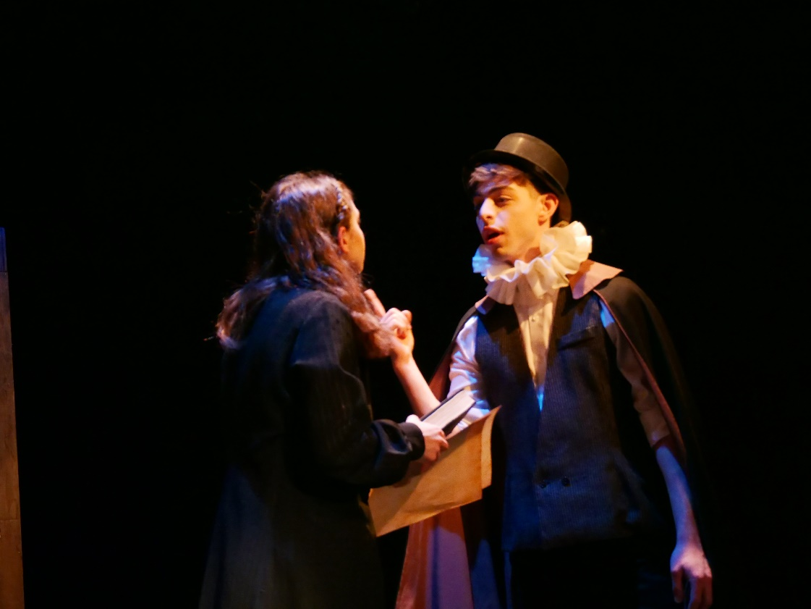
Portia’s father, Brother Jeremiah, condemns theatre.
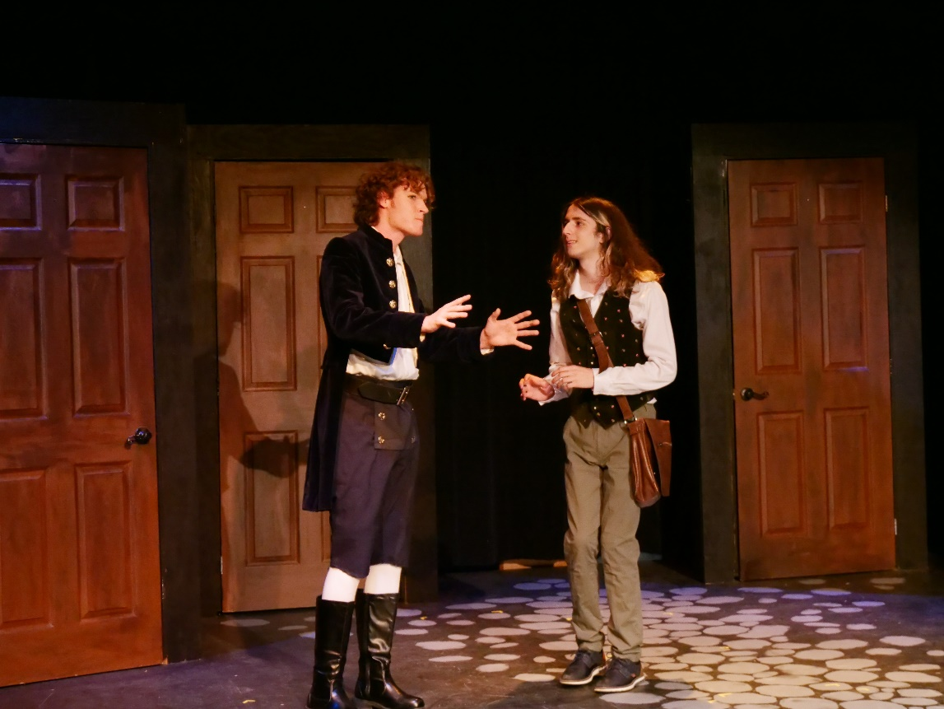
Nick shares the idea of writing a musical with Nigel.
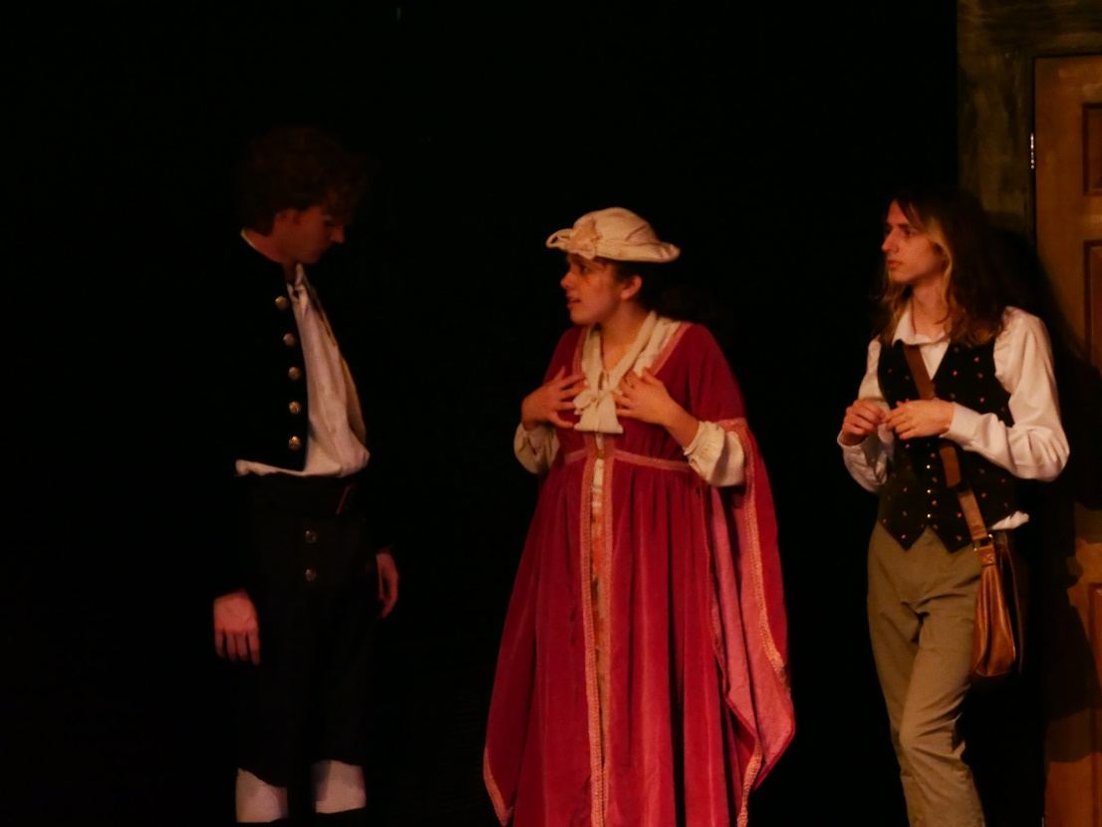
The Bottom brothers present a musical about the Black Death to Lady Clapham.
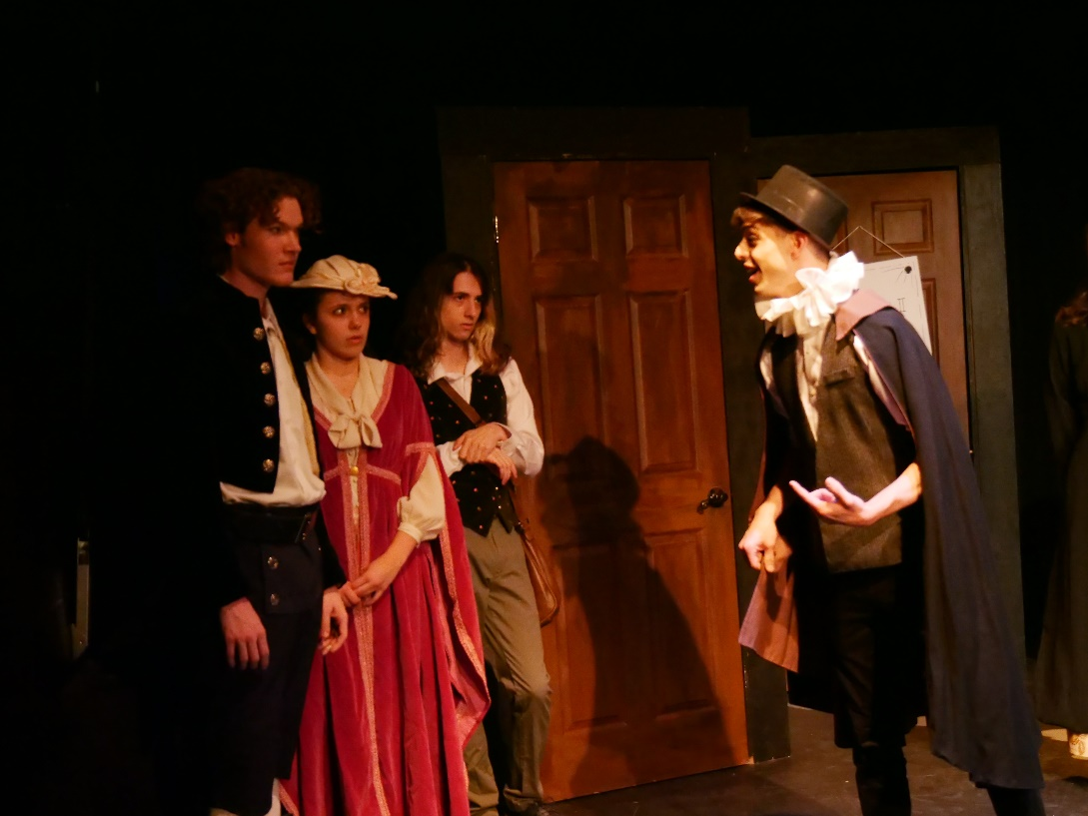
With pressure from Brother Jeremiah, Lady Clapham withdraws her patronage.
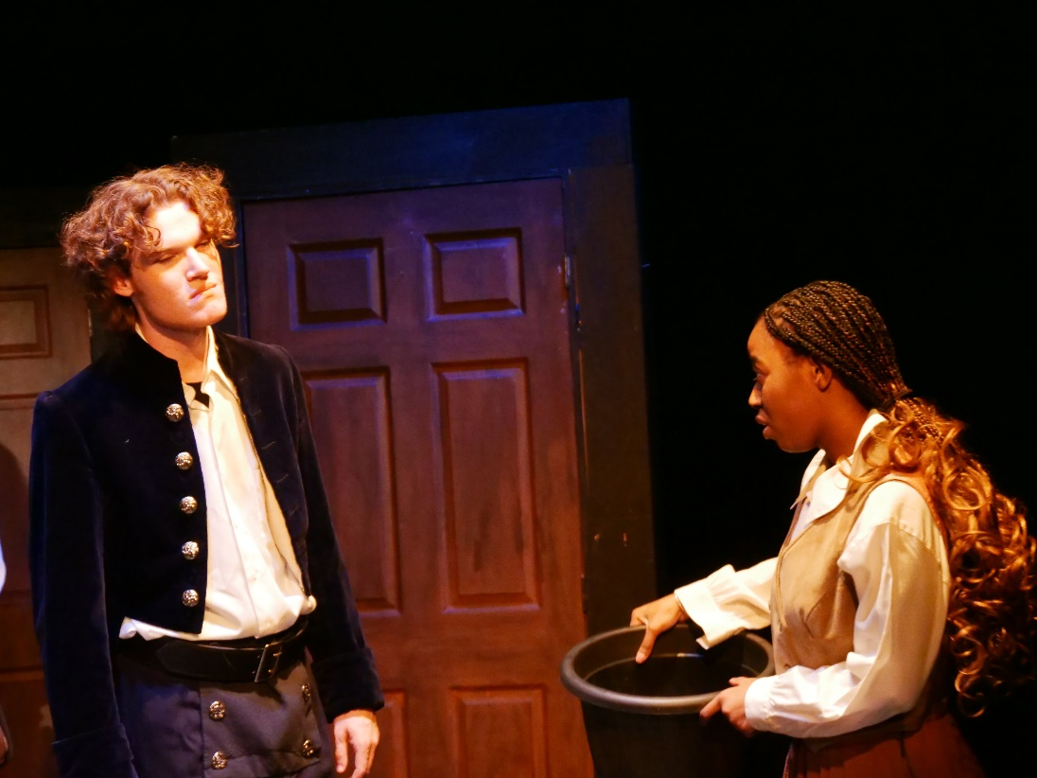
The Bottom brothers, still distraught, encounter Bea dressed as a man.
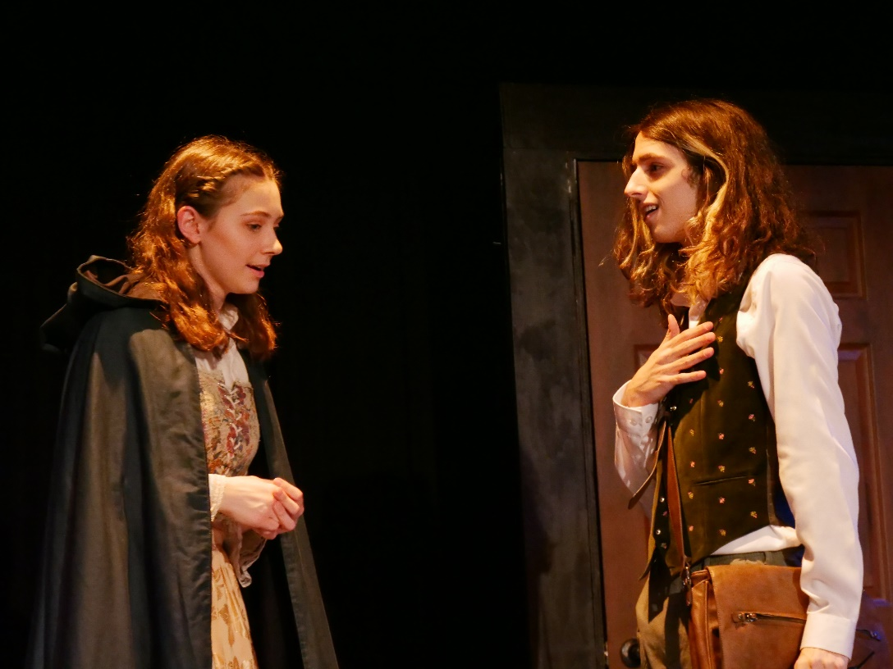
Portia approaches Nigel and they bond over theatre and poetry.
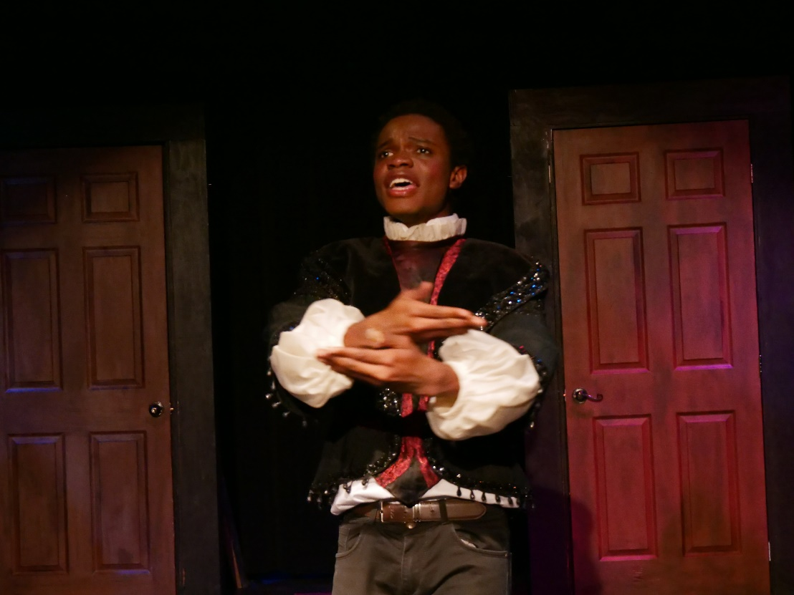
Shakespeare performs to an enthusiastic crowd in a park.
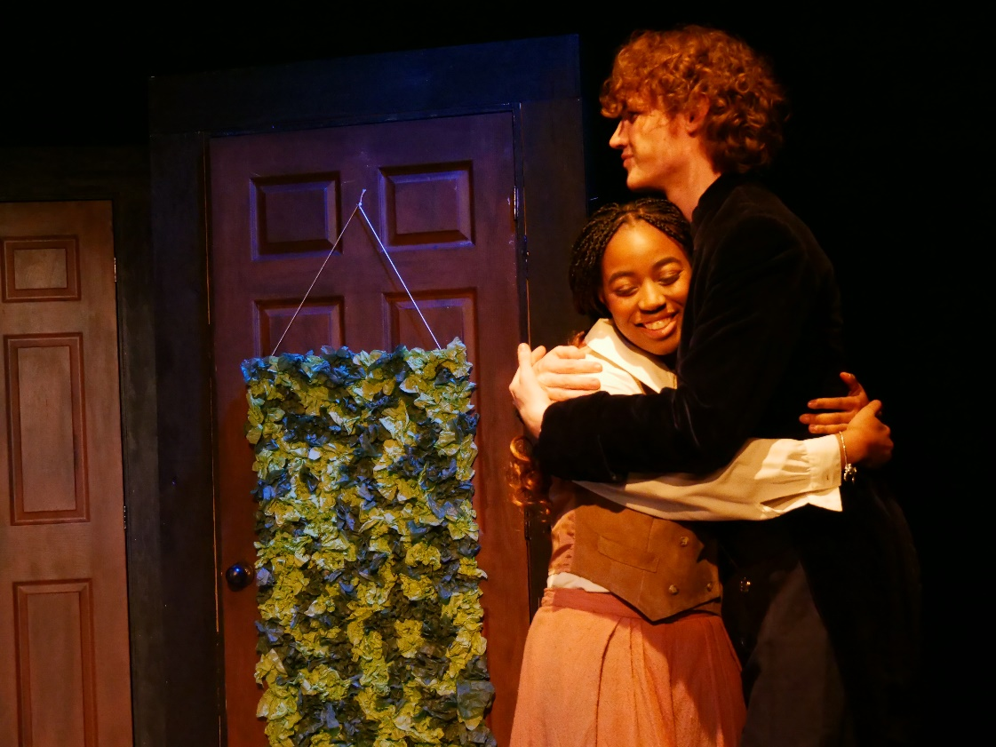
Bea tells Nick she is pregnant.
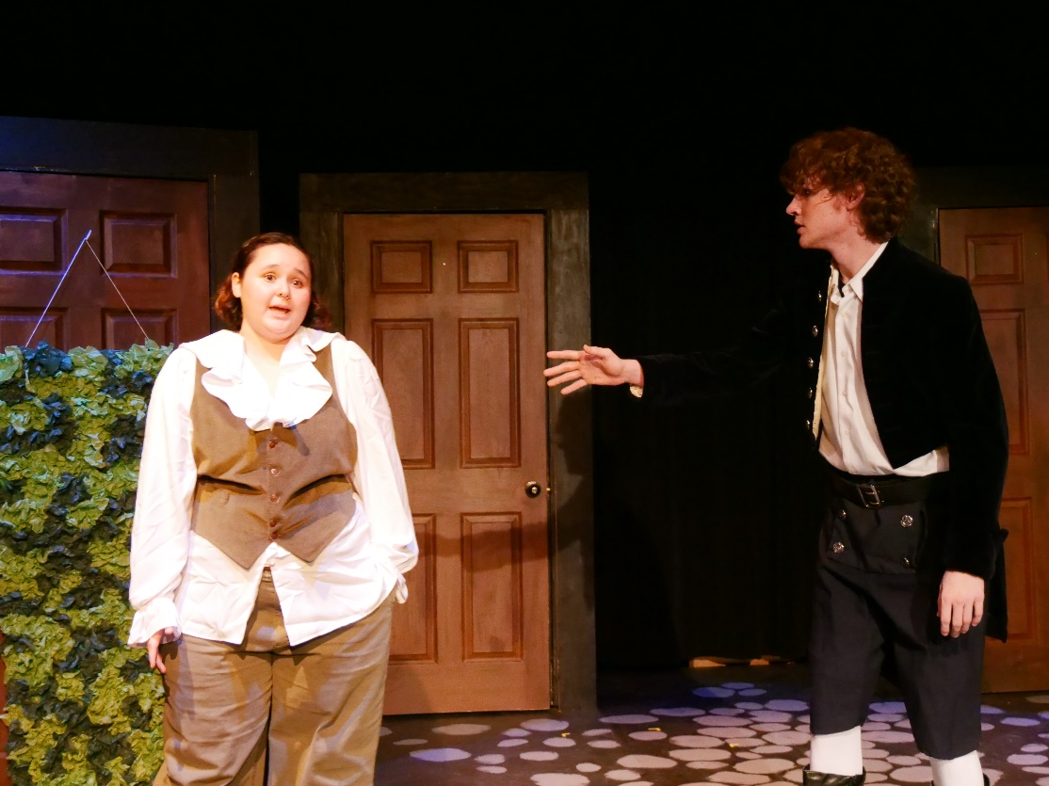
Shylock reveals to Nick that Nigel is attending Shakespeare’s party.
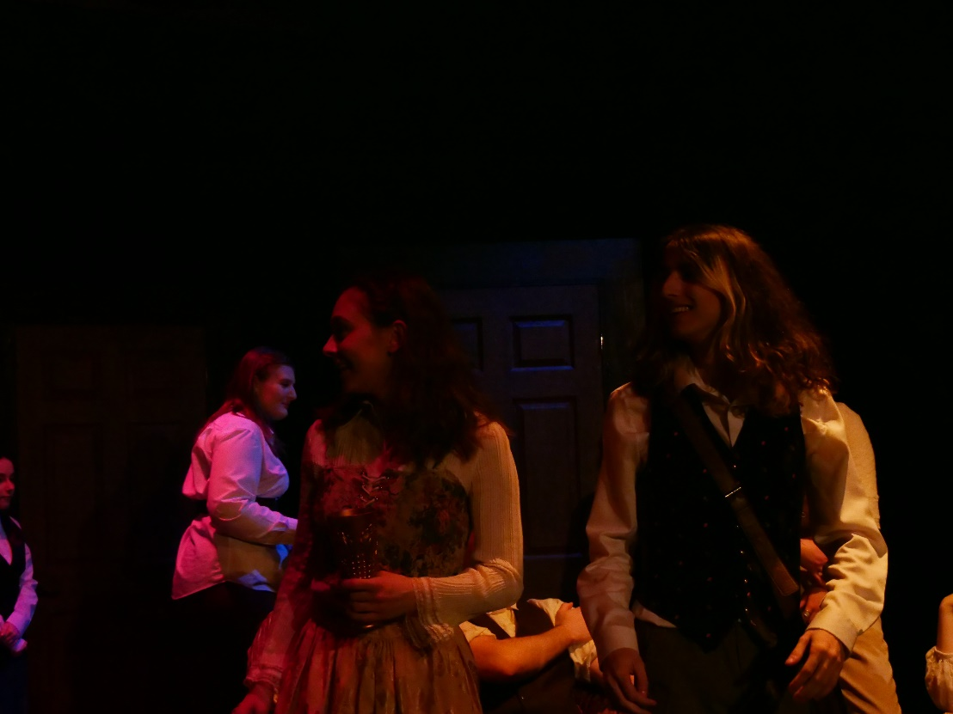
Nigel and Portia share a drink at Shakespeare’s afterparty.
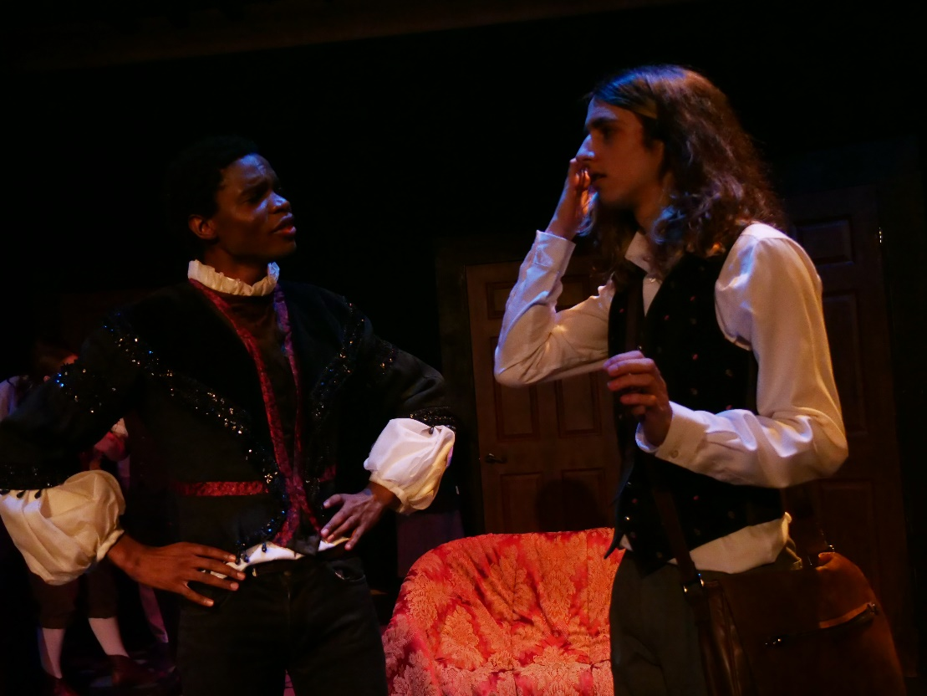
Shakespeare chats with Nigel and asks to read his work.
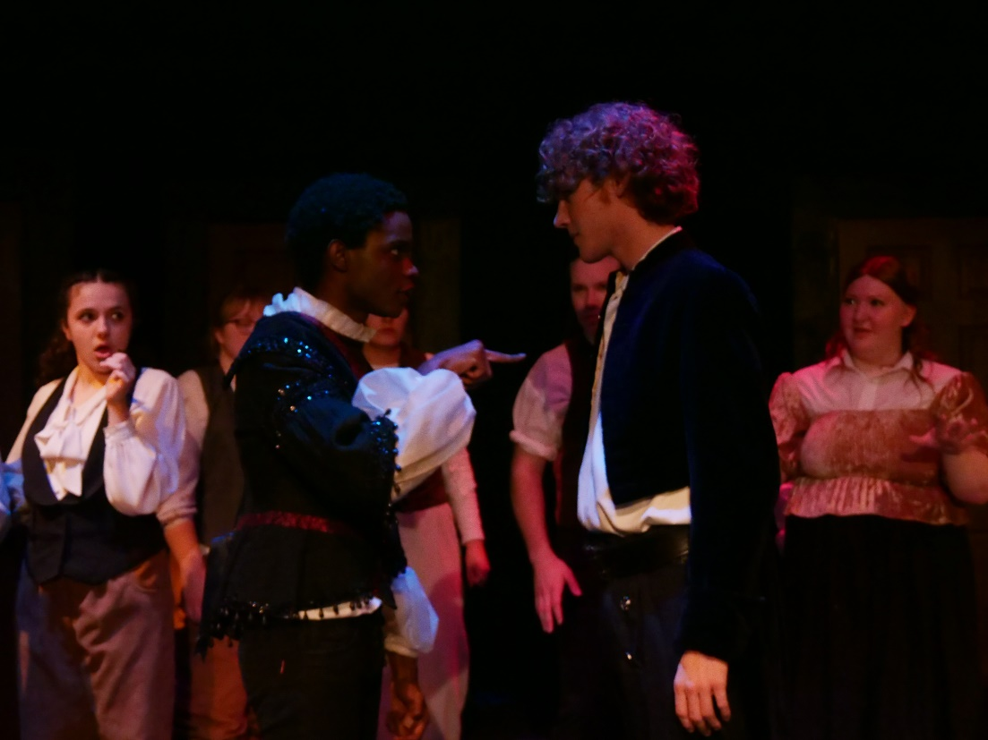
Nick barges in with Shylock and snatches Nigel’s work back out of Shakespeare’s hands.
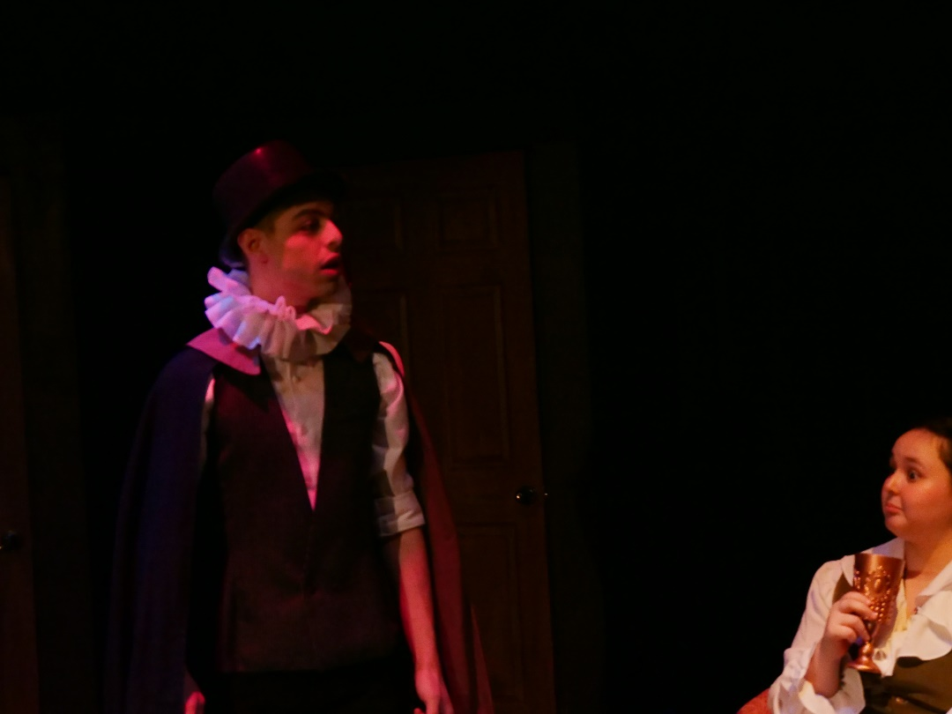
Brother Jeremiah catches Portia reprimands her and drags her away.
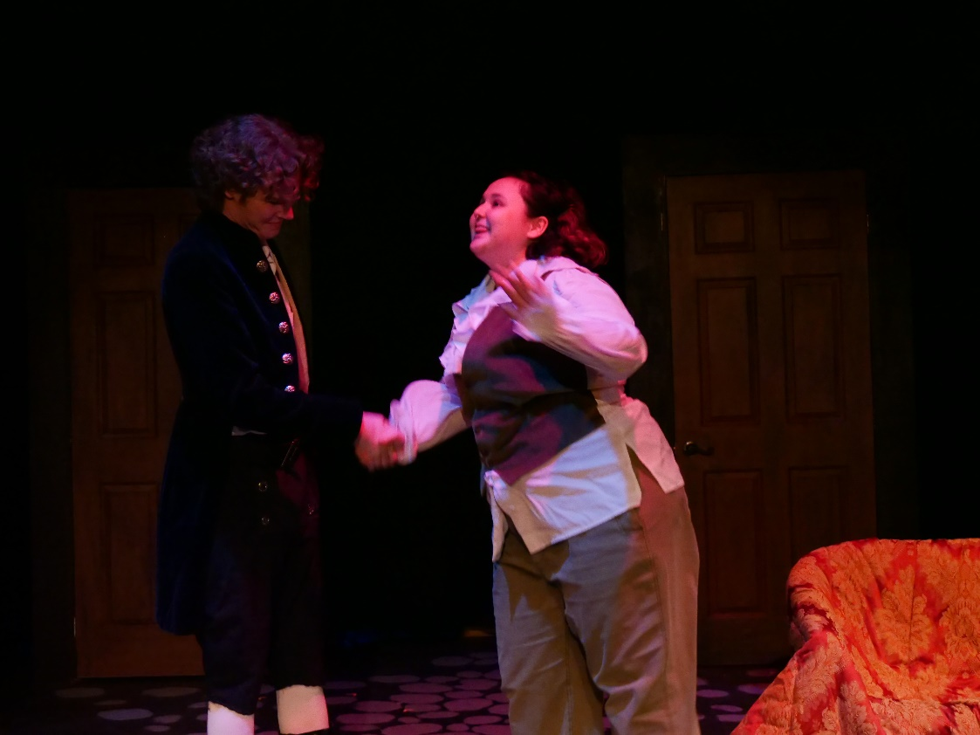
Nick agrees for Shylock to be a patron.
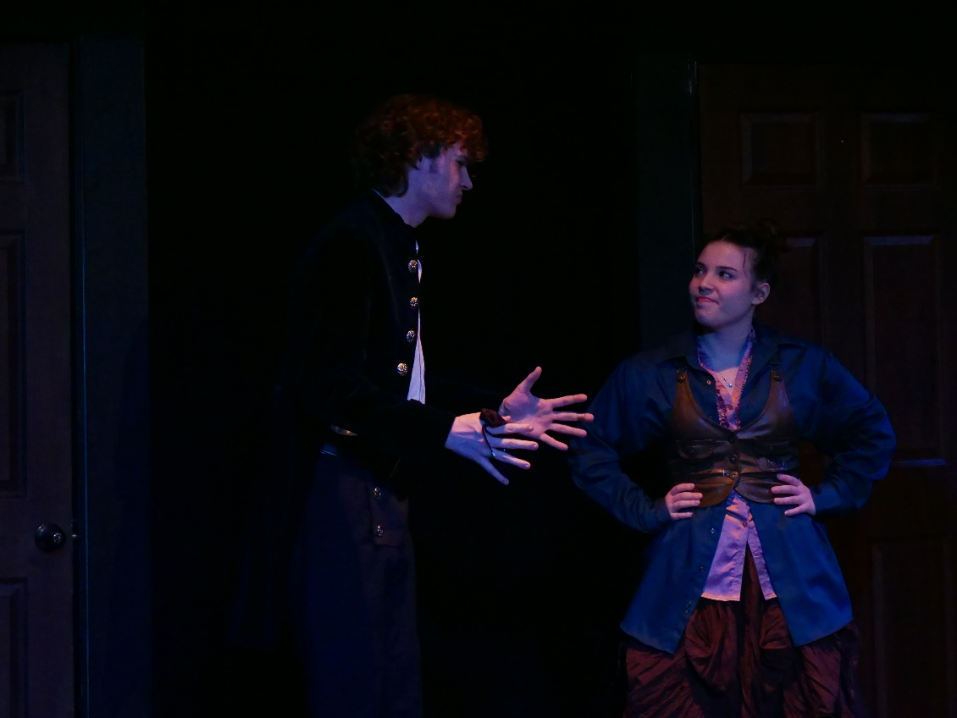
Nick and Nostradamus are brainstorming an idea for a musical.

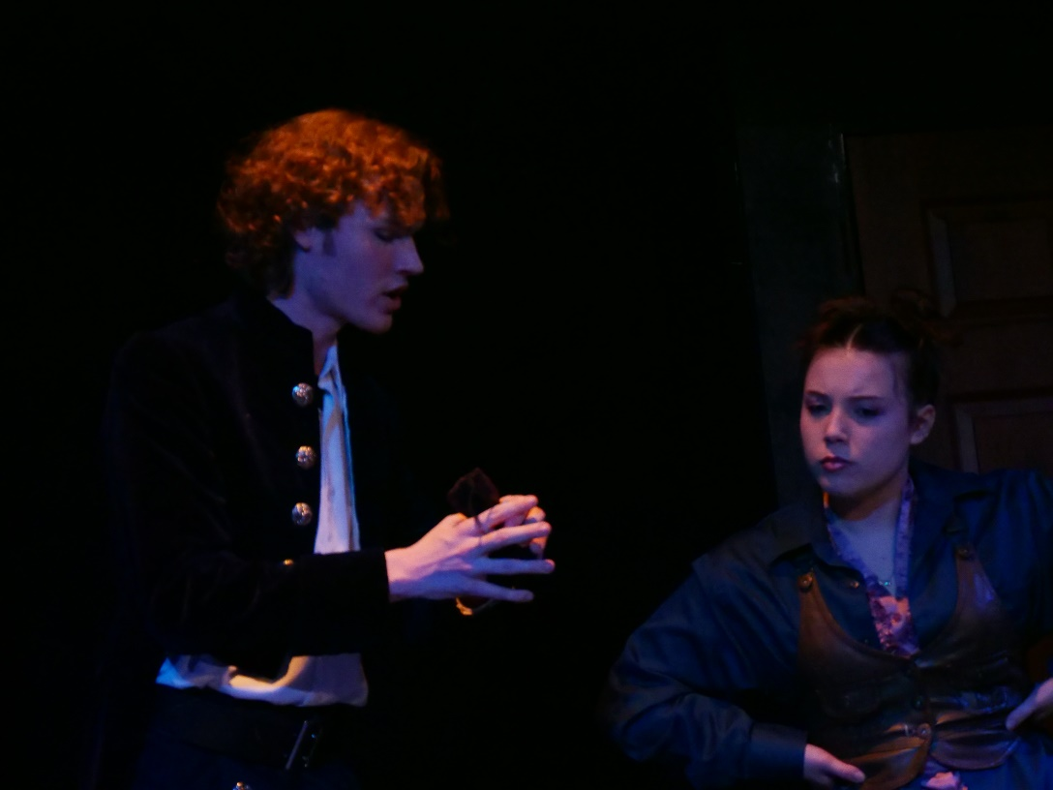
Nick begs Nostradamus to look into the future and find out Shakespear’s hit play.
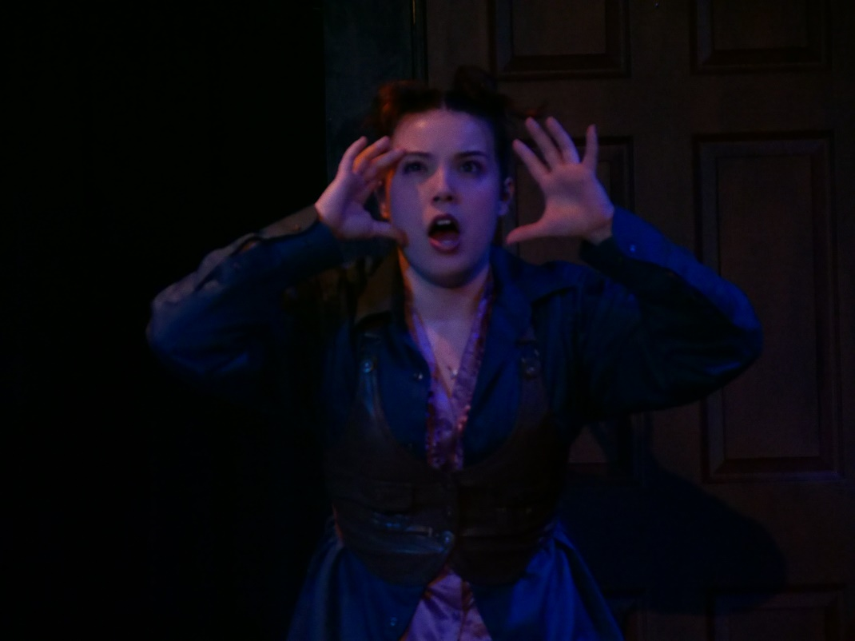
Nostradamus tells Nick that it is called “Omelette” (a wrong pronunciation of “Hamlet).
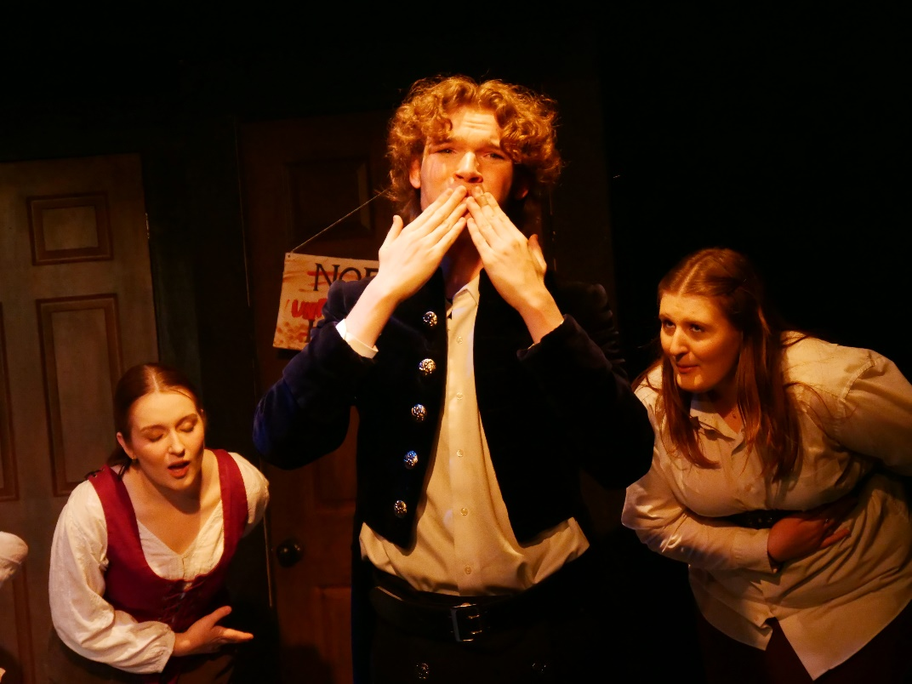
Nick starts imagining himself as a successful playwright.

ACT 2
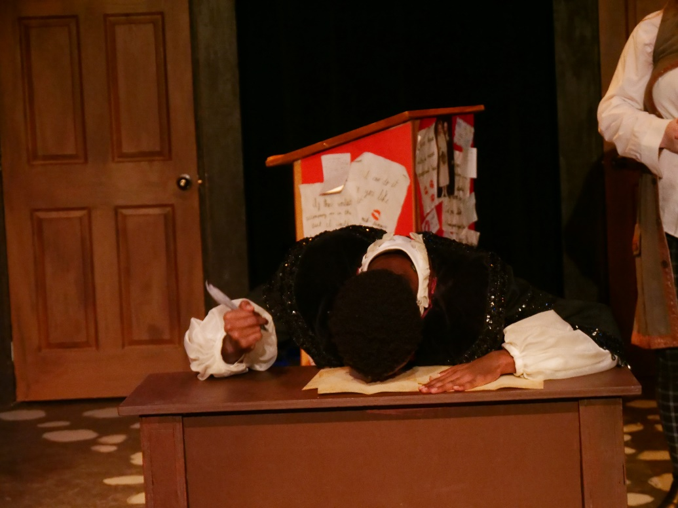
Shakespear is complaining about how hard his life is.
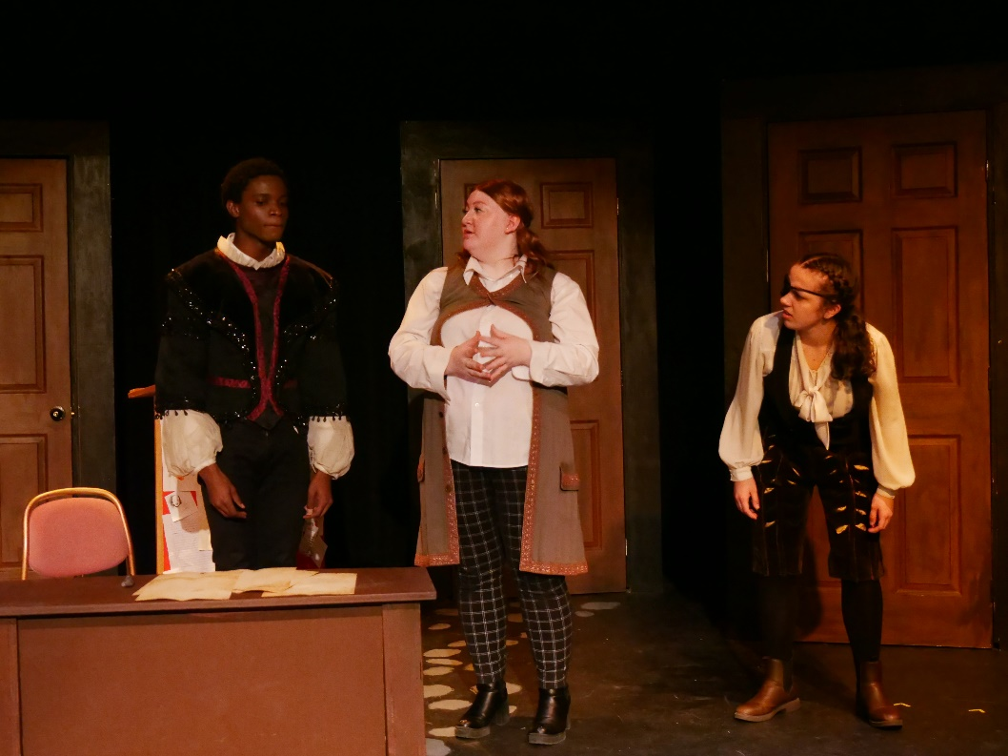
The valet and the man with the eyepatch tell Shakespear about Nick’s plans.
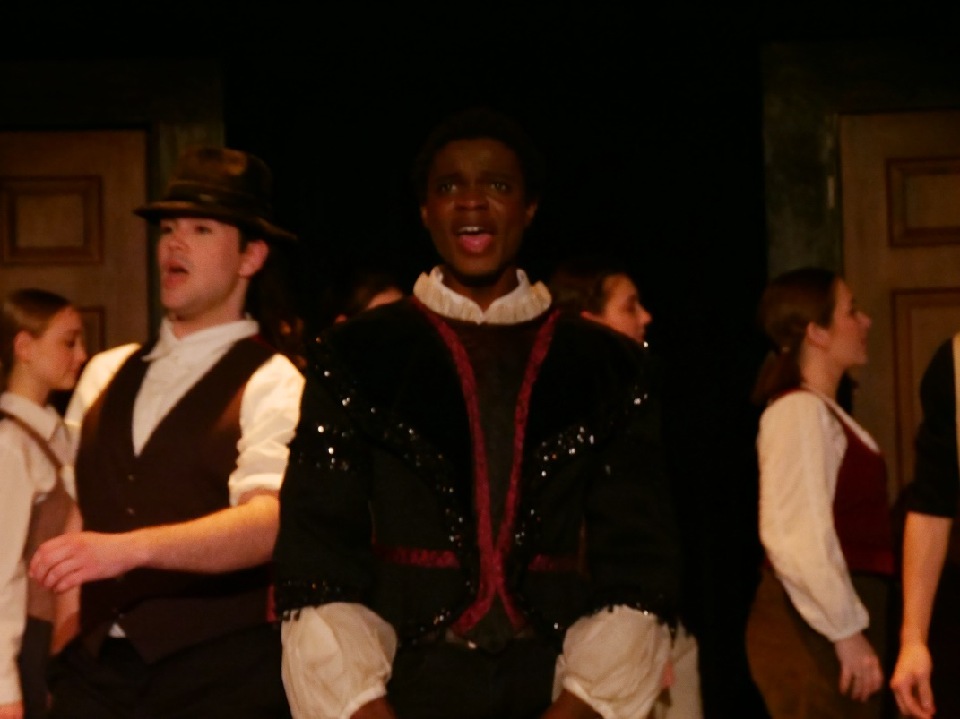
Shakespear is now determined to find out what the musical is going to be about.
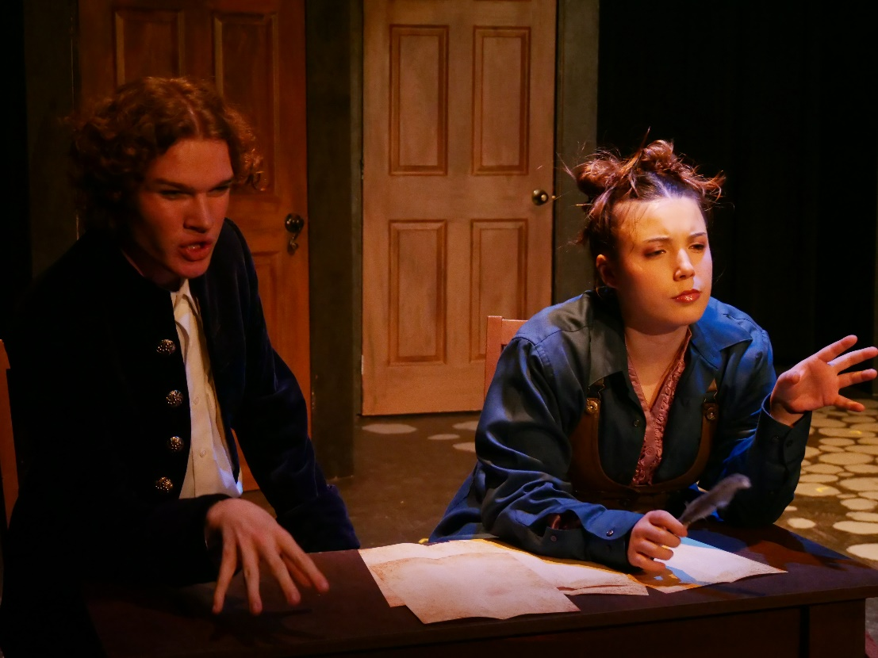
Nick and Nostradamus are reviewing the musical that Nostradamus saw in his visions.
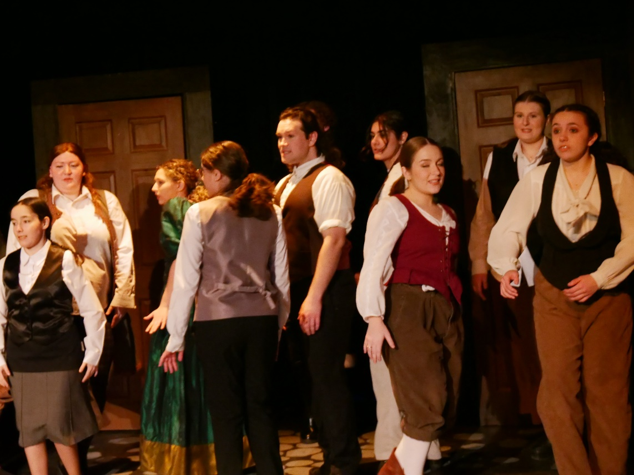
The chorus practice a song from the musical.
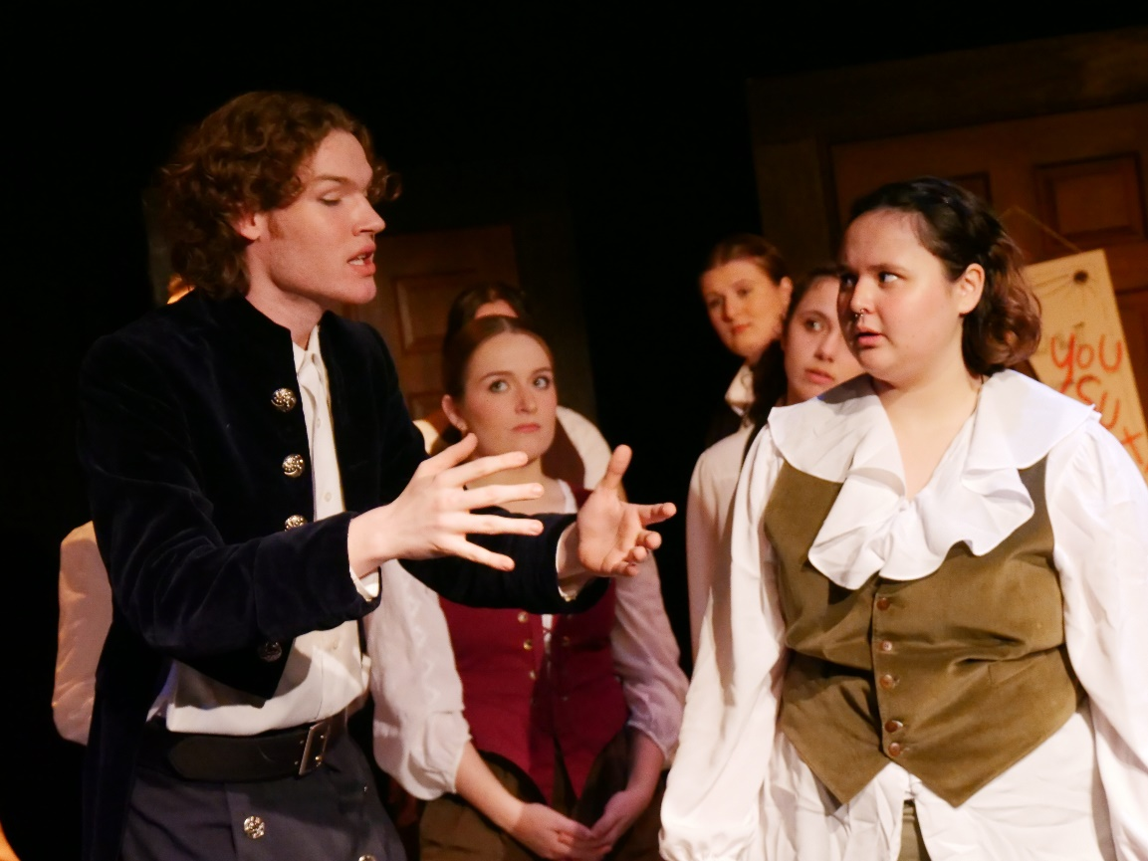
Shylock and Nigel question Nick’s choice in the musical.
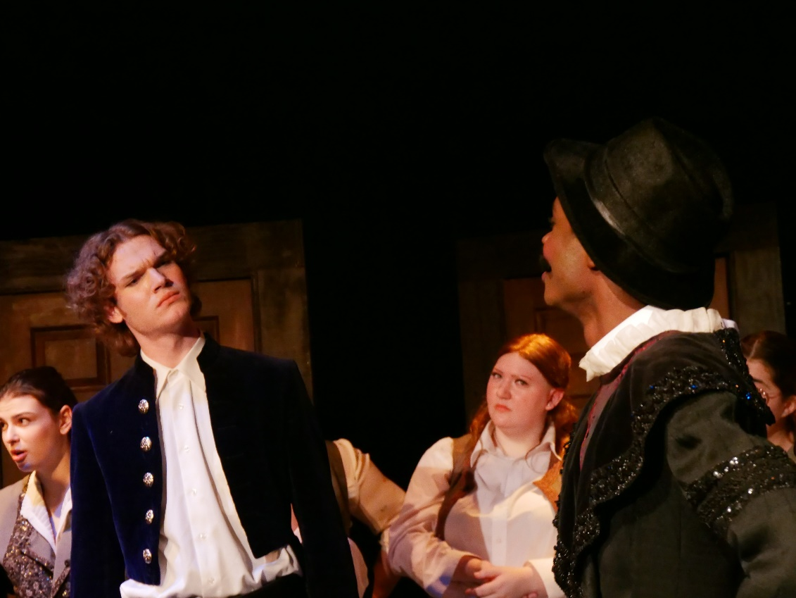
Shakespear, disguised as Toby, asks to audition for the musical. Nick hires him.
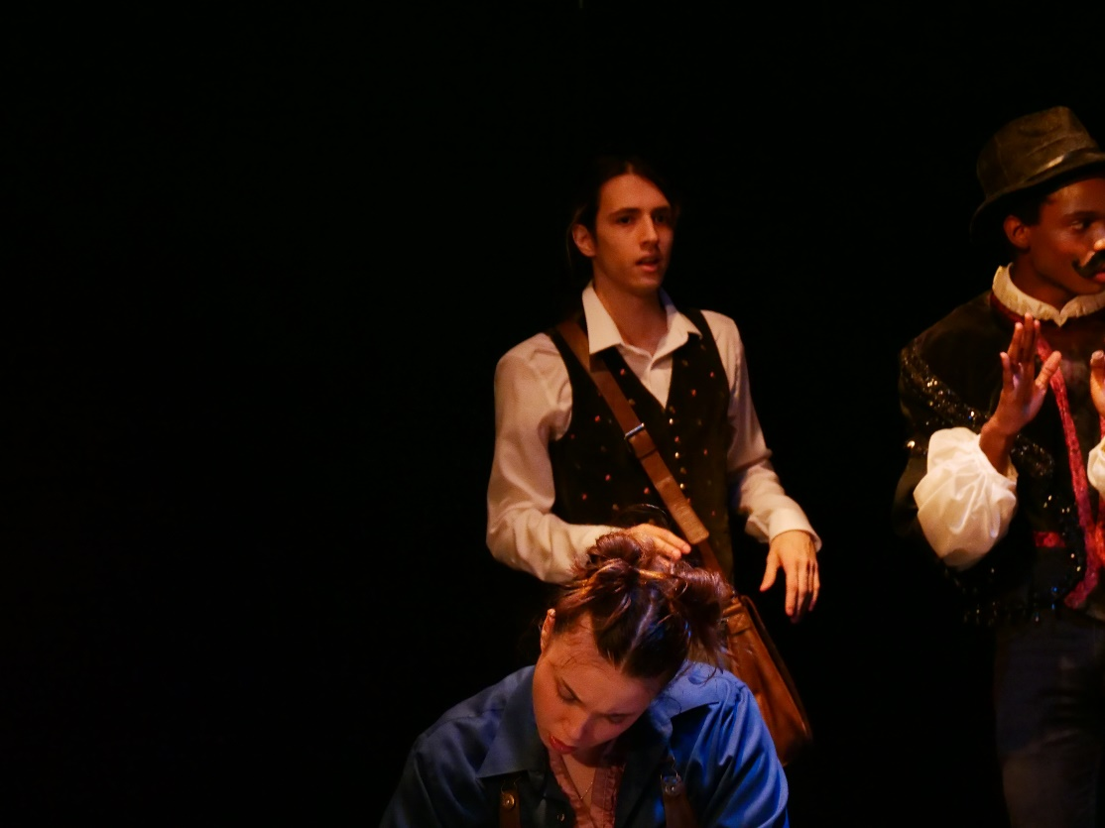
Nigel walks out, insisting on exploring other ideas for the musical.

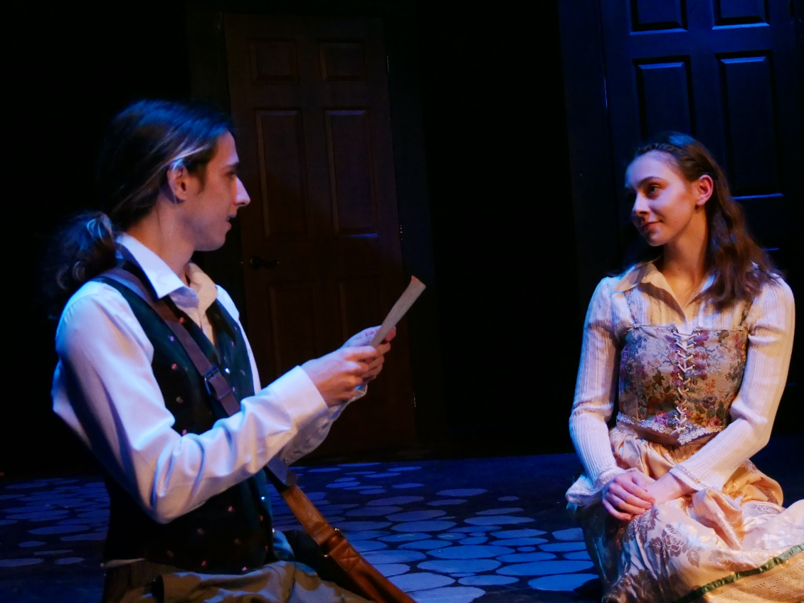
Nigel and Portia meet. Nigel reads to her a love poem.
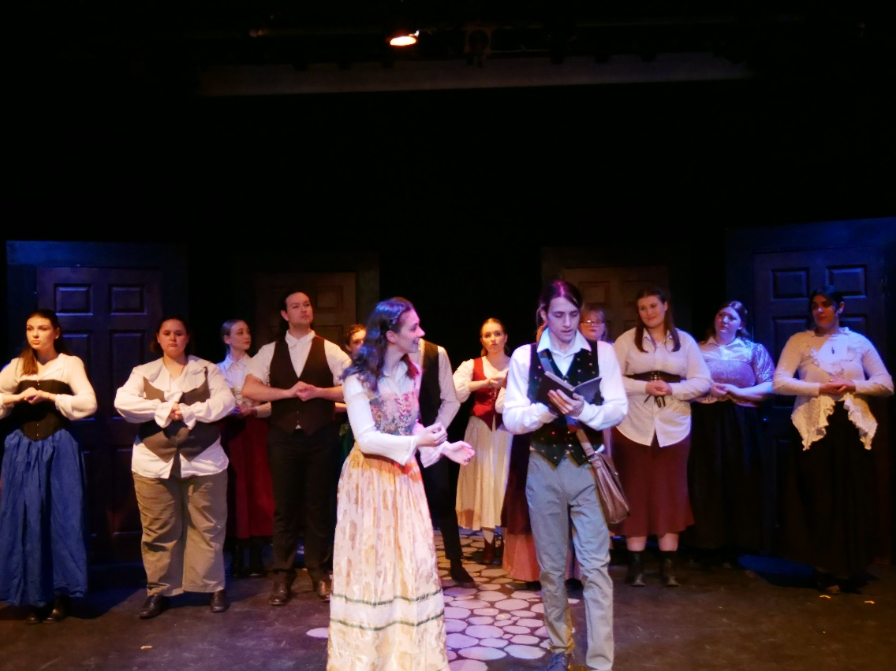
Portia suggests to Nigel to write another poem from his heart.
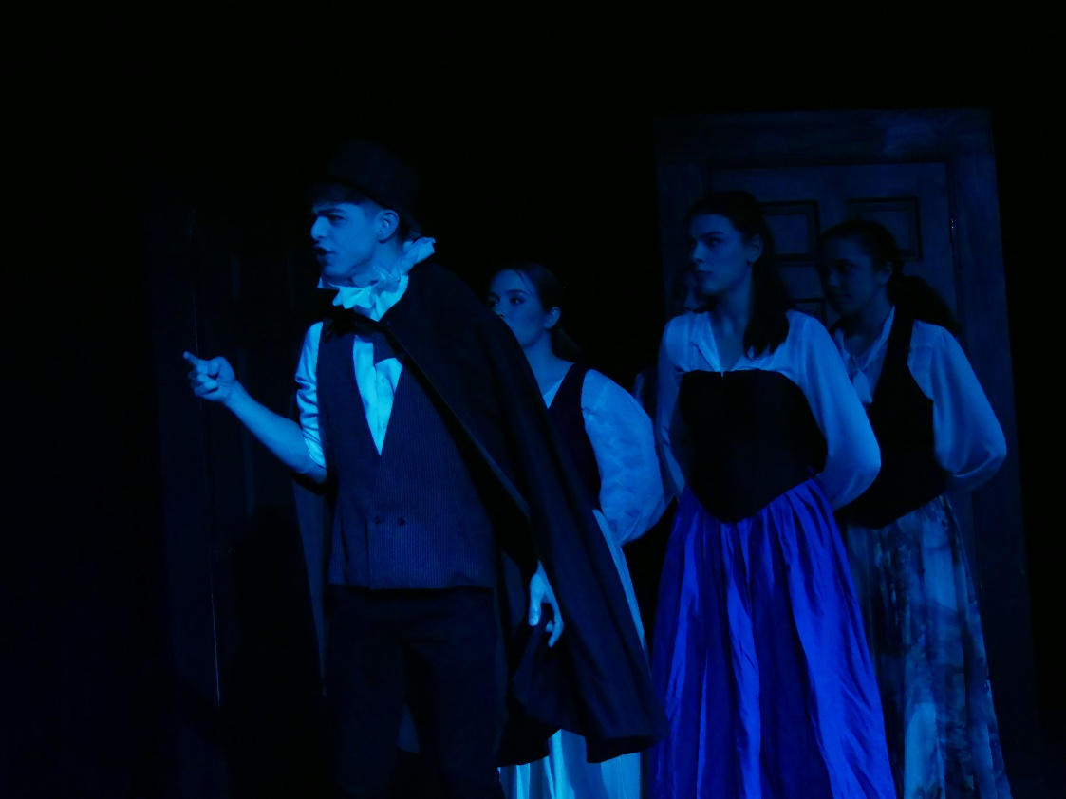
Brother Jeremiah catches Portia and Nigel. He drags Portia away.
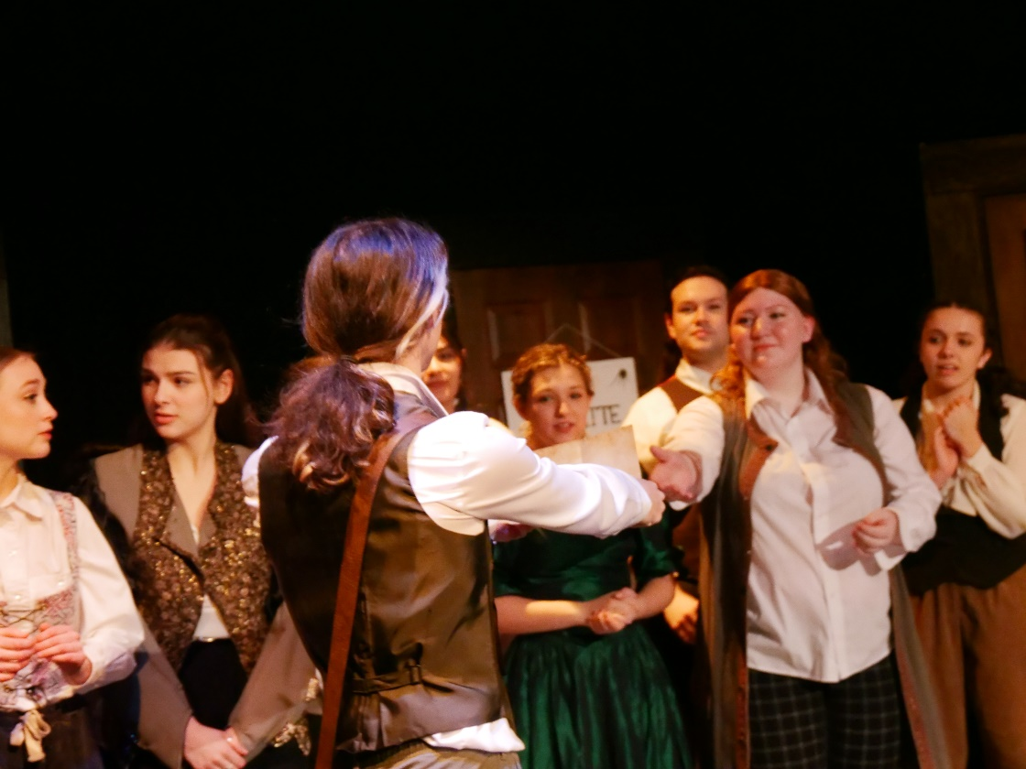
The troupe act out a piece of what Nigel wrote out.
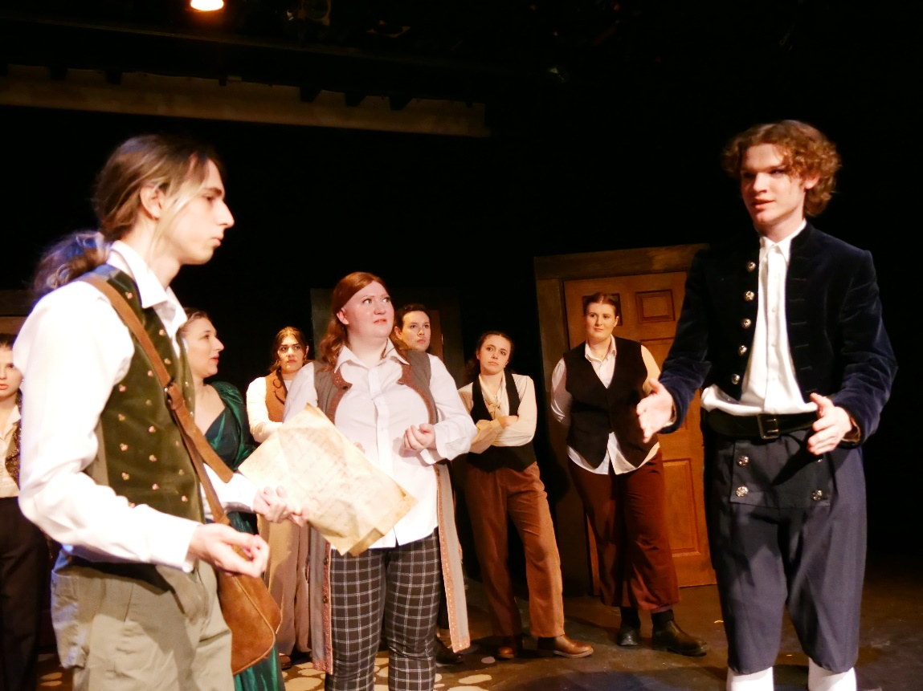
Nigel explains his take on the play to Nick.
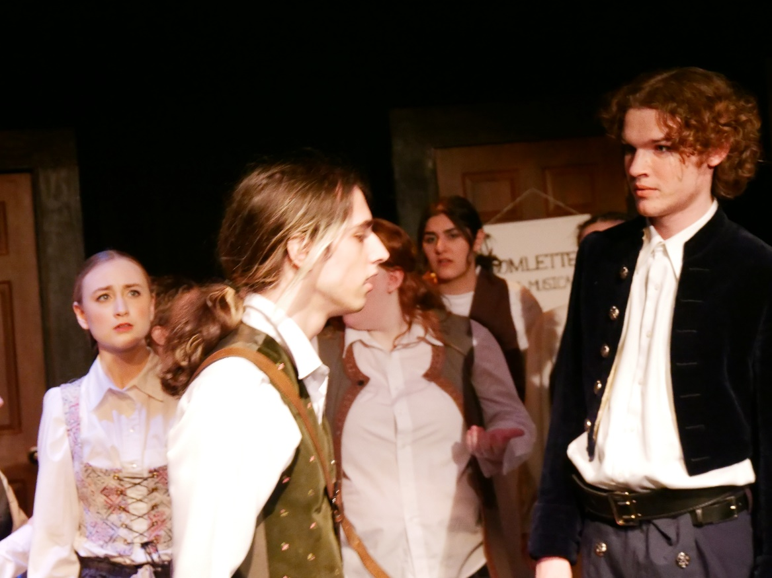
Nick insists on doing the play his way, and Nigel storms off.
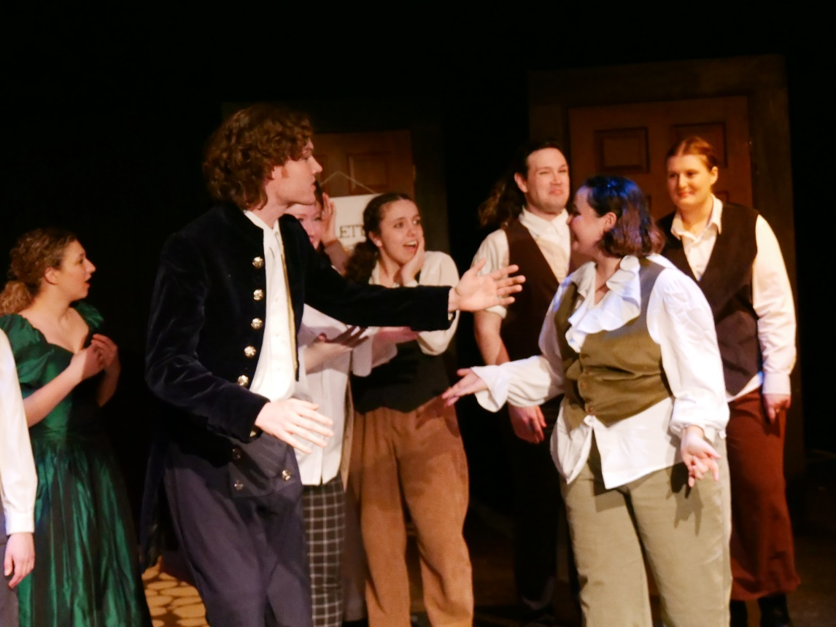
Shylock informs Nick that the musical sold out.

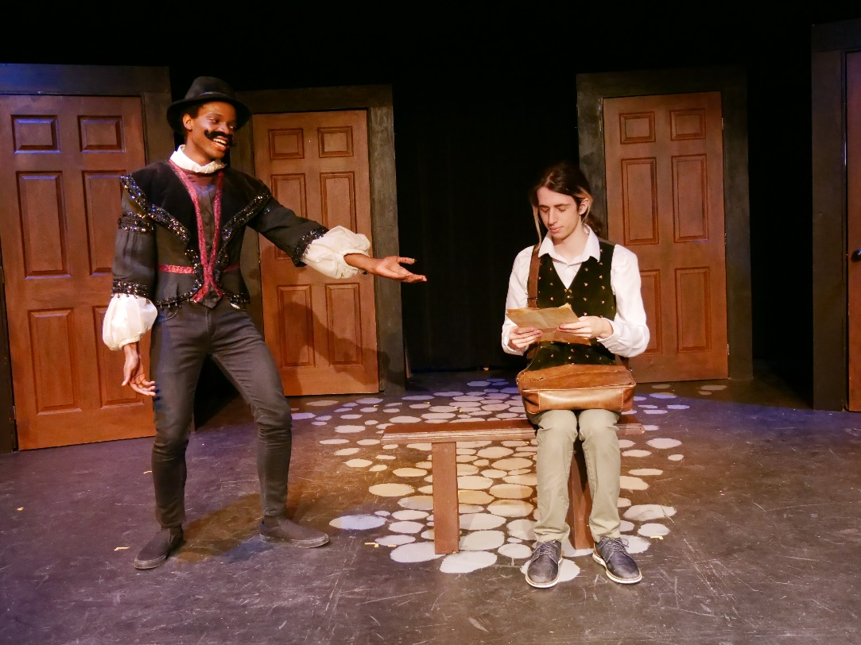
Shakespear encourages Nigel to continue writing his own script.
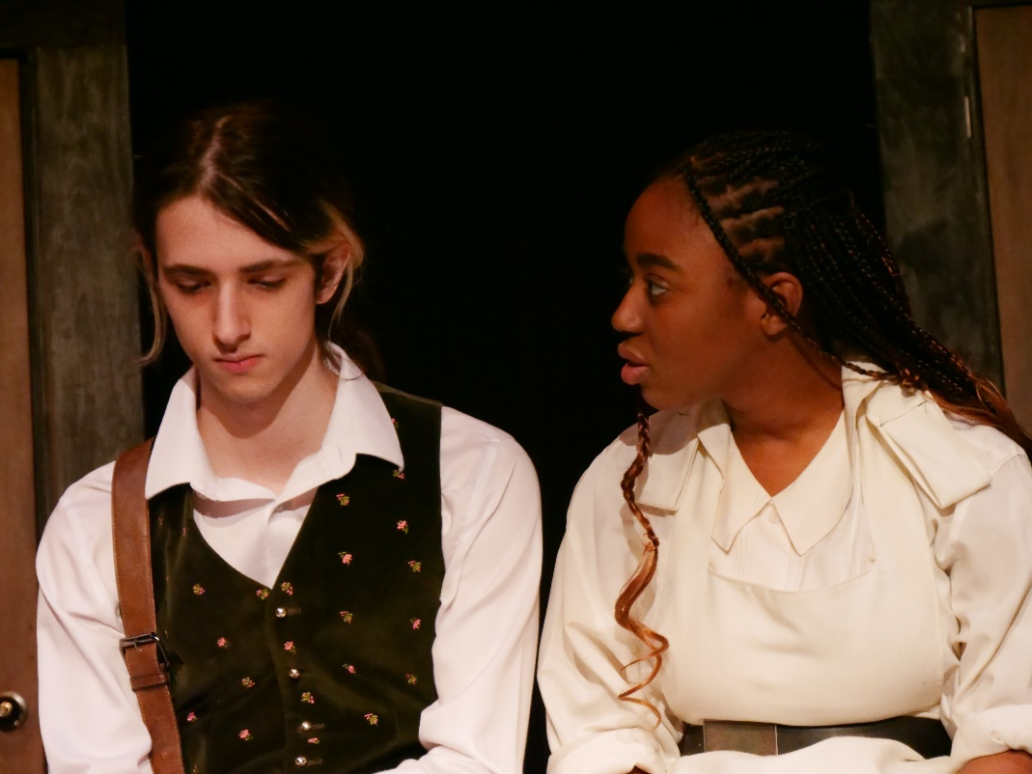
Bea sees Nigel sad about what Nick said to him. She cheers him up.
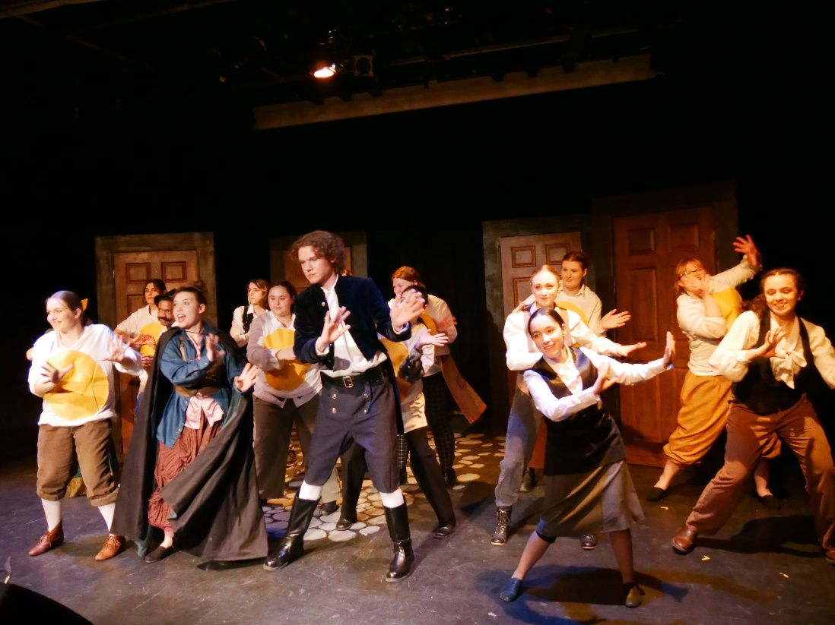
Nick and the troupe sing about making an omelette.
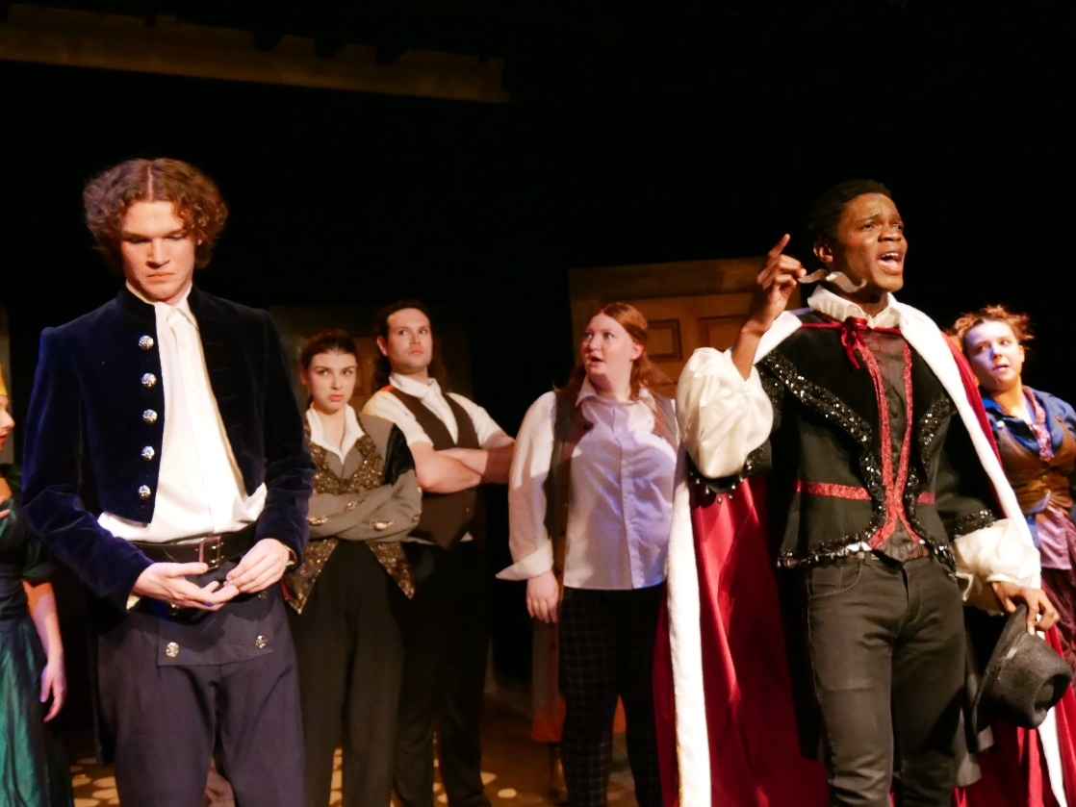
Shakespeare reveals his identity and exposes Nick for stealing his idea.

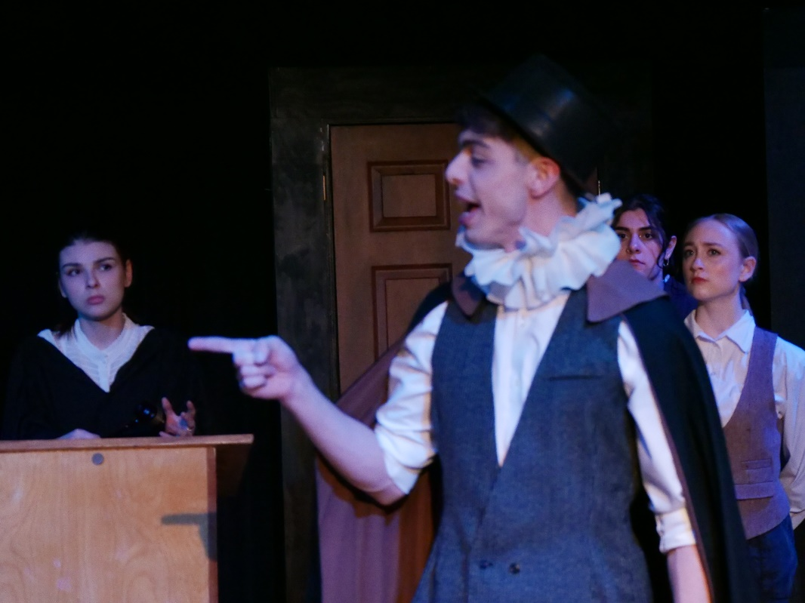
Nigel and Nick are in a courtroom with Brother Jeremiah demanding their execution.
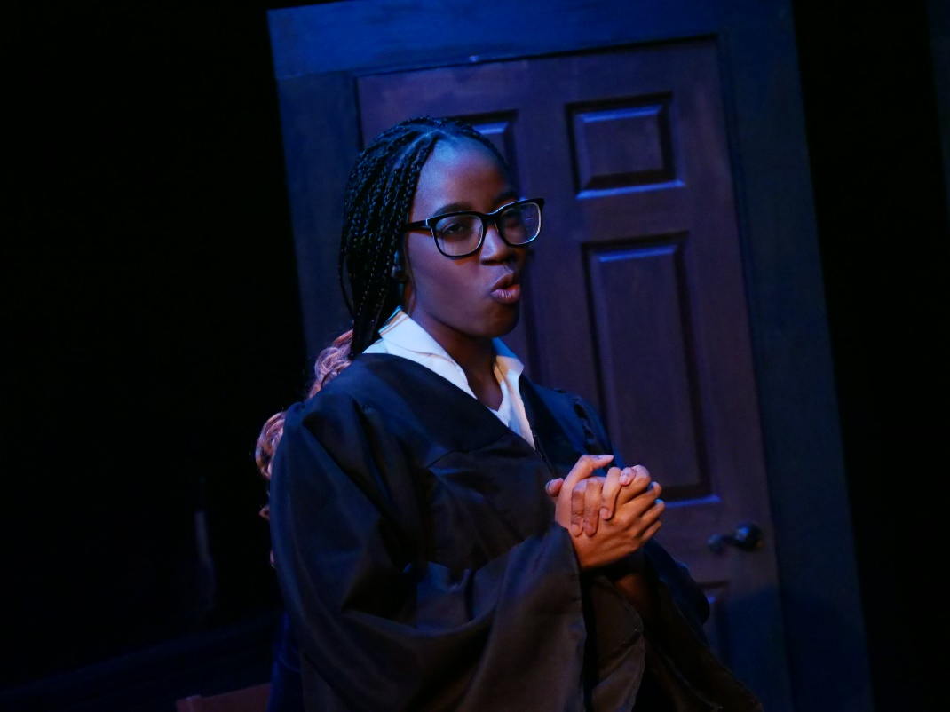
Bea, disguised as a councillor, defends Nick saying he is insane.
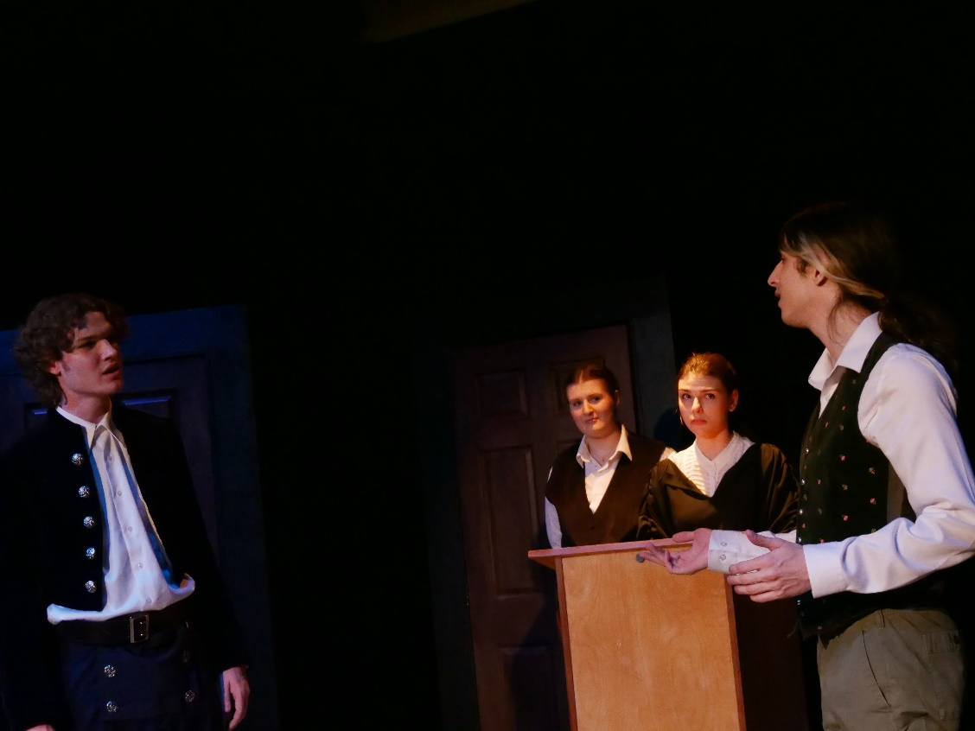
Nick admits what he did wrong and apologizes to Nigel.
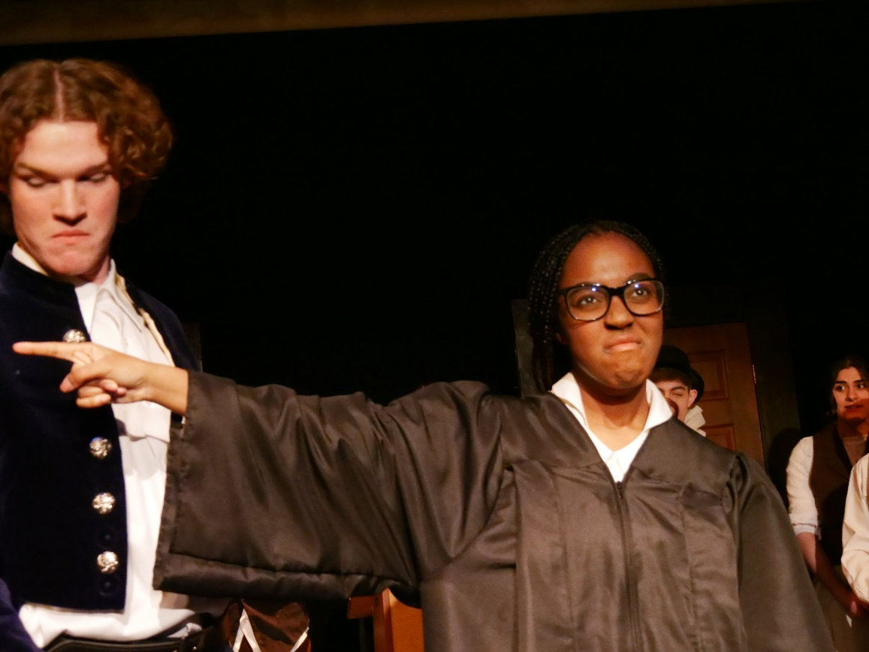
The court are still not convinced, and Bea bring Shakespear into the court.
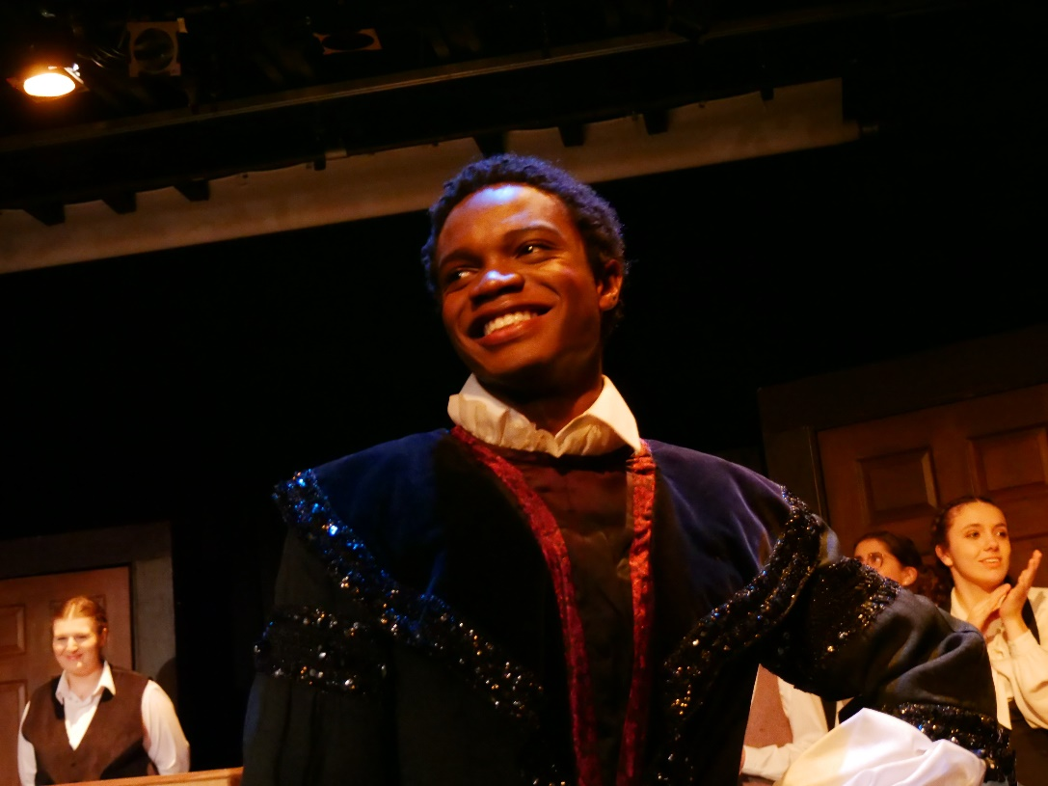
Shakespear convinces the court to banish Nick and Nigel to America to continue their musicals.
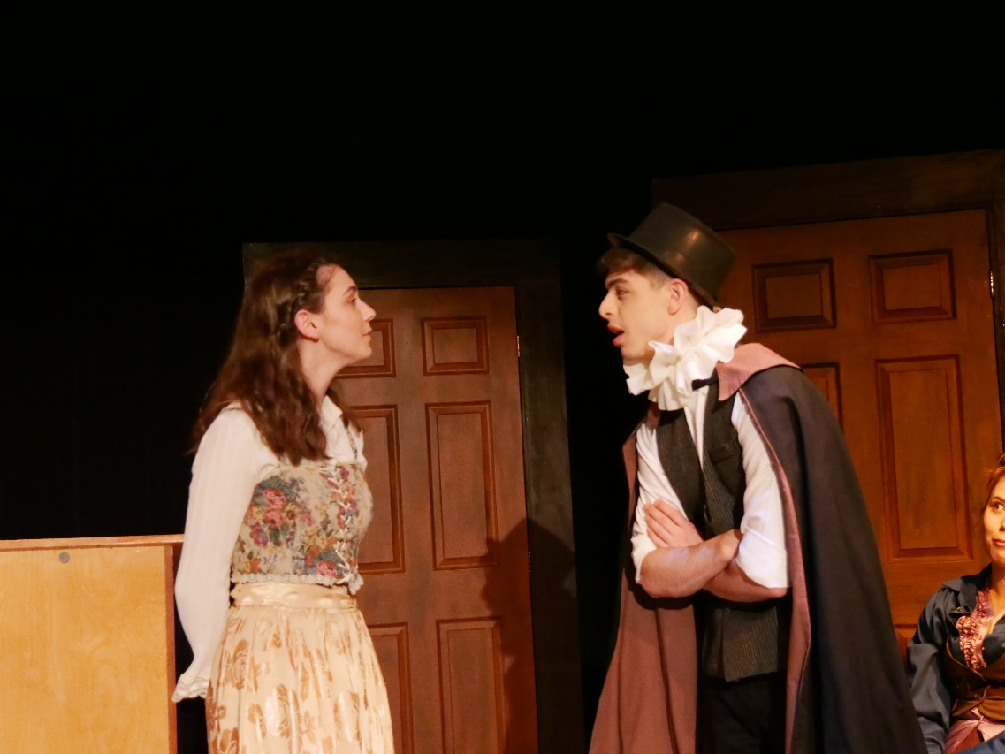
Portia joins Nigel to go to America.


Everybody is happy in America.

