The Muscle Health Research Centre at York University presents the
12th Annual Muscle Health Awareness Day (MHAD12)

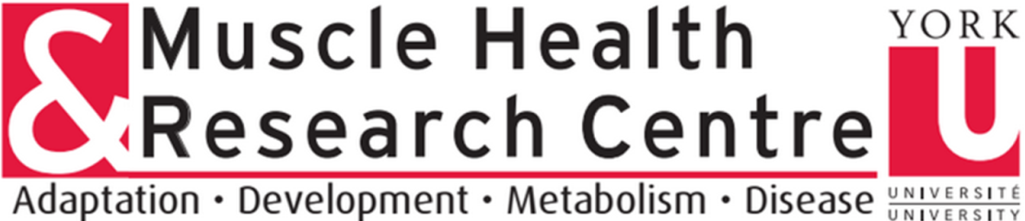

Please fill out the form below. Once completed, save the file, and then email the completed form as an attachment to mhrc@yorku.ca to register for and/or submit an abstract for MHAD12. You will receive an email confirmation from the MHRC Coordinator confirming your successful registration and/or abstract submission.

Please fill out all of the following fields contained within this box (Required):
Last Name: Chen First Name: Chris
University: York Supervisor: Dr. David Hood
Current Degree Program (click the appropriate box):
Undergraduate ☐ Master’s Degree ☒ Doctoral Degree ☐
Post-doctoral fellow ☐ Other ☐ (please specify) Click here to enter text.
Email Address: dhood@yorku.ca
Are you submitting an abstract for this publication in MHAD Proceedings? Yes ☒ No ☐

Would you like this Abstract to be considered for an Abstract Award and Presentation via Zoom? Yes ☒ No ☐

Please fill out the fields below to submit an abstract and follow the formatting instructions beside the text box. Use Times New Roman text, 12 pt font, and lower case text except for the title. A sample for formatting is provided here.
The information you include below will be included in the official proceedings of MHAD11.

Abstract Title (all CAPS): PARKIN MEDIATED MITOPHAGY IN SKELETAL MUSCLE WITH ENDURANCE TRAINING
Authors (Bold): Chris C.W. Chen and David A. Hood
Author Affiliations: Muscle Health Research Centre, School of Kinesiology and Health Science, York University, Toronto, Canada, M3J 1P3
Abstract text (no figures, no Bold): Skeletal muscle is a highly adaptive tissue that is responsive to environmental cues. With exercise training, intracellular signaling pathways are activated that promote the synthesis of mitochondria, a process termed biogenesis. The increased number of mitochondria allows for efficient substrate utilization and greater muscle endurance. However, little is known regarding mitochondrial turnover with training. Mitophagy is a process involved in the specific elimination of dysfunctional mitochondria. It is unclear if mitophagy undergoes adaptive responses in muscle with training. Parkin is a ubiquitin ligase involved in neuronal mitophagy but its role in muscle remains inconclusive. To investigate Parkin’s role in muscle with exercise training, we subjected 3-month-old wild-type (WT) and Parkin knock out (KO) mice to a 6-week voluntary wheel running training paradigm. Overall, WT mice ran 28% longer than KO mice in average total running distance. Endurance training elicited 1.5- and 1.4-fold increases in whole muscle mitochondrial content in WT and KO mice, respectively. Furthermore, subunits I and IV of cytochrome c oxidase and mitochondrial transcription factor A were augmented on intermyofibrillar mitochondria (IMF) isolated from hindlimb muscles of trained WT animals. This was supported by a 1.7-fold increase in State 3 (active) IMF respiration in trained WT mice. Following 6 weeks of training, both Parkin KO and WT mice exhibited 2-fold increases in running performance during an exhaustive bout of exercise, compared to their untrained counterparts. Interestingly, basal mitophagy flux and mitochondrial localization of LC3II were augmented by 1.5-fold in muscle of trained WT mice. However, this increase was abolished in KO animals. However, during exercise-induced mitophagy, an attenuation of autophagy proteins localized on mitochondria occurs, which is partly Parkin-mediated. With training, exercise-induced mitophagic signaling is reduced, likely due to enhanced mitochondrial biogenesis, leading to improved endurance. Supported by NSERC.

