

**Summer Language Program 2019  
Handbook**

**for Students from**

**Ontario**

**Prepared by the Ontario Program Office**

**Rosanna Furgiuele**

**ORA Academic Director**

Updated April 2019

**www.ora.ouinternational.ca**

***This handbook is to assist you, the participants, from the time your host university in Rhône-Alpes has officially admitted you until you return to Canada. I sincerely hope it will help you settle down in France.***

***I would also like to thank all the persons who have contributed to making this handbook possible:***

***Ministry of Training, Colleges and Universities***

***Agnes Poleszczuk, Program Manager***

***Dagmar Todd, Program Administrator***

***Consul Général de France à Toronto***

***Attachée culturel, Consul Générale de France à Toronto***

***Peggy Harvey, Chargée de coopération universitaire et correspondante***

***CampusFrance, General Consulate of France in Toronto***

***Elisabeth Verger, Emmanuelle Lop et Clotilde Peschet, Université Lumière, Lyon 2***

***International Offices in Rhône-Alpes universities***

***Present and Past Participants***

***PLEASE NOTE: By mentioning particular commercial companies, the Program Office is in no way endorsing them.***

***\*\*\*\*\*\*\*\*\*\*\*\*\*\*\*\*\*\*\*\*\*\*\*\*\*\*\*\*\*\*\*\*\*\*\*\*\*\*\*\*\*\*\*\*\*\*\*\*\*\*\*\*\*\*\*\*\*\*\*\*\*\*\*\*\*\*\*\*\*\*\*\*\*\*\****

**TABLE OF CONTENTS**

# 

1. INTRODUCTION 4

2. TRAVEL ARRANGEMENTS 5

3. ADMINISTRATIVE FORMALITIES 6

4. EXPENSES 6

5. ACCOMMODATION 7

6. HEALTH INSURANCE 9

7. IMPORTANT DOCUMENTS TO TAKE WITH YOU 10

8. ACADEMICS 10

9. COMMUNICATIONS 11

10. TAXES 12

11. ADVICE AND SUPPORT 12

12. SHOPPING 13

ADVICE AND INFORMATION FROM CURRENT STUDENTS 13

APPENDIX A: COMMONLY USED ACRONYMS AND VOCABULARY (in alphabetical order) 14

APPENDIX B: THE RHÔNE-ALPES REGION 15

« RELATIONS INTERNATIONALES » ET CONTACTS ORA 16

# 1. INTRODUCTION

Congratulations! You have been chosen to par­ti­ci­pate in the Summer Language Program, one of the programs offered by the Ontario/Rhône-Alpes (ORA) Univer­sity Student Ex­change Program, collaborative ini­tia­tive of univer­sities in Rhône-Alpes and the Ontario Ministry of Training, Colleges and Uni­ver­sities. The Summer Language Program is a per­sonal opportunity for you to pur­sue your studies at one of the par­ticipating language schools in uni­versities in Rhône-Alpes while re­maining a degree can­didate at your home uni­versity in Ontario, and to grow from the experience of living in a foreign culture.

The handbook gives you information that will help you make the most of your month in Rhône-Alpes. You should also consult the website of your host university for further information and practical advice regarding your time in Rhône-Alpes.

**Be alert to this sym­bol: It signals key infor­mation worth noting and knowing!**

This Handbook focuses on **generic** rather than **specific** issues.

The information is based on the experience of the Program Office, official and unofficial sources, and the advice of former participants, to whom we are especially indebted.

The **Ontario Program Office**, housed at York University, is there to help you and to answer any questions you may have now and during your stay in Rhône-Alpes.



#### Contact Information

Ontario Program Office

Ontario/Rhône-Alpes Student Exchange

270 K&L York Lanes

York University 4700 Keele Street Toronto ON M3J 1P3

Fax: 416-736-5709

Website: <http://ora.ouinternational.ca/>

|  |  |  |
| --- | --- | --- |
| Rosanna Furgiuele Academic Director  [rfurgiuele@ouinternational.ca](mailto:rfurgiuele@ouinternational.ca) 416 532-5492  437 776 9899 (cell) | Agnes Poleszczuk Program Manager  [apoleszczuk@ouinternational.ca](mailto:apoleszczuk@ouinternational.ca) 416-736-2100 ext. 40006 | Dagmar Todd  Program Administrator [dtodd@ouinternational.ca](mailto:%20dtodd@ouinternational.ca) 416-736-2100 ext. 22919 |

**Expectations and Responsibilities**

The Program Office will do all it can to assist you. In the interests of avoiding misunderstandings, please be aware of, and hold to, the fol­­lowing list of expectations and responsi­bilities:

1. You are responsible for keeping the Program Office and the International Office in Ontario informed of your address, telephone number, and e-mail address during your stay abroad.
2. You are responsible for **all aspects** of your participation in the Program, including, but not limited to, your health, safety, travel plans, legal status and financial obligations. The Ontario Program Office, your home and host universities, and their representatives and agents assume no financial or other liability arising from or related to your participation in the Program.
3. You are responsible for submitting a final report on your participation in the Program to the Program Office by the end of August, and for responding to requests for infor­mation from the Program Office during the year.
4. Credit for work done abroad is granted at the discretion of your **home university**. You are responsible for documenting work done abroad, and for applying to your home university for credit you wish to receive.
5. After you return home we hope that you will stay in contact with us. We hope too that you will want to act as a mentor for Ontario students coming to your home university and an ambassador for the Program.

# 2. TRAVEL ARRANGEMENTS

You are responsible for making your own travel arrangements to France. The nearest international airport for all establishments in the Rhône-Alpes region is Aéroport Saint-Exupéry-Satolas in Lyon [http://www.lyon.aeroport.fr/](http://www.lyon.aeroport.fr/%20%20). Inquire about the shuttle bus services and train from Saint-Exupéry to Grenoble and Saint-Étienne.

You may find flight from Canada to Lyon through London (UK) or Frankfurt or Amsterdam with a connecting flight to Lyon. It is also possible to route through Paris and either fly to Lyon or take the high-speed TGV train (for which you must reserve a seat) to both cities. It is 2 hours to Lyon, and 3 hours to Grenoble or Saint-Étienne. Check <http://www.voyages-sncf.com/leisure/fr/launch/home/>

Travel CUTS **http://www.travelcuts.ca/en/images/Splash-pg/TravelCUTS-Logo.jpg**

[www.travelcuts.com](http://www.travelcuts.com) offers open return tickets and various insurance plans to Europe for students. They have offices in most Ontario universities. You should make sure in booking that you specify your student status and naturally the earlier you are able to make your booking the more choice you will have.

Also, there are many charter companies such as Air Transat [www.airtransat.com](http://www.airtransat.com), etc.

Look for seat sales with Air Canada.



Excess baggage fees can be quite high.

If you plan to take luggage beyond your official allowance, check with the airline to find out its policy and rates on accompanied excess baggage as freight.

Also make sure you know the carry-on luggage latest rules.

Try to take only what you REALLY need. As it is you might accumulate stuff while in France. Shipping stuff back to Canada is expensive.

We recommend you have an **International Student Identity Card (ISIC).** It may be free for you depending on your university/faculty. It offers discounts abroad and in Canada. It can be bought at Travel CUTS. Also check with International Office at your home university. <http://www.travelcuts.com/isic>



ISIC is also a student travel services

confederation. Check

<http://www.isic.org/>

The Federal government has published a few booklets for Canadians travelling and/or living abroad.

The [**Bon Voyage, But...**](http://travel.gc.ca/docs/publications/bvb-eng.pdf)**, essential information for Canadian travelers** published by the [Consular Affairs Bureau](http://www.voyage.gc.ca/) of Foreign Affairs and International Trade Canada, is available online. It is an important publication, which encourages Canadians to educate themselves to travel the world responsibly.

This pocket-sized booklet offers essential guidelines and provides vital information on consular services and Canadian government offices worldwide.

This and other smart-travel publications, such as [Her Own Way](http://travel.gc.ca/docs/publications/her_own_way-en.pdf), Dual Citizenship and [Traveller’s Checklist](http://travel.gc.ca/docs/publications/ch_traveller-en.pdf) can also be downloaded at [**www.voyage.gc.ca**](http://www.voyage.gc.ca/)**.** Copies may be ordered, free of charge, online or by contacting the department’s Enquiries Service by e-mail at [enqserv@international.gc.ca](mailto:enqserv@international.gc.ca). We hope that you will find these publications useful. They also have country specific Travel Reports. For France <http://www.voyage.gc.ca/countries_pays/report_rapport-eng.asp?id=92000>.

# 3. ADMINISTRATIVE FORMALITIES



**Student Visas**

For a short stay (less than 90 days), you do not need a visa. This is most likely your case.

However, for a long stay (more than 90 days) you require a visa.

The French Embassy in Canada outsourced the collection of visa applications to **VFS Global.** VFS has offices in four Canadian cities including Toronto and Ottawa. VFS Global’s call centre: **+1 613 927 92 66** and online services: [Info.FranceCanada@vfsglobal.com](mailto:Info.FranceCanada@vfsglobal.com)),

**To apply for a student visa,** visit the official website **France-Visas** (<https://france-visas.gouv.fr/en>) You apply as a student trainee.

Fill in your visa application on-line (your visa application form will be automatically filled in and available for printing). Make an appointment. A service fee will be charged and will be payable online when making an appointment. You have to bring a completed printed visa application form to the appointment as well as **all the supporting documents (including** a letter of admission and the Internship Agreement.)

The **VFS Global Centre in Toronto** is located at **208 Bloor St. West, 4th floor, Toronto, Ontario, M5S 3B4**

The total length of the review process is about 30 business days. The applicant’s passport **must** remain with the application file during the entire process.

# 4. EXPENSES

Your expenses may vary depending on your plans, your personal needs and interests, where you live, how much you travel, etc.

During the month you will be spending in St. Etienne or Grenoble, your expenses will include course fee, accommodation, food, transportation, entertainment, and personal expenses and travels.

Substantial student discounts are available for many athletic events, cultural attractions, shows, transportation,

etc.

Scholarships

The **ORA** scholarships are funded by the Ontario Ministry of Training, Colleges and Universities (MTCU). The scholarship amount for participating in the Summer Language Program is $1000. **International students are not eligible to apply for the ORA scholarship**.

The procedure for you to receive the scholarships is as follows:

1. We will send you a *Scholarship Agreement* by email that you must fill out, sign and return to us by post.
2. If you are eligible for an ORA scholarship we will send a cheque to the postal address you will provide *(Please Note: It’s impossible to deposit a Canadian cheque into a French account so please provide a Canadian postal address, and have someone in Canada deposit the cheque into your Canadian account*).
3. On the scholarship agreement form, we will ask you to provide us with your Social Insurance Number. As the scholarship granting institution, we are required by Canada Revenue Agency (CRA) to submit the SIN numbers of all scholarship recipients. York University’s financial office will process the scholarship cheques on our behalf and as such they need to issue the T4A forms for tax purposes. We will not be able to process the scholarship cheques without your SIN numbers.
4. You will receive the scholarship AFTER you have finished the language course.

Check with your Home University for any travel scholarships for which you may be eligible. If these exist, they may be administered by the international/exchange office, by your department, by your home faculty, or by a central office such as Financial Aid.

# 5. ACCOMMODATION

You have already made a preliminary choice in your application as to your preference of accommodation.

Once you have been placed either at St. Etienne or Grenoble, the school will receive a copy of your application including your choice of accommodation. Based on this, they will confirm the arrangements.

**SHORT STAY ACCOMMODATION**

In the event that you decide to visit other parts of Rhône-Alpes before or after the Summer course, these are some addresses.

**Lyon**

• Auberge de Jeunesse du Vieux Lyon

41-45 Montée du Chemin Neuf 69005 Lyon - 04 78 15 05 50

<http://www.fuaj.org>

Métro Ligne D, arrêt Vieux Lyon

• Auberge de Jeunesse de Vénissieux

51 rue Roger Salengro 69200 Vénissieux - 04 78 76 39 23

<http://www.fra.cityvox.fr/hotels_lyon/auberge-de-jeunesse-de-venissieux_18525/Profil-Lieu>

Bus 36, arrêt Auberge de jeunesse.

• Le Totem

90 cours Tolstoï 69605 Villeurbanne - 04 72 65 19 19

Métro Ligne A, arrêt Gratte-ciel puis Bus 69 direction Sans Souci, arrêt Verlaine

• Chambres d’hôtes

04 72 13 99 35 [www.chambreslyon.com](http://www.chambreslyon.com)

Centre International de Séjour de Lyon **:**

103 boulevard des États-Unis - 69008 Lyon

33 (0) 4 37 90 42 42

<http://www.cis-lyon.com/>

Autres adresses utiles pour trouver un logement à Lyon :

• L’Office de tourisme

http://www.lyon-france.com

Place Bellecour 69002 Lyon - 04 72 77 69 69

• Le site des étudiants lyonnais (infos sur le logement et la vie pratique)

<http://www.lyoncampus.org/S-installer_r32.html>

• le site des étudiants de Lyon 2

<http://etu.univ-lyon2.fr/>

It has lots of ads “For rent”

Le Petit Paumé

<http://www.petitpaume.com/>

Then click on Lyon Pratique

**Saint-Étienne**

<http://www.fjtclairvivre.com>

[www.resibelle.fr](http://www.resibelle.fr)

**Grenoble**

Le service hébergement passager et accueil de groupes est **rattaché au Pôle Logement**.  
Ce service accueille, dans la limite des places laissées vacantes par les étudiants de l'académie, les étudiants venant à Grenoble, pour effectuer un stage dans le cadre de leur cursus universitaire ou pour se présenter à un examen ou un concours ou pour tout autre motif lié à leur parcours universitaire.

La demande doit être faite par courrier mentionnant les dates d’hébergement souhaitées accompagnée de la copie de la carte d’étudiant et de la convention de stage ou du justificatif de la présence à Grenoble.

Mail service des boursesLa demande peut être adressée par mail, en joignant la totalité des documents demandés, à l'adresse suivante: [passager@crous-grenoble.fr](mailto:passager@crous-grenoble.fr)

Elle peut également être adressée **par fax** au: 04.56.52.88.03 ou par courrier postal à l'adresse suivante:

CROUS - Pôle logement - Hébergement passager

351 allée Hector Berlioz

38402 ST MARTIN D'HERES

**Tél.:**04 56 52 88 43

Grenoble Universités website has a lot of information. Grenobles Universités include Université de Savoie.

<http://etu.univ-grenoble-alpes.fr/>

**General**

**Youth Hostels *Auberges de jeunesse***

1. **National Office** **Administration and Booking**   
   27 rue Pajol   
   75018 Paris  
   phone: +33-1 44 89 87 27fax : +33-1 44 89 87 49  
   E-mail: [fuaj@fuaj.org](mailto:fuaj@fuaj.org)  
   <http://www.fuaj.org/>
2. **In Rhône-Alpes**  Auberge de Jeunesse  
   10 Avenue du Gresivaudan  
   38130 Echirolles  
   phone :chrome://skype_ff_toolbar_win/content/space.gifchrome://skype_ff_toolbar_win/content/space.gif+33-4 76 09 33 52chrome://skype_ff_toolbar_win/content/cb_transparent_r.gif - fax : +33-4 76 09 38 99   
   E-mail: [grenoble@fuaj.org](mailto:grenoble@fuaj.org)

To stay in a Youth Hostel in France, you'll need a membership card, which you can obtain from the National Association of your home country.

Please check the International Youth Hostel website for prices: <http://www.hihostels.com>.

In Canada, in Ottawa

### Hostelling International - Canada

205 Catherine Street, Suite 400 Ottawa Ontario K2P 1C3

Tel.: (1) (613) 237 7884; Fax: (1) (613) 237-7868 E-mail: [info@hihostels.ca](mailto:info@hihostels.ca)

[www.hihostels.ca](http://www.hihostels.ca)

1. Studélites en Rhône-Alpes

<http://www.studelites.com/fr/logement-etudiant-residence-etudiante-courts-sejours.cfm>

1. In most cities

<http://www.lamy-residences.fr/>

[www.residhotel.com](http://www.residhotel.com)

# 6. HEALTH INSURANCE

Health insurance is crucial.

In any case before you leave Canada, make sure you know exactly what coverage OHIP, (and / or your own insurance if applicable) includes and how you can be reimbursed.

And check what OHIP covers while abroad 

<http://www.health.gov.on.ca/english/public/pub/ohip/travel.html>

It is highly recommended that you cover yourself as much as possible. Take an extended health insurance for the period of your stay in France. You never know!!!

Besides OHIP and an Extended Care Insurance, it is recommended that you get an insurance that has liability coverage (*responsabilité civile*) to protect you from liability for accidental harm you may cause to others, as well as coverage for injuries and damages you may sustain as a result of an accident.

# 7. IMPORTANT DOCUMENTS TO TAKE WITH YOU

It is a good idea to make a check list well in advance of your departure to avoid a last minute panic. You should also make photocopies of all important documents and cards (i.e. credit cards, health cards etc.). Take one copy with you and leave another with a friend or family member for safe-keeping.

* Please note that many countries, including France, require a passport valid three months after the expiry date of the visa. **If you are eligible for a European passport, you should definitely apply; it will make some procedures easier**.

**Please carry with you**

* The letter of acceptance/admission from your host university, and the letter confirming your participation in the Program from the ORA Program Office.
* Medical prescription, eye-glass prescription (if required).

**STRONGLY RECOMMENDED**

* A Youth Hostel card <http://www.hihostels.ca/en/home.aspx> or a European Youth Hostels Card or any similar card if you intend on travelling
* An International Student Identity Card (ISIC), available from Travel CUTS. It’s useful for discounts in Europe
* A map of the city you will be going to

# 8. ACADEMICS

When you arrive in France at your assigned school, you will be given a placement test which will determine your level in that school.

You are expected to treat this summer course seriously as you are going to receive 12 ECTS, the equivalent of a full time course in Ontario.

The school in France will give you an official Transcript. It is your responsibility to ask for validation of these credits in your Home University. Do not forget to get a Letter of Permission from your Home University prior to your departure if your intention is to have the French credits validated towards your Ontario degree upon your return from France

# 9. COMMUNICATIONS

Phone numbers have 10 digits in France. The first two digits (01 to 05) represent the five divisions of the country. When calling France from another country don’t dial the zero.

01 Paris and surroundings

04 South East (where Rhône-Alpes is)

06 is for cell phones

Calling France from Canada: dial 011-33 + 9 digits. **No 0**. Same rule applies for fax numbers and cell phones.

Calling Canada from France: dial 001 + area code + number.

You can call Canada from a phone booth (*une cabine téléphonique*). Phone booths have their own number so you can ask to be called back. No extra charge.

You can buy phone cards (*une télécarte*). They are sold in tobacco shops (bureau de tabac), newsstands (maison de la presse).

**Cell phones**

You may decide that you need a cell phone while in France. Calls to and from cell phones are expensive, but you don’t pay anything when someone calls you. For a short stay, you may look into a plan with your provider in Ontario or you may buy a SIM card that you insert in your phone and pay as you go.

There are three major providers in France: SFR, Bouygues Télécom, Orange. Check their websites and compare!

**SFR** <http://www.sfr.fr/> 

**Orange** <http://www.orange.fr/> [orange.com](http://www.orange.com/default.asp)

**Bouygues Telecom** <http://www.bouyguestelecom.fr/> [http://www.bouyguestelecom.fr/client/homev2/imagesSite/logo-hub.gif](http://www.bouyguestelecom.fr/home.htm)

More and more students these days use ***skype*** to make phone calls. Taking your own laptop with you is an excellent idea.

[www.skype.com/intl/en/](http://www.skype.com/intl/en/) [Skype](http://www.skype.com/intl/en/)

# Free: <http://www.free.fr/adsl/index.html>

# 10. TAXES

**TVA** *(VAT)* There is only one tax called TVA (Taxe à la valeur ajoutée). It’s **included** in price tags (service in bars and restaurants is also included in the check).

**Tax Refund when you leave the EU (***détaxe***)**

If you stay less than 6 months you are entitled under certain conditions to get a tax refund on what you bought in the EU and are taking with you back home when you leave the EU.

Please check which conditions apply and how you can get your refund

<http://www.douane.gouv.fr/page.asp?id=49>.

It’s great but when you arrive in Canada you have to declare what you bring in the country… then you’d better check this website

<http://www.cbsa-asfc.gc.ca/travel-voyage/declare-eng.html>.

# 11. ADVICE AND SUPPORT

Each participating Summer Program university has an office. A list of the contact people we have identified is attached for your information. You should be able to get details on procedure, living arrangements and other aspects of academic life at these offices.

If you are interested in “what to do in Rhône-Alpes”, we leave it to you to discover what the region has to offer by checking the following websites.

<http://www.culture.fr/> and then choose Rhône-Alpes

<http://www.culture.fr/fr/sections/regions/rhone_alpes>

There are great museums (the most recent La Cité du design in Saint-Étienne must not be missed <http://www.citedudesign.com>, great ski resorts, theatres, festivals, small old villages, vineyards.

# 12. SHOPPING

There are *hypermarchés* which are very large supermarkets.

Here is a short list of the cheapest store

- Carrefour <http://www.carrefour.fr/>. It has everything food included. It is similar to Wal-Mart.

- For food Ed is one of the cheapest <http://www.dia.fr/>.

- Les supermarchés et hypermarchés Leclerc are also a good deal

<http://www.e-leclerc.com>

- Champion supermarkets <http://www.carrefour.fr/>

- The hard discounter Lidl [www.lidl.fr](http://www.lidl.fr/cps/rde/xchg/lidl_fr/hs.xsl/index.htm)

- For food: les marchés (*open air markets)* et les Halles (*indoor markets)*. Don’t miss them!

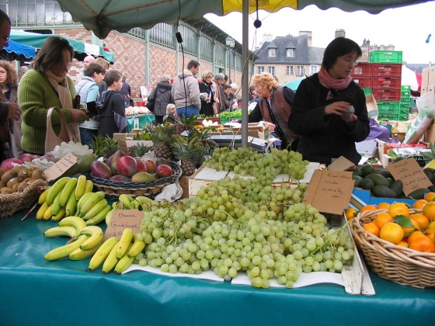

# ADVICE AND INFORMATION FROM CURRENT STUDENTS

Ontario students who have studied in Rhône-Alpes universities have written pages of information and advice for you. Read them carefully. They have done ***A WONDERFUL JOB.*** Their input is invaluable. You will find these reports on the ORA website at the following address

<http://ora.ouinternational.ca/ontario-alumni-reports>.

Also, you are encouraged to accept to join the ORA facebook page. You will be able to communicate with current and past ORA students.

For the most part the success of your stay in Rhône-Alpes will largely depend on your attitude and actions. If you are trying to perfect your French then avoid the habit of speaking English at every opportunity. Try to train yourself to speak French from the first day - even with your fellow Anglophone exchange students. This will become easier with practice.

**HAVE AN INCREDIBLE SUMMER!**

# APPENDIX A: COMMONLY USED ACRONYMS AND VOCABULARY (in alphabetical order)

* **ADSL or haut débit** *(high speed Internet)*
* **Restau U** sometimes **RU** restaurant univer-sitaire
* **HT: Hors taxes** *(before taxes)* **and TTC Toutes taxes comprises** *(taxes included)*
* **QCM: Questions à choix multiple** (*multiple choice*)
* **SNC:** Service non compris (*gratuities not included*)
* **SNCF:** French Railway Corporation. Check <http://www.voyages-sncf.com/> 

And [https://www.raileurope.ca/](http://www.europrail.net/)

* **TER:** Train Express Régional *regional trains* run by SNCF

<http://www.ter-sncf.com/rhone_alpes/index.asp>

Within Rhône-Alpes you will take TER, i.e. to go from Chambéry to Lyon

** **

* **TGV:** Train à Grande Vitesse (*fast train).* You need a reservation <http://www.tgv.com/>
* iDTGV gets you the cheapest tickets as long as you book early and depending on which days of the week you will be traveling

<http://www.idtgv.com/fr/>

* Eurostar (to London); Thalys (to Brussels); Lyria (to Switzerland); etc.

**Transports urbains (***Transit system***):**

**TCL, in Lyon** [www.tcl.fr](http://www.tcl.fr); in Grenoble **SEMTAG** [www.semitag.com](http://www.semitag.com);

in Chambéry **la STAC** <http://www.bus-stac.fr/>;

in Annecy la **SIBRA** <http://www.sibra.fr/site/index.htm>;

in Saint-Étienne **la STAS** <http://www.reseau-stas.fr/>

**TVA:** stands for Taxe à la valeur ajoutée (*VAT* *value added tax*). In France it’s always included in quoted prices. Check this website to find out TVA rates in EU

**EC**: Eurpean Comision <http://ec.europa.eu/>

**UE:** Union Européenne

**ECTS:** European Credit Transfer System (*credits*)

**FLE**: Français Langue étrangère

**EVERYDAY VOCABULARY (In alphabetical order)**

**Un acompte** or **des arrhes:** a deposit

**Une assurance:** insurance

**Assurance maladie:** Health Insurance

**Une assurance responsabilité civile:** liability insurance

**Une attestation:** proof

**Une caution:** security deposit

**La cité** or **résidence universitaire:** student residence

**Composter votre titre de transport:** validate your bus, streetcar, subway, train ticket yourself.

**Coordonnées:** contacts

**Un département:** a division of the region (*see Appendix B*)

**État civil:** personal information

**Un exposé:** an in-class presentation

**Une location:** rental **; un loyer:** rent

**Un médecin traitant:** your GP

**Une mutuelle:** extended insurance

**Un particulier:** an individual

**Un portable:** cell phone

**Un pourboire:** a tip. It’s included in restaurant bills.

**La Préfecture:** *Département* administrative building

**Un récépissé:** areceipt

**Les Transports:** **train** (train), **métro** (subway), **tramway** (streetcar), **autobus** (bus).

# APPENDIX B: THE RHÔNE-ALPES REGION

1. **The region**

France is divided in regions. Rhône-Alpes is a region and its capital city is Lyon. Each region is divided in *départements* (French administrative divisions). They each have a number according to their alphabetical order. Departments are often referred to by their numbers, the way we refer to our own neighbourhood by using the phone area code. The French say, “j’habite dans le 69” the same as we say, “I live in the 905 area”. In Rhône-Alpes (RA) there are 8 departments as follows:

(01) Ain: capital city: Bourg-en-Bresse; has branches of Lyon 1 and Lyon 3 Universities.

(07) Ardèche: capital city Privas; no university

(26) Drôme: capital city Valence; has branches of all 3 Grenoble Universities

(38) Isère: capital city Grenoble

<http://www.grenoble.fr>

(42) Loire: capital city Saint-Étienne

<http://www.saint-etienne.fr/>; there is a branch of l’Université Jean Monnet in Roanne in the same department

(69) Rhône: capital city Lyon

<http://www.lyoncampus.info/>

(73) Savoie: capital city Chambéry

[http://www.chambery.fr/](http://www.mairie-chambery.fr/)

(74) Haute-Savoie: capital city Annecy; has a branch of l’Université de Savoie

<http://www.annecy.fr/>

1. **Postal addresses/Postal codes**

These above mentioned department numbers are used as first two digits for Postal codes, which have 5 digits in total. For example: ***38 000 Grenoble***, or ***69003 Lyon***. Postal code is placed in front of city name on envelopes. In Lyon the last digit indicates the *arrondissement*. Lyon is divided into 9 *arrondissements* (wards). (See List of Contacts for university postal addresses).

**EUROPEAN UNION:** 27 countries

Austria, Belgium, Bulgaria, Cyprus, Czech Republic, Denmark, Estonia, Finland, France, Germany, Greece, Hungary, Ireland, Italy, Latvia, Lithuania, Luxembourg, Malta, Netherlands, Poland, Portugal, Romania, Slovakia, Slovenia, Spain, Sweden, United Kingdom. <http://europa.eu/>



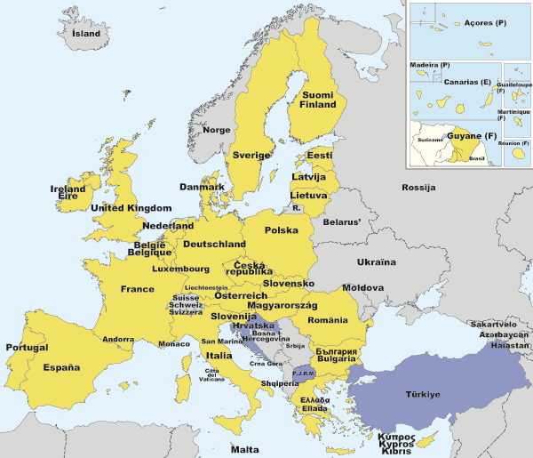

**SCHENGEN SPACE**

Check <http://www.schengenvisa.cc/apply.html>.

If you hold a Canadian passport you are exempted from a visa for the Schengen States for 90 days in a 6 month period.

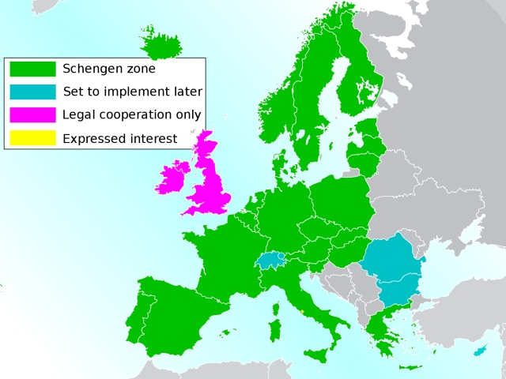

# PROGRAMMES ET CONTACTS ORA

|  |  |  |  |
| --- | --- | --- | --- |
| **ETABLISSEMENT** | **NOMS DES CONTACTS ORA** | **TÉLÉPHONE, FAX** | **E-MAIL** |
| **Université Jean Monnet Saint-Étienne**  **CILEC** (Centre international de langue et civilisation) | Christelle SERAFINI | **Tel:** 33 4 77 42 13 73  33 4 77 42 16 46  **Fax:** 33 4 77 73 79 71 | [christelle.serafini@univ-st-etienne.fr](mailto:christelle.serafini@univ-st-etienne.fr) |
| **Université Grenoble Alpes**  **CUEF** (Centre universitaire d'études françaises) | Rose-Marie SARAIVA | **Tel:** 33 4 76 82 41 69 **Fax:** 33 4 76 82 41 74 | [rose-marie.saraiva@u-grenoble3.fr](mailto:rose-marie.saraiva@u-grenoble3.fr) |

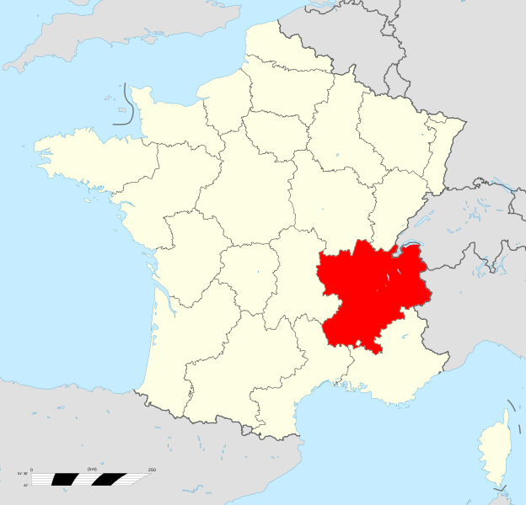

***Angleterre Mer du Nord***

***Belgique***

***Manche***

***Allemagne***

***Luxem-***

***bourg***

***Paris***

***Suisse***

***Rhône-Alpes***

***Océan Atlantique***

***Italie***

***Espagne Mer Méditerranée***

***Andorre***