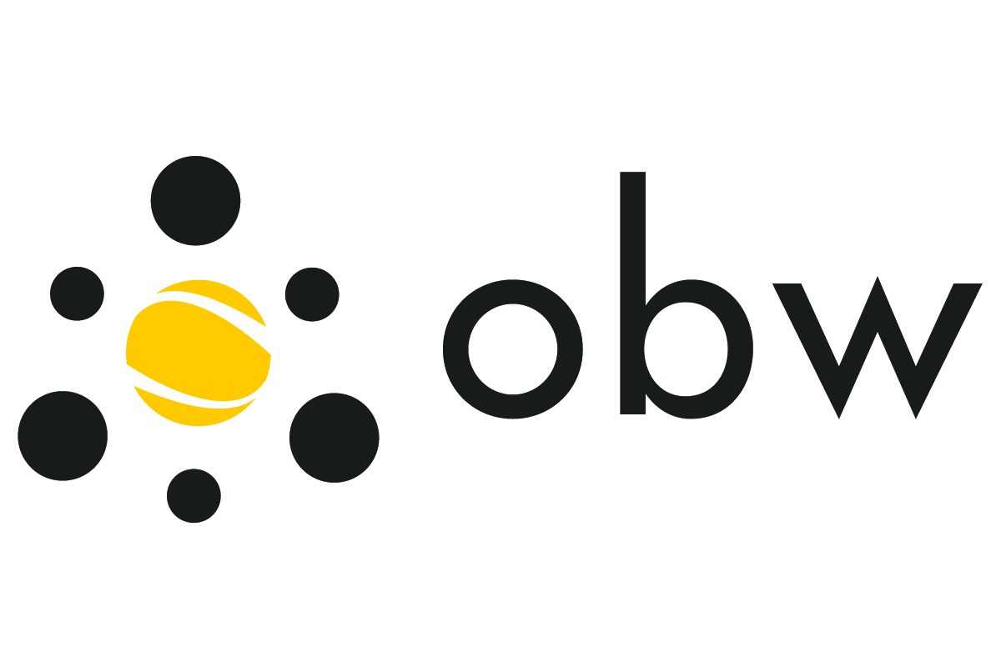 | Ontario/Baden-Württemberg Exchange Program  Faculty Research Exchange 2023−2024  Award Holder Agreement
Personal Information
Family name, given names _________________________________________________________________
Permanent address _________________________________________________________________
Social Insurance Number ______________________ Date of birth __________________________
Declaration
I will participate in the OBW Faculty Research Exchange from __________________ until __________________ (dd/mm/yyyy). During this time I undertake to carry out the research program described in my application to the Program and to meet the additional Faculty Research Exchange requirements stated on the OBW website with regard a) to the public presentation of my work at the host university in Baden-Württemberg, and b) to the submission of a report to the OBW Program on completion of the period of my participation.
I consent to the publication on the OBW website of my name, home university, host university, and a link to my webpage at my home university, as well as of the brief description of my research project, which I submitted as part of the application process.
I understand that the OBW award will be paid monthly by direct deposit to my Canadian bank account in the form of a tax-free allowance of $1,750 per month related to my stay in Germany. I certify that:
- my duties associated with the OBW Faculty Research Exchange require me to be away from my principal place of residence;
- I have to work at a special work site where the duties performed are of a temporary nature;
- I am keeping, at another location, a self-contained domestic establishment as my principal place of residence,
  - which throughout the period of my participation is available for my occupancy, and which I am not renting it to any other person; and
  - to which, because of distance, I cannot reasonably be expected to return daily from the special work site; and
- the allowance for board and lodging is for a period of at least 36 hours.
I understand that my one-time round-trip travel costs between Ontario and Baden-Württemberg will be reimbursed, separately from the monthly allowance, up to a maximum amount of $1,750 upon submission of original receipts (including original boarding passes) and of my OBW Faculty Research Exchange report following my return to Canada. York University travel policies will apply in determining eligible expenses; see: www.yorku.ca/univsec/policies/document.php?document=60 .
___________________________________ _____________________________________________
Signature Place, date
Please return a scan of a) this form, completed and signed, b) the completed “Application for Vendor Direct Deposit form (available on the OBW website), and c) a scan of a void personal cheque showing your Canadian banking information (required by York University for the purpose of direct deposit) to Ms. Agnes Poleszczuk at apoleszczuk@ouinternational.ca.
Please then also return (by IUTS or mail) the completed and signed original of this form to:
OBW Exchange Program, 270K York Lanes, York University, 4700 Keele Street, Toronto, ON M3J 1P3

