Symposium Location: Osgoode Hall Law School, 1014 Ignat Kaneff Building.

Accommodation: We have reserved rooms for conference participants who require accommodation at the Executive Learning Center (ELC), Schulich School of Business. We have secured a special symposium rate at the ELC and in order to get this rate could you please use the following confirmation number: "Sudan/South Sudan Symposium, block number 4993256". The reception desk is open 24 hours.

This is located on-campus at York University. Please find below the maps of buildings.
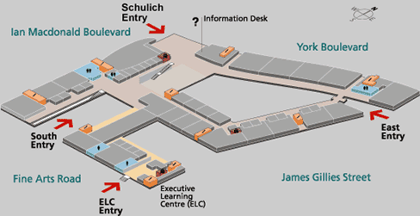


Executive Learning Centre

Schulich School of Business
York University
4700 Keele Street
Toronto, Ontario
CANADA M3J 1P3

On Campus Address
56 Fine Arts Road

Phone
(416) 650 8300

Fax
(416) 650 8333

E-mail
elc@schulich.yorku.ca

Website
http://www.schulich.yorku.ca/SSB-Extra/elc.nsf
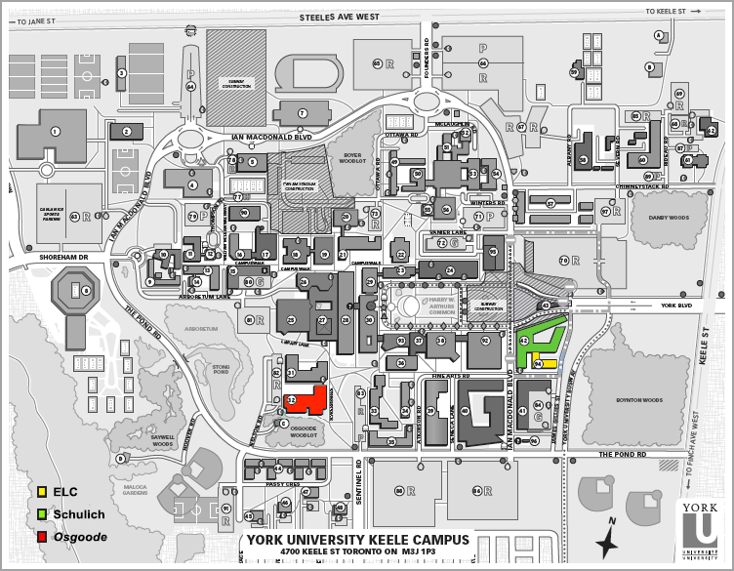

Directions to York University and the Executive Learning Centre

From Toronto Pearson International Airport  Exit the Airport and take Hwy 409 north, proceed to Hwy 401 east. Travel east on Hwy 401 to Hwy 400 north. Take Hwy 400 north to Steeles Avenue. Exit onto Steeles Avenue east. Follow Steeles Avenue east to Keele Street. At Keele Street turn right going south, the campus is located on the right. Turn right onto the campus via The Pond Road entrance, the second stop light after Steeles. Take The Pond Road to James Gillies Street, the Student Services Parking Garage will be visible on the left. The Executive Learning Centre (ELC) is next door to the Student Services Parking Garage, on Fine Arts Road, adjacent to the Schulich School of Business. | 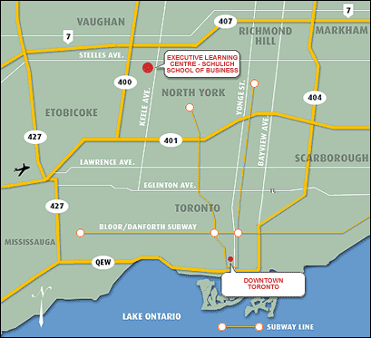

From Downtown Toronto
Take the Allen Expressway north to Finch Avenue. Turn left, going west on Finch Avenue to Keele Street. Turn right onto Keele Street going north to The Pond Road entrance. Turn left onto the campus via The Pond Road entrance. Take The Pond Road to James Gillies Street, the Student Services Parking Garage will be visible on the left. The Executive Learning Centre (ELC) is next door to the Student Services Parking Garage, on Fine Arts Road, adjacent to the Schulich School of Business.

Public Transit
Several buses are routed to the campus or have express services to York University from the Toronto Transit Commission (TTC) Subway. Here are a few common ones:
- From TTC Downsview Station on the Yonge University Line – Take 196 York U Rocket Bus.
- From TTC Finch Subway Station on the Yonge Line – Take the 60C or 60F Bus.
- From TTC Jane Station on the Bloor Line – Take the 35E Bus.

For participants arranging alternative accommodations, below is a list of other hotels:

Near York University Campus
Holiday Inn Express North York
30 Norfinch Drive, North York, ON M3N 1X1
Tel: 1-416-665-3500 Fax: 1-416-665-0807 Email: whg4106agm@whg.com
Website: http://www.ichotelsgroup.com/h/d/ex/1/en/hotel/yyzny

Travelodge Toronto North
50 Norfinch Drive, North York, ON M3N 1X1
Tel: 1-416-663-9500 Fax: 1-416-663-8480 Email: whg7118gs@whg.com
Website : http://www.travelodge.com/Travelodge/control/Booking/property_info?propertyId=09777&brandInfo=TL

Comfort Inn North York
66 Norfinch Drive, North York, ON M3N 1X1
Tel: 1-416-736-4700 Fax: 1-416-736-4842 Email: cn283@whg.com
Website: http://www.comfortinn.com/hotel-north_york-canada-CN283

Downtown Toronto, with easy TTC subway access to York University campus
Holiday Inn Midtown
280 Bloor St. West, Toronto, ON M5S 1V8
Front Desk Tel: 1-416-968-0010 Fax: 1-416-968-7765
Website : http://www.ichotelsgroup.com/h/d/hi/1/en/hotel/yyzbs
If you have any questions or concerns please contact Michele Millard at:

Tel: 416-736-2100 ext. 30391
Fax: 416-736-5688
Email: mmillard@yorku.ca

