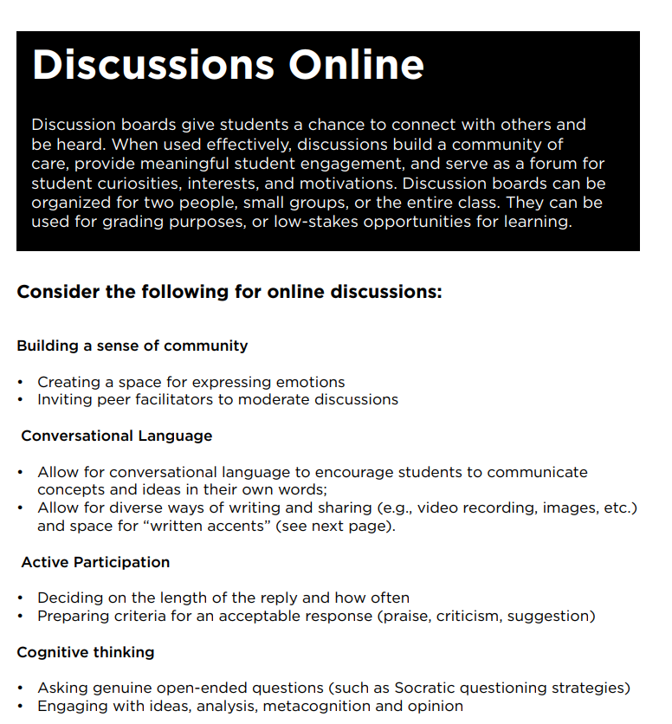

Create Contribution Guidelines

The quality of a student’s contribution is more important than the length of each posting. For example, students should be expected to:
• Solve a problem
• Lend support
• Challenge an idea
• Offer some alternatives
• Come up with a creative solution
• Ask good questions
• Assist someone in clarifying their ideas
• Give examples from their personal experience
• Contribute solid evidence to support opinion
• Acknowledge and affirm someone else’s ideas
• Bring a derailing dialogue back on track
• Ask questions when written accent impedes comprehension: “By brightens the depth, do you mean x

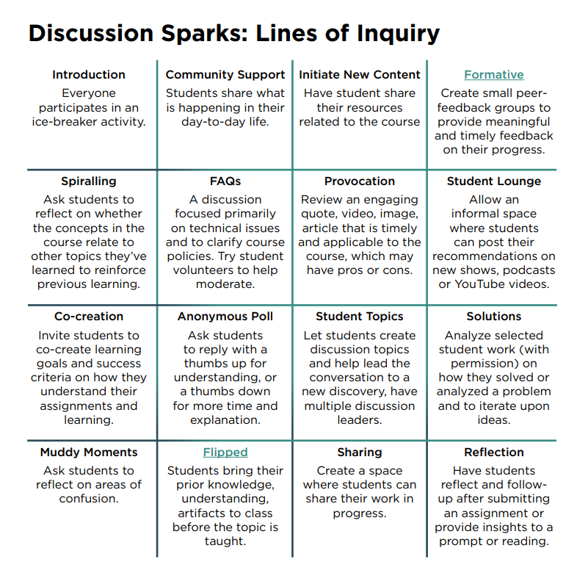

Choosing the Objective

While keeping your learning objectives in mind, consider the online learning environment and whether you’d like to encourage varying levels of critical engagement through convergent, divergent, or evaluative thinking skills.

Here are a few ways you can frame your discussion:

Convergent Thinking: begin with why, how, in what ways..

Evaluative Thinking: begin with imagine, suppose, predict, if…then…, how might, can you create, what are some possible consequences…

Divergent Thinking: try these words or phrases: defend, judge, justify, what do you think about, what is your opinion about...

